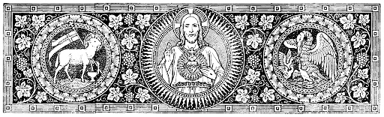

RECESSIONAL HYMN

O SACRED HEART music: R. R. Terry

words: F. Stanfiled

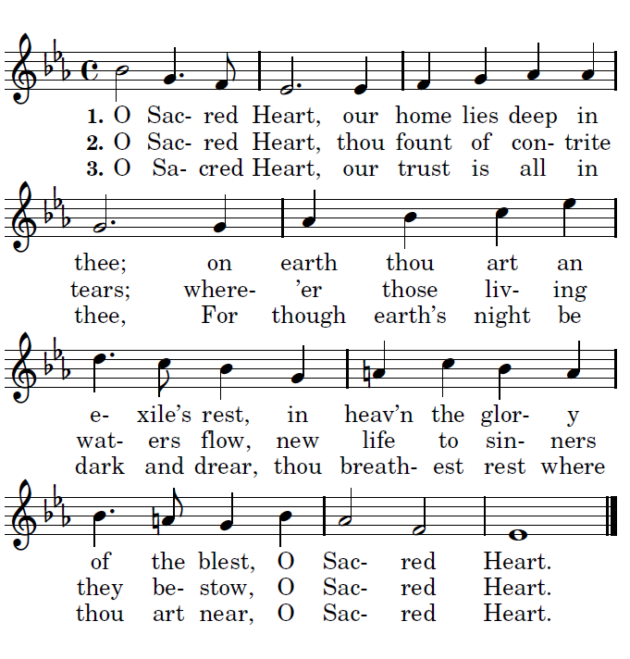



**TENTH SUNDAY**

**OF ORDINARY TIME**

ENTRANCE ANTIPHON

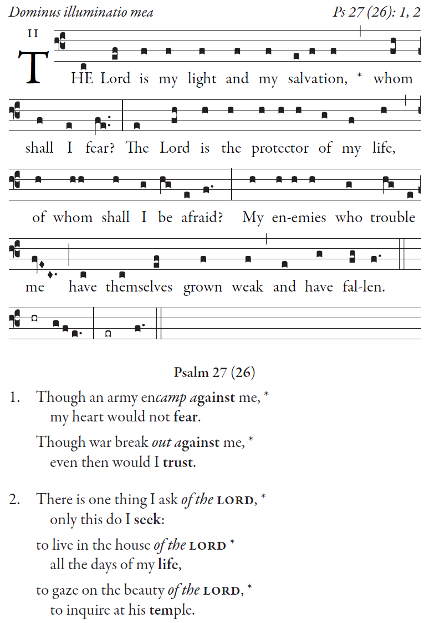

**Psalm 27 (26)**

**Though an army encamp against me,**

**my heart would not fear.**

**Though war break out against me,**

**even then would I trust.**

**There is one thing I ask of the LORD,**

**only this do I seek:**

**to live in the house of the LORD**

**all the days of my life,**

**to gaze on the beauty of the LORD,**

**to inquire at his temple.**

OFFERTORY ANTIPHON

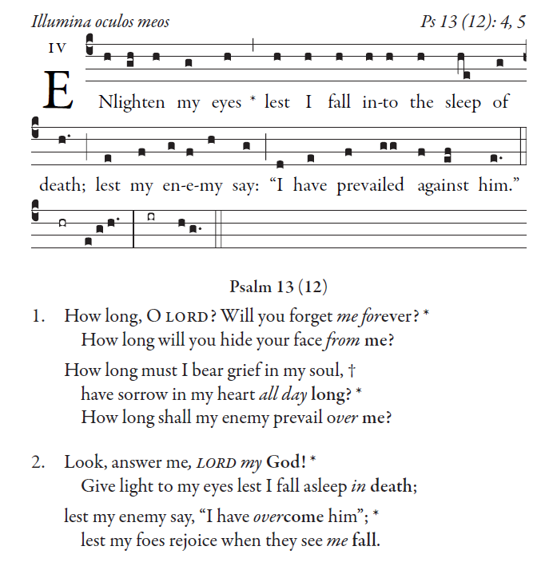

Psalm 13 (12)

**How long, O LORD? Will you forget me forever?**

**How long will you hide your face from me?**

**How long must I bear grief in my soul,**

**have sorrow in my heart all day long?**

**How long shall my enemy prevail over me?**

**Look, answer me, LORD my God!**

**Give light to my eyes lest I fall asleep in death;**

**lest my enemy say, “I have overcome him”;**

**lest my foes rejoice when they see me fall.**

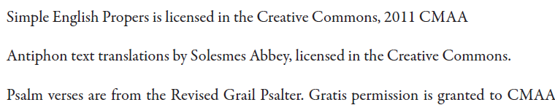

COMMUNION ANTIPHON

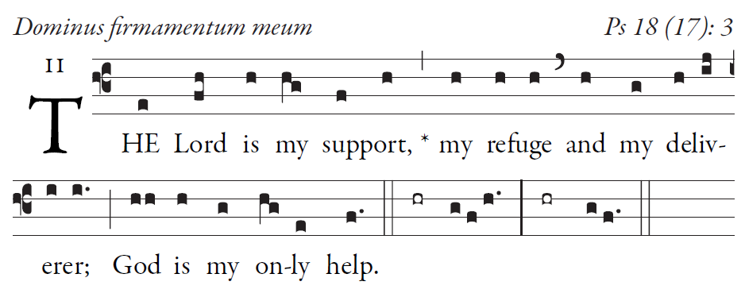

**I cry out, “Praised be the LORD!”**

**and see, I am saved from my foes.**

**In my anguish I called to the Lord**

**I cried to my god for Help**

**From his temple he heard my voice;**

**my cry to him reached his ears.**

**for you save a lowly people,**

**but bring low the eyes that are proud.**

**29It is you who give light to my lamp;**

**the LORD my God lightens my darkness.**

**For who is God but the LORD?**

**Who is a rock but our God?**

**33It is God who girds me with strength,**

**and keeps my path free of blame.**

**You gave me your saving shield;**

**with your right hand, you gave me support;**

**you bent down to make me great.**