**for you save a lowly people,**

**but bring low the eyes that are proud.**

**2It is you who give light to my lamp;**

**the LORD my God lightens my darkness.**

**For who is God but the LORD?**

**Who is a rock but our God?**

**3It is God who girds me with strength,**

**and keeps my path free of blame.**

**RECESSIONAL HYMN**

**O SACRED HEART**

**Music: R.R. Terry**

**Text: F. Stanfiled**

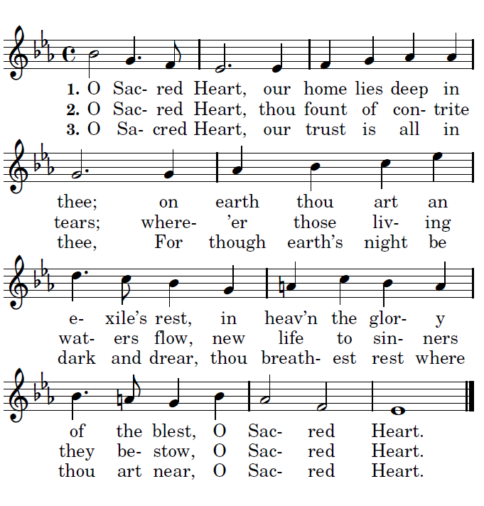



**TENTH SUNDAY**

**OF ORDINARY TIME year B**

ENTRANCE ANTIPHON

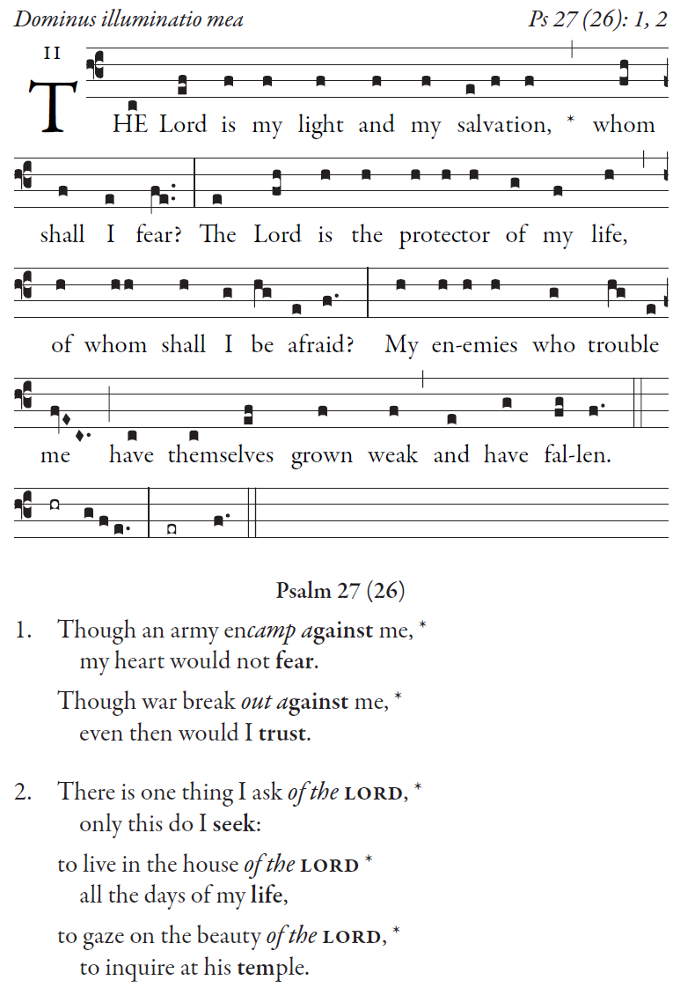

**Psalm 27 (26)**

**Though an army encamp against me,**

**my heart would not fear.**

**Though war break out against me,**

**even then would I trust.**

**There is one thing I ask of the LORD,**

**only this do I seek:**

**to live in the house of the LORD**

**all the days of my life,**

**to gaze on the beauty of the LORD,**

**to inquire at his temple.**

**RESPONSORIAL PSALM**

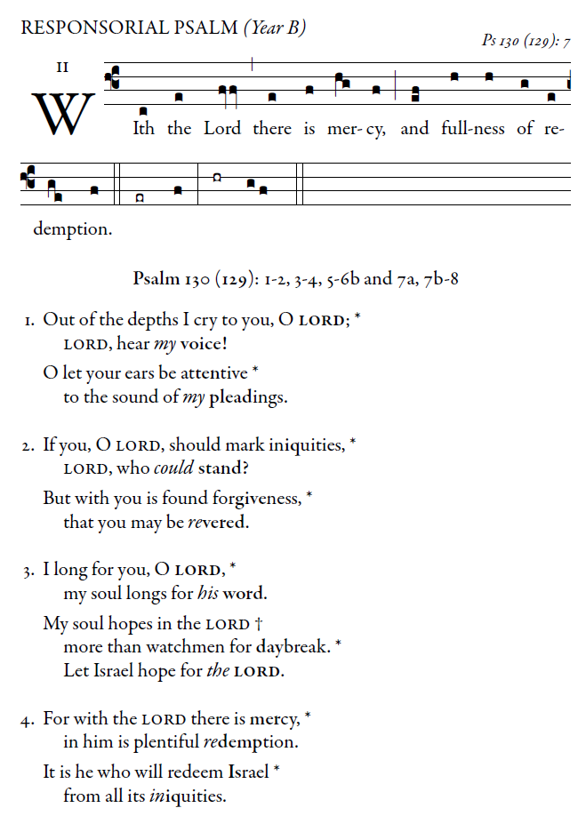

Illuminarepublications.com

**Out of the depths I cry to you, O LORD;  
LORD, hear my voice!  
Let your ears be attentive  
to my voice in supplication.  
  
If you, O LORD, mark iniquities,  
LORD, who can stand?  
But with you is forgiveness,  
that you may be revered.  
  
I trust in the LORD;  
my soul trusts in his word.  
More than sentinels wait for the dawn,  
let Israel wait for the LORD.  
  
For with the LORD is kindness  
and with him is plenteous redemption  
and he will redeem Israel  
from all their iniquities.**

**ALLELUIA**

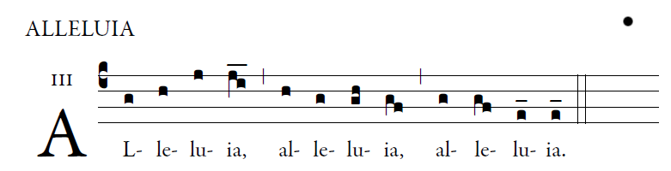

**_____________________________________________**

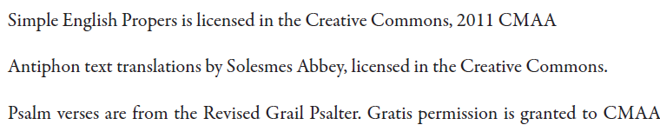

**OFFERTORY ANTIPHON**

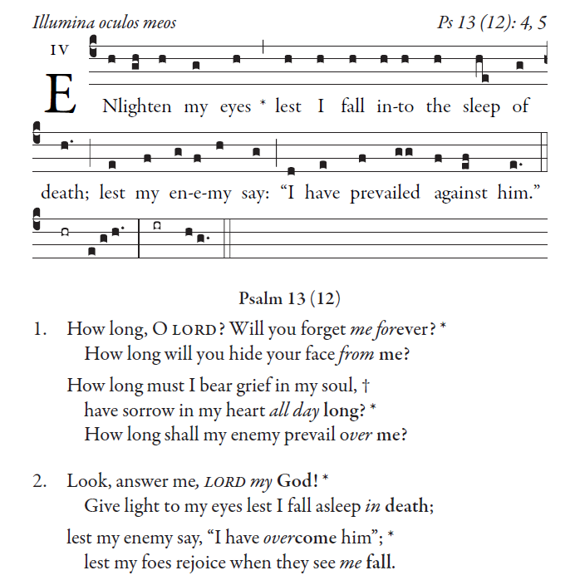

Psalm 13 (12)

**How long, O LORD? Will you forget me forever?**

**How long will you hide your face from me?**

**How long must I bear grief in my soul,**

**have sorrow in my heart all day long?**

**How long shall my enemy prevail over me?**

**OFFERTORY HYMN “ All is Well with my Soul ”**

**COMMUNION ANTIPHON**

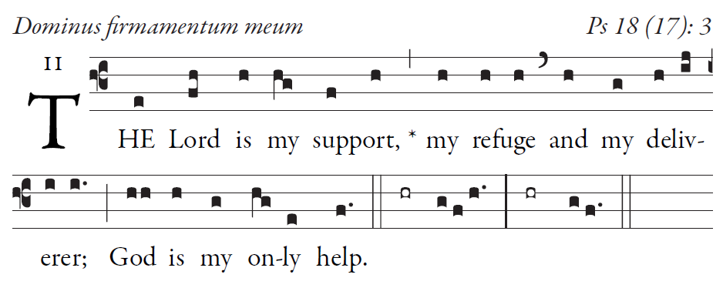

**I cry out, “Praised be the LORD!”**

**and see, I am saved from my foes.**

**In my anguish I called to the Lord**

**I cried to my god for Help**

**From his temple he heard my voice;**

**my cry to him reached his ears.**