Offertory Hymn: “O Jesus Joy of Loving Hearts”

Communion Antiphon:

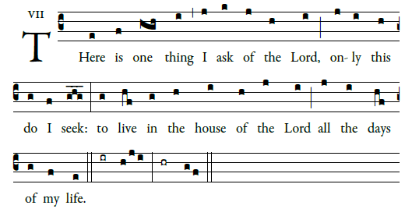
©Illuminare Publications.com

Recessional Hymn: “To Jesus Heart All Burning”

T
o Jesus’ Heart, all burning
with fervent love for men,
my heart with fondest yearning
shall rise its joyful strain.

refrain

While ages course along,
blest be with loudest song
the Sacred Heart of Jesus
by ev’ry heart and tongue.

O Heart, for men on fire
with love no man can speak,
my yet untold desire
God gives me for thy sake.

11 Sunday in Ordinary Time

Entrance Antiphon

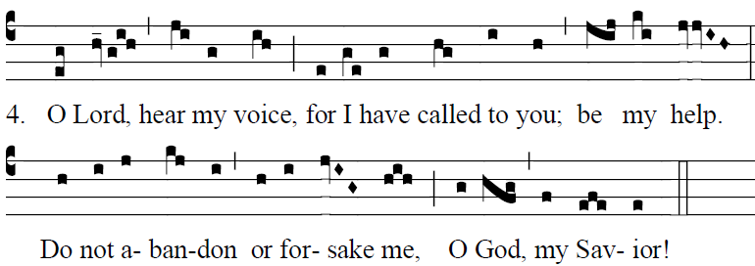
Fr Columba Kelly ©Sain Meinrad Archabbey
The LORD is my light and my salvation;
whom shall I fear?
The LORD is the stronghold of my life;
whom should I dread? 

²When those who do evil draw near
to devour my flesh,
it is they, my enemies and foes,
who stumble and fall. 

Glory be to the Father … 

GLORIA

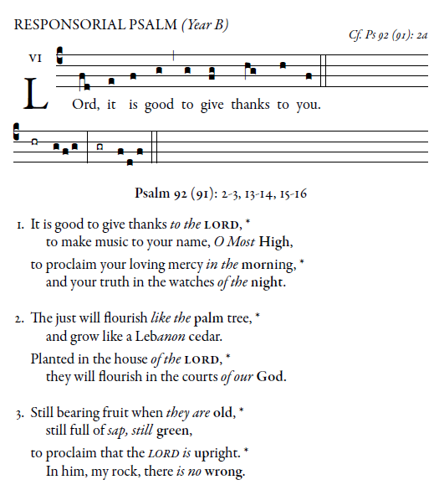
Illuminarepublication.com

