COMMUNION ANTIPHON ©Illuminare Publications.com

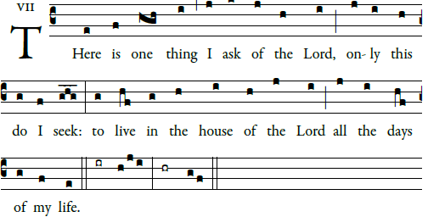

RECESSIONAL HYMN: “ O SACRED HEART”
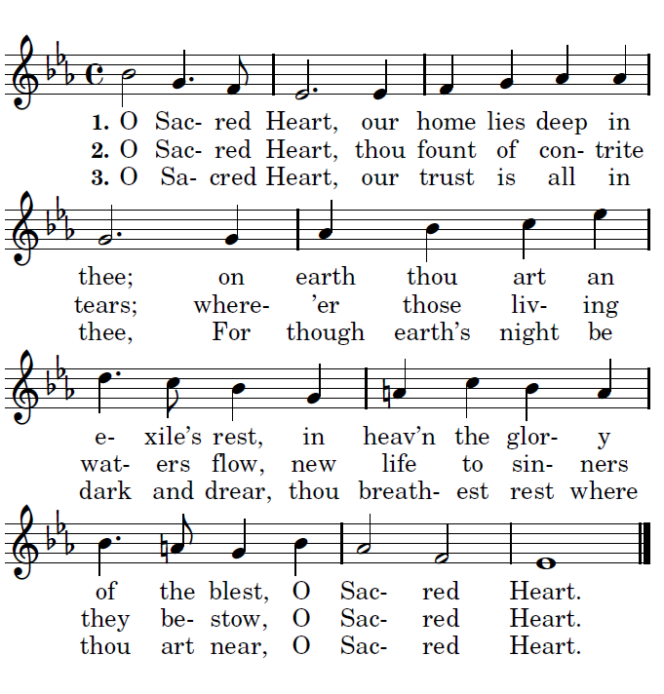

ELEVENTH SUNDAY IN ORDINARY TIME

ENTRANCE ANTIPHON

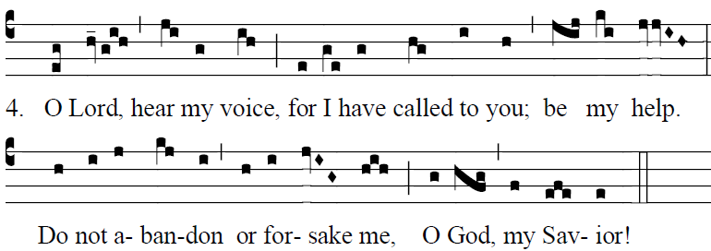
Fr Columba Kelly ©Sain Meinrad Archabbey

The LORD is my light and my salvation;
whom shall I fear?
The LORD is the stronghold of my life;
whom should I dread? 


LORD HAVE MERCY
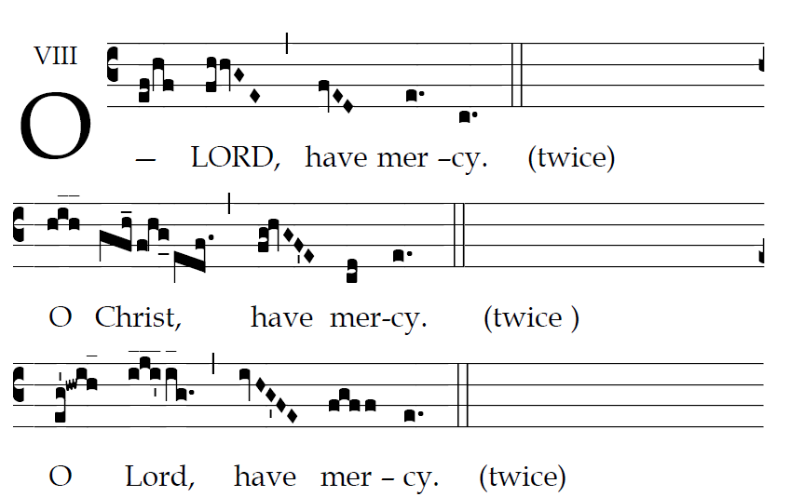

GLORIA

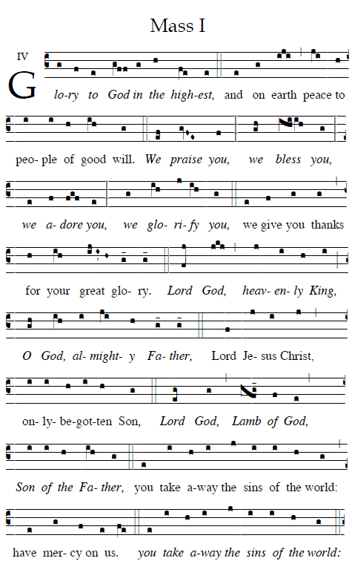

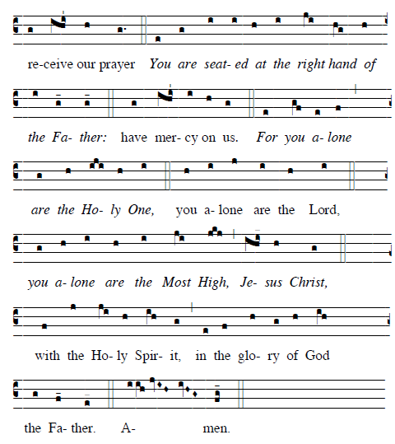

OFFERTORY HYMN: Hymn of the Holy Year Of Mercy
“Be merciful as your Father is merciful ; for his mercy is everlasting”
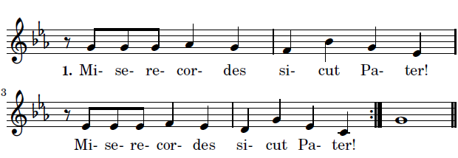
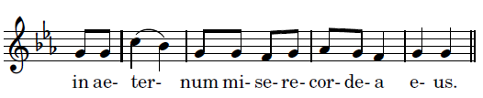
RESPONSE AFTER EACH VERSE

