COMMUNION ANTIPHON © Marco Frisina
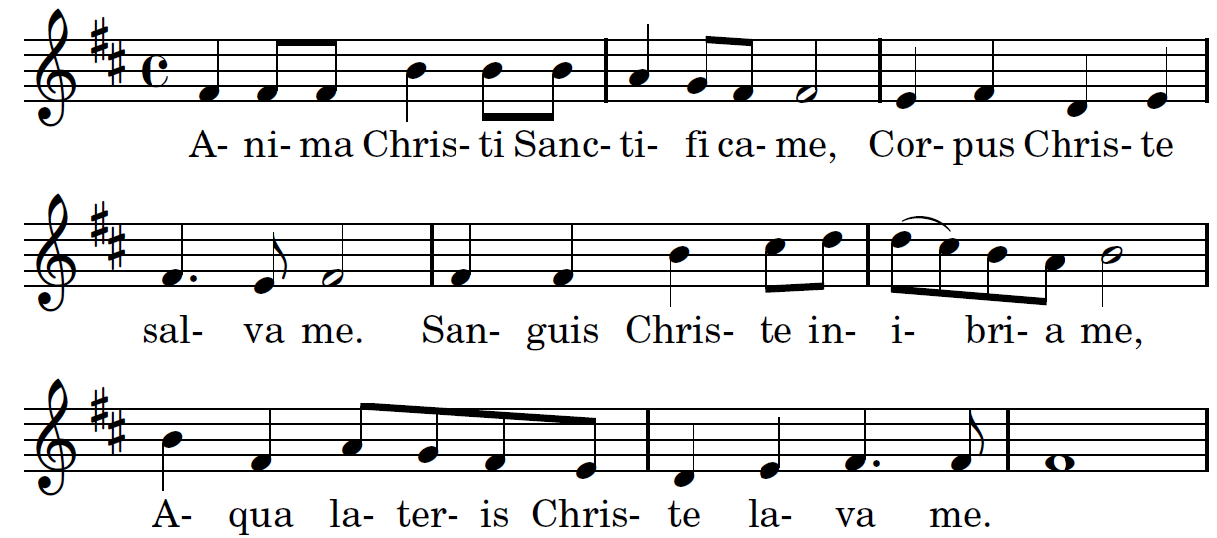

Soul of my Savior sanctify my breast,
Body of Christ, be thou my saving guest,
Blood of my Savior, bathe me in thy tide,
wash me with waters flowing from thy side.

RECESSIONAL HYMN: “ O SACRED HEART”
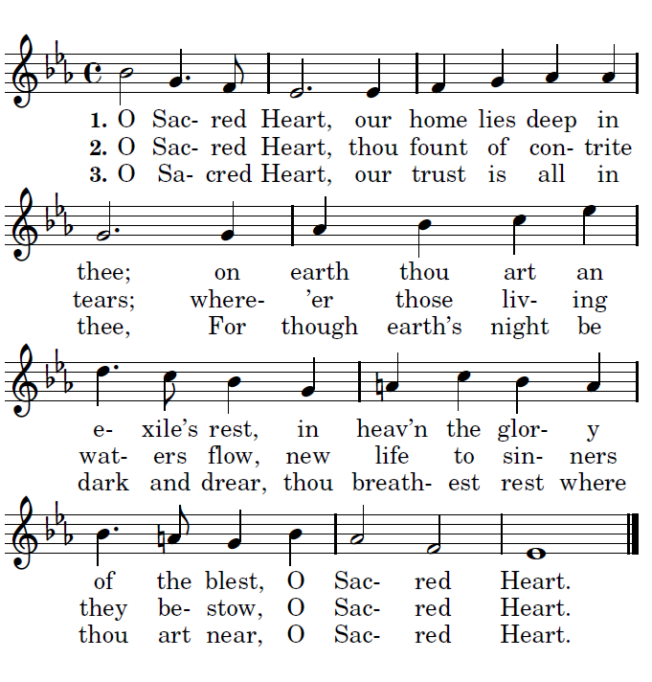

TWELFTH SUNDAY IN ORDINARY TIME
~~~~~ June is the month of the Sacred Heart ~~~~~
YEAR A

YEAR A

ENTRANCE ANTIPHON

To you, O LORD, I call;
my rock, be not deaf to me.
I shall go down to those in the pit,
if you are silent to me.

Hear the voice of my pleading
as I call to you for help,
as I raise my hands
toward your holy place.

RESPONSORIAL PSALM Year A Ps 69

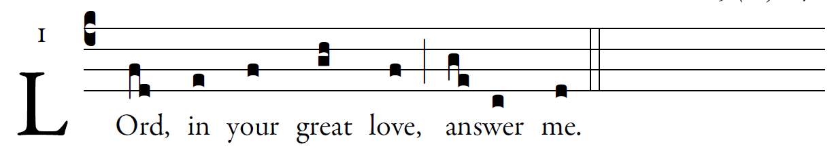
©Illuminarepublications.com

For your sake I bear insult,
and shame covers my face.
I have become an outcast to my brothers,
a stranger to my children,
Because zeal for your house consumes me,
and the insults of those who blaspheme you fall upon me.
I pray to you, O LORD,
for the time of your favor, O God!
In your great kindness answer me
with your constant help.
Answer me, O LORD, for bounteous is your kindness;
in your great mercy turn toward me.
"See, you lowly ones, and be glad;
you who seek God, may your hearts revive!
For the LORD hears the poor,
and his own who are in bonds he spurns not.
Let the heavens and the earth praise him,
the seas and whatever moves in them!''

ALLELUIA

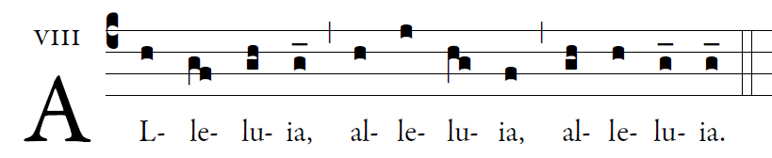

The Spirit of truth will testify to me, says the Lord;
and you also will testify.

OFFERTORY

©Illuminarepublications.com

O LORD, hear a cause that is just;
pay heed to my cry.
Turn your ear to my prayer:
no deceit is on my lips.
From you may my justice come forth.
Your eyes discern what is upright.

Search my heart and visit me by night.
Test me by fire, and you will find no wrong in me.
My mouth does not transgress as others do;
on account of the words of your lips,
I closely watched the paths of the violent.

