RECESSIONAL HYMN:

TO JESUS HEART ALL BURNING
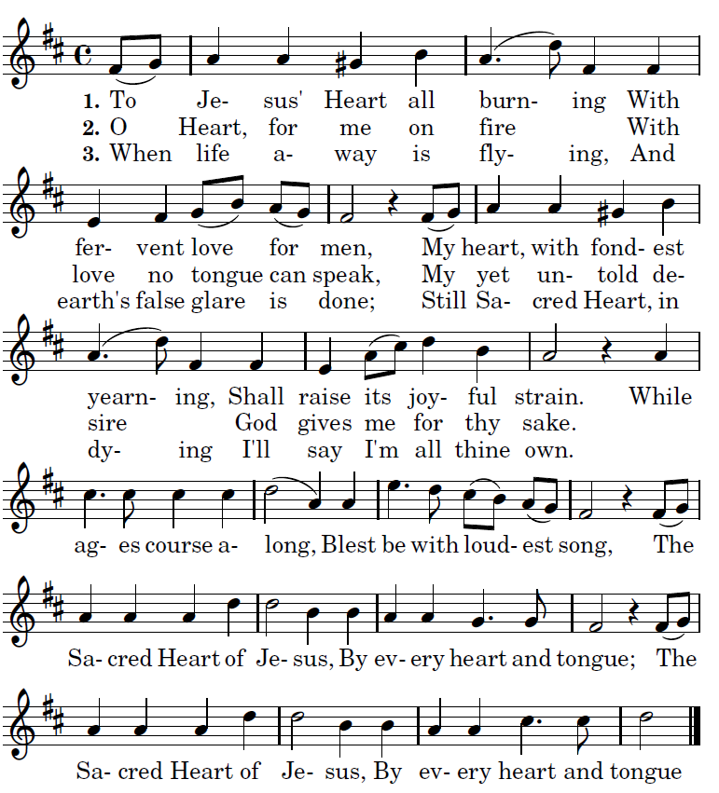

proper antiphons from Illuminarepublications.com

13TH SUNDAY IN ORDINARY TIME

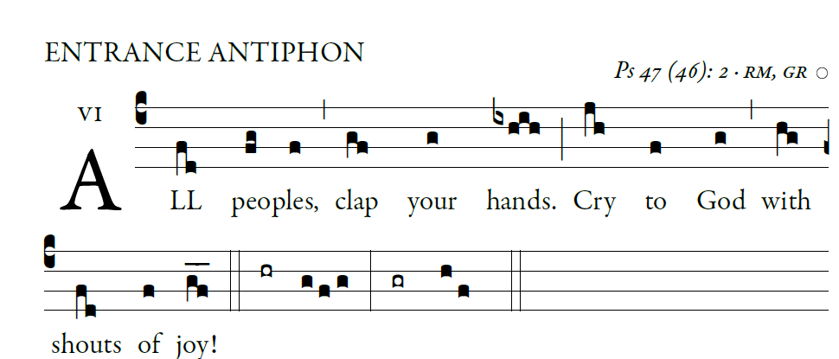
ENTRANCE ANTIPHON

Psalm 28 (27)

For the LORD, the Most High, is awesome,
the great king over all the earth.
He humbles peoples under us
and nations under our feet.

Our heritage he chose for us,
the pride of Jacob whom he loves.
God goes up with shouts of joy.
The LORD goes up with trumpet blast.

Sing praise for God; sing praise!
Sing praise to our king; sing praise!
God is king of all the earth.
Sing praise with all your skill.
God reigns over the nations.
God sits upon his holy throne.

ALLELUIA

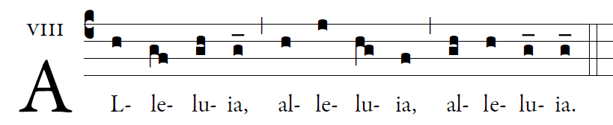

Speak , Lord, your servant is listening;
you have the words of everlasting life.   

OFFERTORY HYMN

“O God beyond All Praising”

COMMUNION ANTIPHON

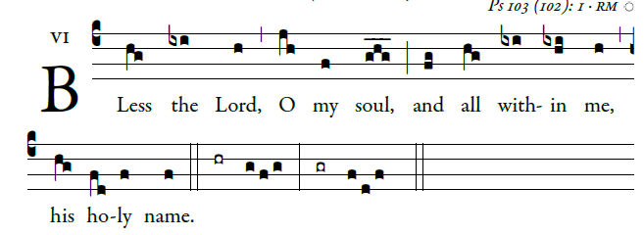

Bless the LORD, O my soul,
and all within me, his holy name.
²Bless the LORD, O my soul,
and never forget all his benefits.

³It is the LORD who forgives all your sins,
who heals every one of your ills,
⁴who redeems your life from the grave,
who crowns you with mercy and compassion,
⁵who fills your life with good things,
renewing your youth like an eagle’s.

⁶The LORD does just deeds,
gives full justice to all who are oppressed.
⁷He made known his ways to Moses,
and his deeds to the children of Israel.

⁸The LORD is compassionate and gracious,
slow to anger and rich in mercy.
⁹He will not always find fault;

