proper antiphon from The Simple English Propers
Adam Bartlett CMAA

14th Sunday in Ordinary Time

Entrance Hymn

PRAISE TO THE LORD
Todays Missal #30

Kyrie 909 and Gloria, 910 Mass of St Paul the Apostle

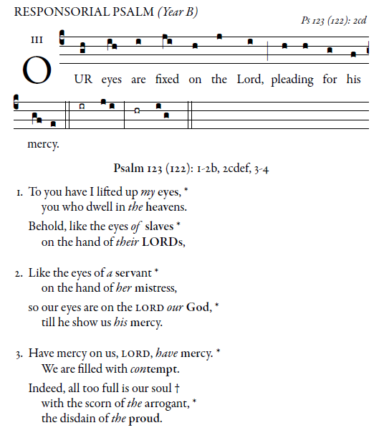
Responsorial Psalm

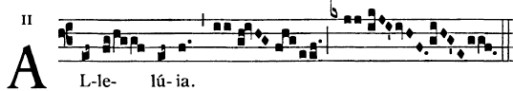

The Spirit of the Lord is upon me
for he sent me to bring glad tidings to the poor.

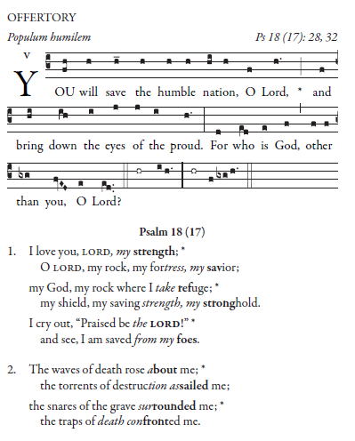
Offertory
Holy 913
Memorial Acclamation 914
Lamb of God: 918
Mass of St Paul the Apostle

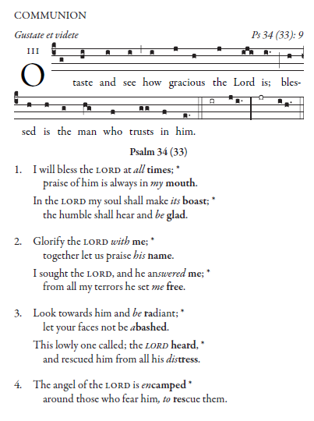
Communion

Recessional Hymn

NOW THANK WE ALL OUR GOD
Todays Missal #31

