COMMUNION HYMN

“O Lord, I Am Not Worthy”

RECESSIONAL HYMN

“All Is Well With My Soul”

proper antiphon from The Simple English Propers
Adam Bartlett ©CMAACreative commons , for free use

14th Sunday in Ordinary Time _{YEAR A}

ENTRANCE ANTIPHON

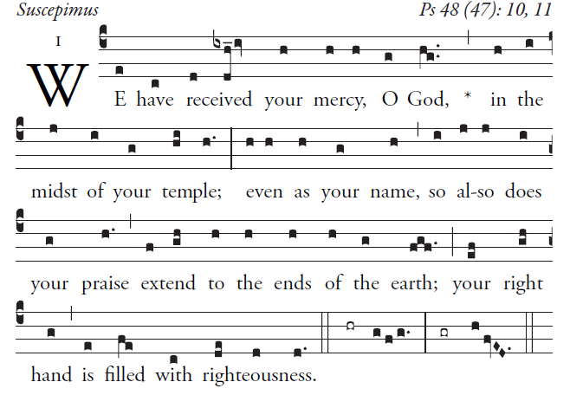

Great is the LORD and highly to be praised
in the city of our God.
His holy mountain rises in beauty,
the joy of all the earth.
Mount Sion, in the heart of the North,
the city of the Mighty King!
God, in the midst of its citadels,
has shown himself its stronghold.

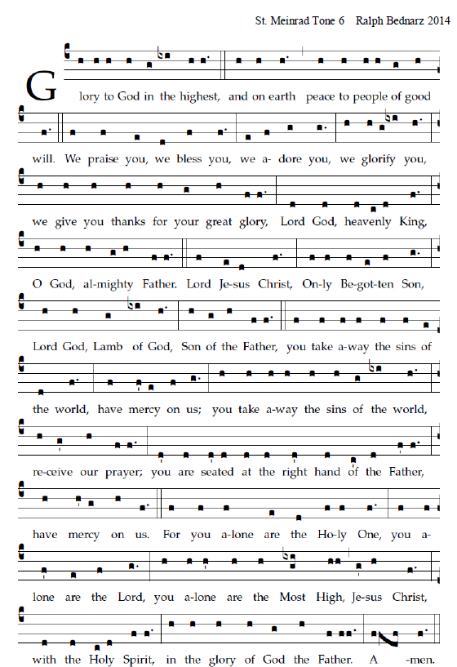

RESPONSORIAL PSALM _{AND} ALLELUIA in Today’s Missal

OFFERTORY ANTIPHON

I love you, LORD, my strength;
O LORD, my rock, my fortress, my savior;
my God, my rock where I take refuge;
my shield, my saving strength, my stronghold.
cry out, “Praised be the LORD!”
and see, I am saved from my foes.

The waves of death rose about me;
the torrents of destruction assailed me;
the snares of the grave surrounded me;
the traps of death confronted me.

