COMMUNION ANTIPHON
Fr. Columba Kelly St .Meinrad Archabbey
Blessings from the LORD shall he receive,
and right reward from the God who saves him.
⁶Such are the people who seek him,
who seek the face of the God of Jacob.

O gates, lift high your heads;
grow higher, ancient doors.
Let him enter, the king of glory!

⁸Who is this king of glory?
The LORD, the mighty, the valiant;
the LORD, the valiant in war.

O gates, lift high your heads;
grow higher, ancient doors.
Let him enter, the king of glory!
¹⁰Who is this king of glory?
He, the LORD of hosts,
he is the king of glory.

RECESSIONAL HYMN
“For the Beauty of the Earth”

16th Sunday in Ordinary Time year A

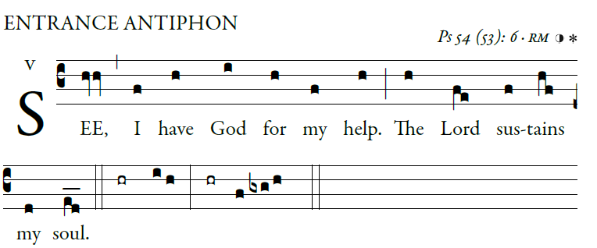 [ I will sacrifice to you with willing heart,
illuminarepublication.com
ENTRANCE ANTIPHON
and praise your name, for it is good:]
O God, save me by your name;
by your power, defend my cause.
⁴O God, hear my prayer;
give ear to the words of my mouth.

⁵For the proud have risen against me,
and the ruthless seek my life.
They have no regard for God.
⁶See, I have God for my help.

The LORD sustains my soul.
⁷Let evil recoil on my foes.
In your faithfulness, bring them to an end.
⁹for it has rescued me from all distress,
and my eyes have gazed upon my foes.

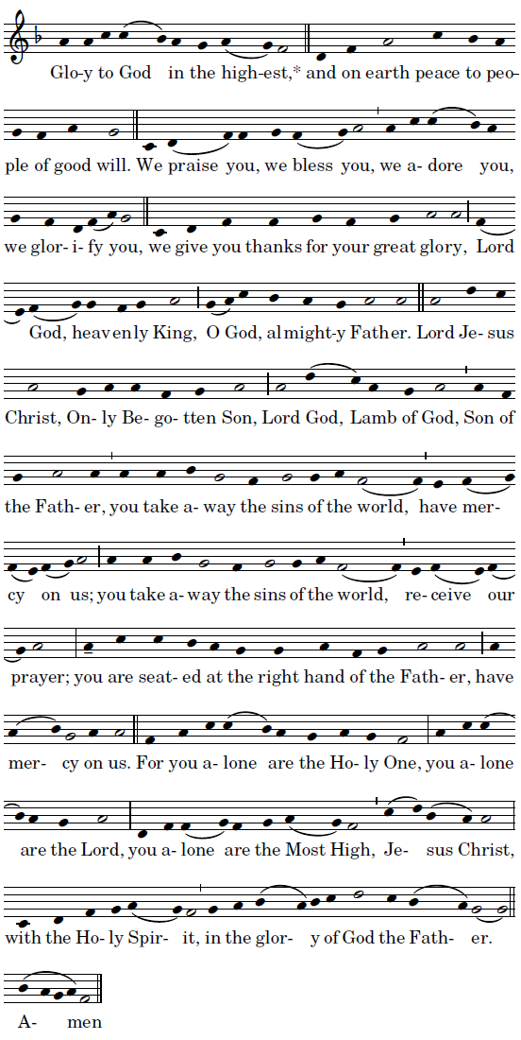OFFERTORY HYMN

“Come ye Thankful People Come” Today’s Missal

SANCTUS
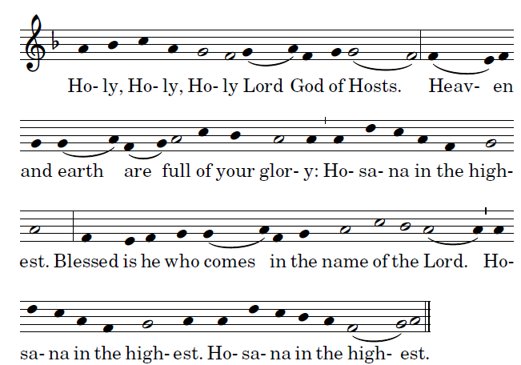
ACCLAMATION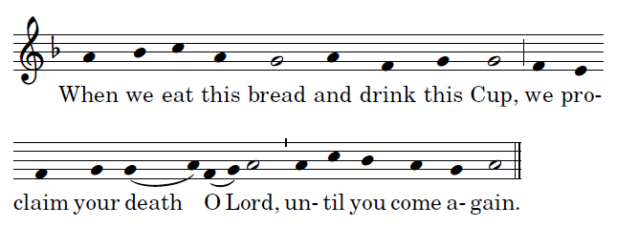
AGNUS DEI 