COMMUNION ANTIPHON

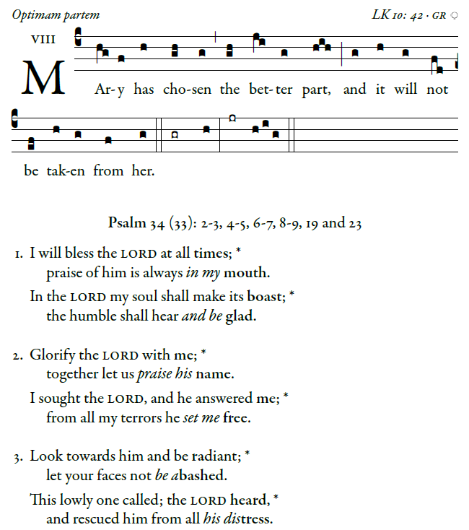

RECESSIONAL HYMN

“Sent Forth by God’s Blessing”

16th Sunday in Ordinary Time YEAR C

ENTRANCE ANTIPHON 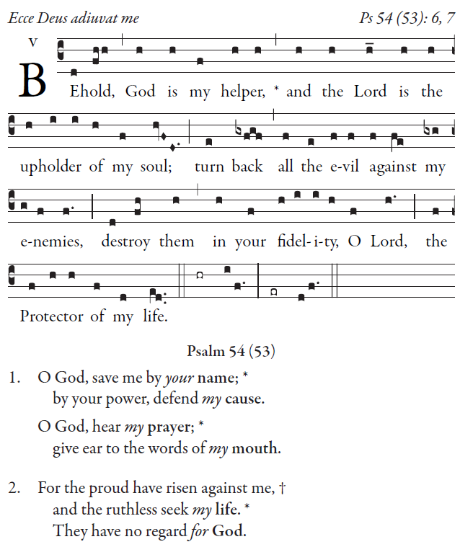

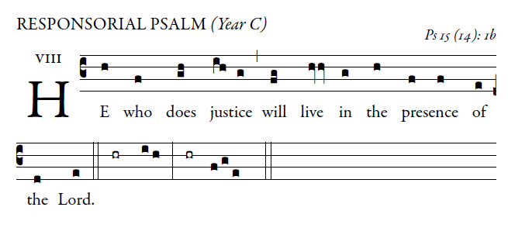
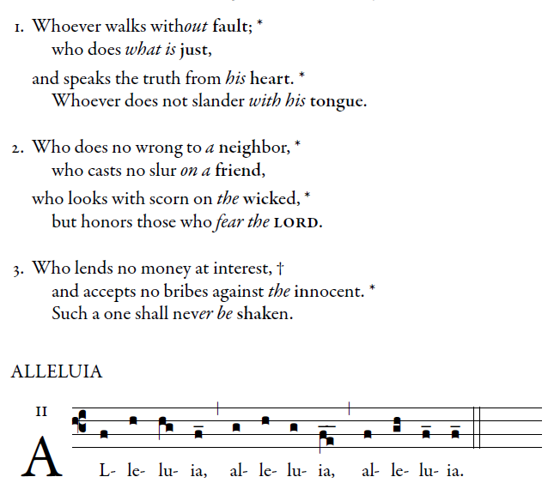

Blessed are they who have kept the word with a generous heart and yield a harvest through perseverance.

OFFERTORY ANTIPHON

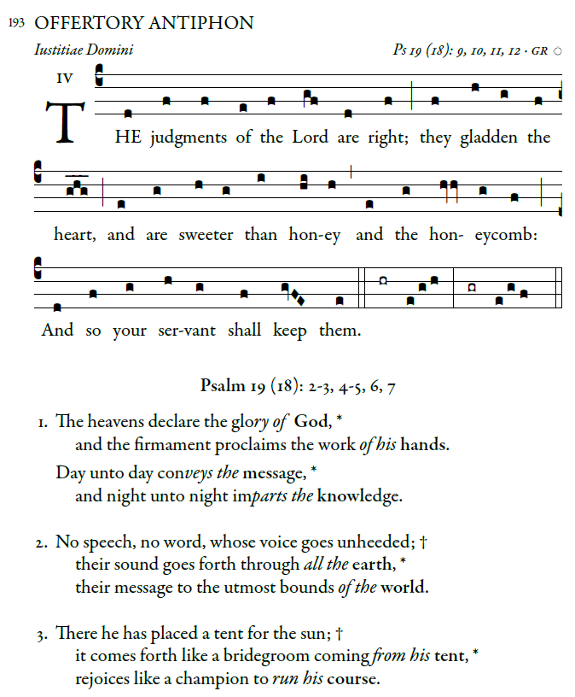

Entrance antiphon, Simple English Propers©CMAA creative commons
Responsorial psalm , Offertory and Communion antiphons and antiphons are from ILLUMINAREPUBLICTIONS.COM AdamBartlett
©Creative Commons

