OFFERTORY HYMN

#326 ” O Sacrament Most Holy”

COMMUNION ANTIPHON

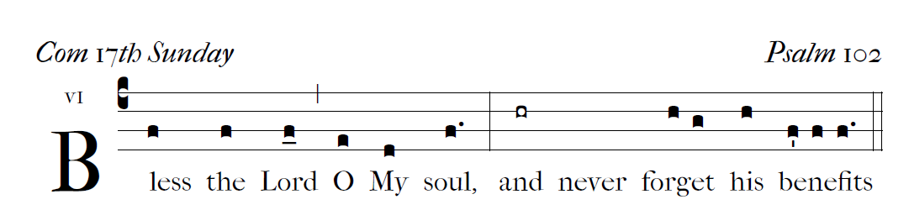

RECESSIONAL HYMN

Jesus My Lord My God My All

Thy Body, Soul - and God - head, all!
O mystery of love divine!
I cannot compass all I have,
For all Thou hast and art is mine!
Refrain:
Sweet Sacrament, we Thee adore!
Oh, make us love Thee more and more.
Oh, make us love Thee more and more.
Sound, then, His prais - es high - er still,
And come, ye angels, to our aid;
For this is God, the very God
Who hath both men and angels made

17 th Sunday in Ordinary Time

ENTRANCE ANTIPHON

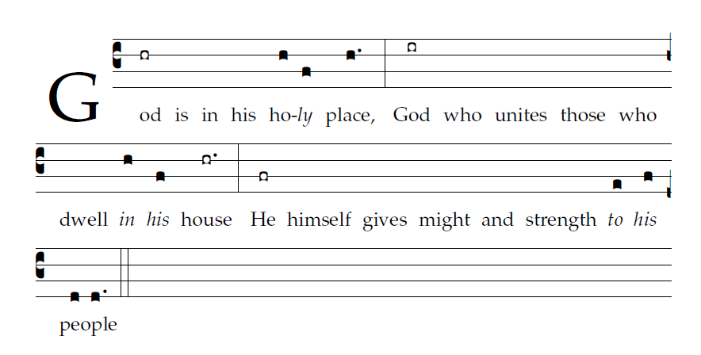

Let God arise; let his foes be scattered.
Let those who hate him flee from his presence.
³As smoke is driven away, so drive them away;
like wax that melts before the fire,  

so the wicked shall perish at the presence of God.
But the just shall rejoice at the presence of God;
they shall exult with glad rejoicing.
⁵O sing to God; make music to his name. 

Glory be to the Father … 

KYRIE
©2014 Richard J. Clark
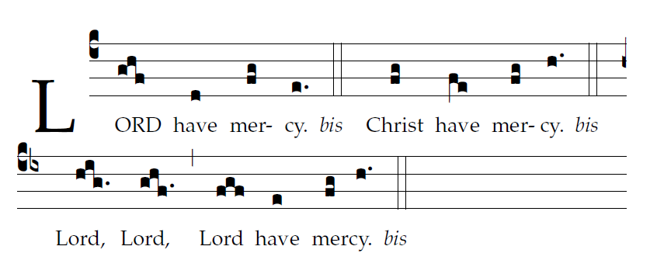

GLORIA R. Bednarz
St Meinrad pslam tone

