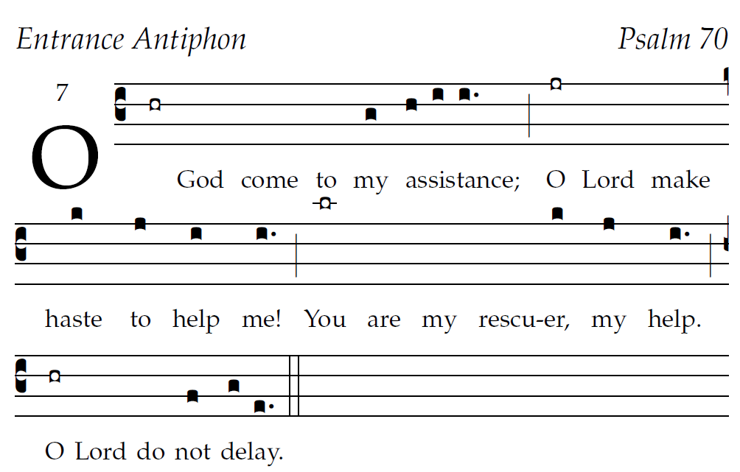

Psalm tone ©St. Meinrad Archabbey

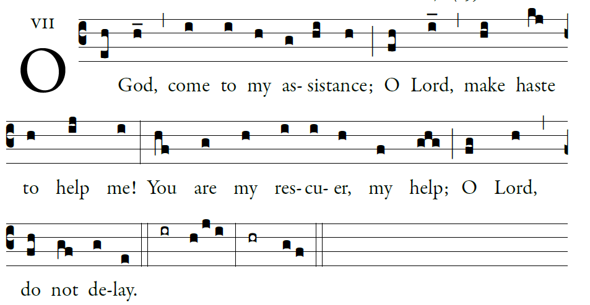

illumlinarepublications.com

Psalm 70
²O God, come to my assistance;
O LORD, make haste to help me!
³Let there be shame and confusion
on those who seek my life.
O let them turn back in confusion,
who delight in my harm;
⁴let them retreat, covered with shame,
who jeer at me and mock
.
⁵O let there be rejoicing and gladness
for all who seek you.
Let them say forever, “God is great,”
who love your saving help.

⁶As for me, wretched and poor,
hasten to me, O God.
You are my rescuer, my help;
O LORD, do not delay
. The Revised Grail Psalms Copyright © 2010, Conception Abbey/The Grail, admin. by GIA Publications, Inc., www.giamusic.com All rights reserved.
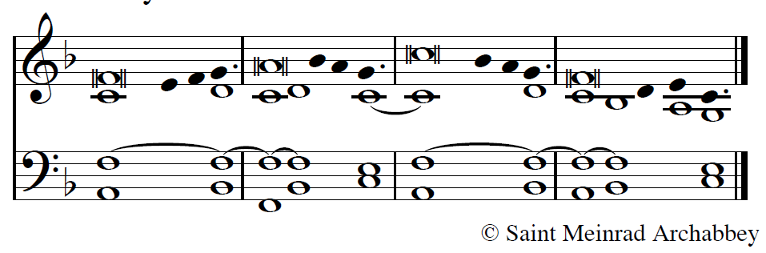
2012 mode 1
2013 mode
2014 7buser-notes: Entrance Antiphon ;
commentary: Psalm 70;
annotation: 7 ;
centering-scheme: english;
%spacing: smith;
%font: palatino;
%width: 4;
%height: 11;
%%
(c3)O(hr) God() come() to() my(g) {a}ssistance;(h/ i/ i.) (;) O(jr) Lord() make() haste (k) to(j) help(i) me!(i.) (;) You(lr) are() my() rescu-()er,(k) my(j) help.(i.) (;) O(hr) Lord() do() not(f) {de}lay.(g/ e.) (::)

