ENTRNACE ANTIPHON FROM ILLUMINAREPUBLICATIONS>COM

19th Sunday in Ordinary Time

Lord have Mercy, Glory to God , Holy, Acclamation, Amen and Alleluia from the MISSA SIMPLEX booklet.

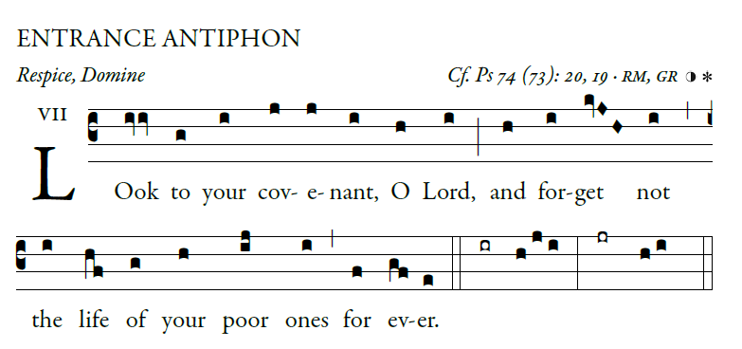

Why, O God, have you cast us off forever?
Why does your anger blaze at the sheep of your pasture?
²Remember your flock which you claimed long ago,
the tribe you redeemed to be your own possession,
Turn your steps to these places that are utterly ruined!
The enemy has laid waste the whole of the holy place.
⁴Your foes have made uproar in
the midst of your assembly;
they have set up their emblems as tokens there.
Arise, O God, and defend your cause!
Remember how the senseless revile you all the day.
²³Do not forget the clamor of your foes,
the unceasing uproar of those who defy you.

LITURGY OF THE WORD
Psalm from Today’s Missal

OFFERTORY HYMN

SOUL OF MY SAVIOR
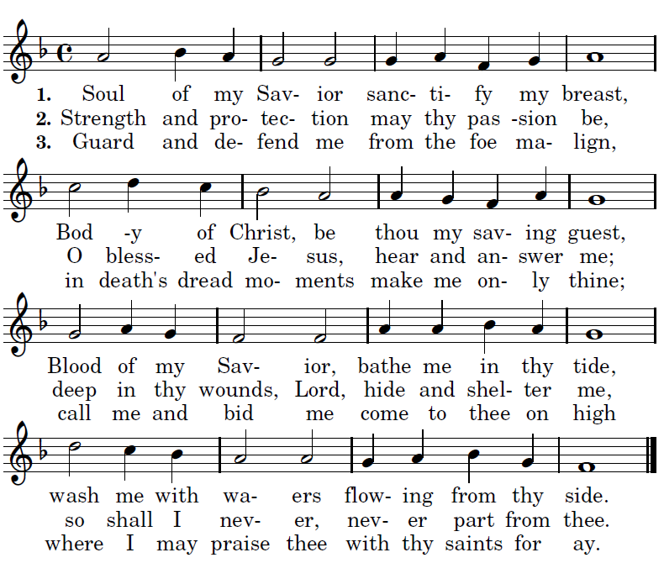

COMMUNION ANTIPHON
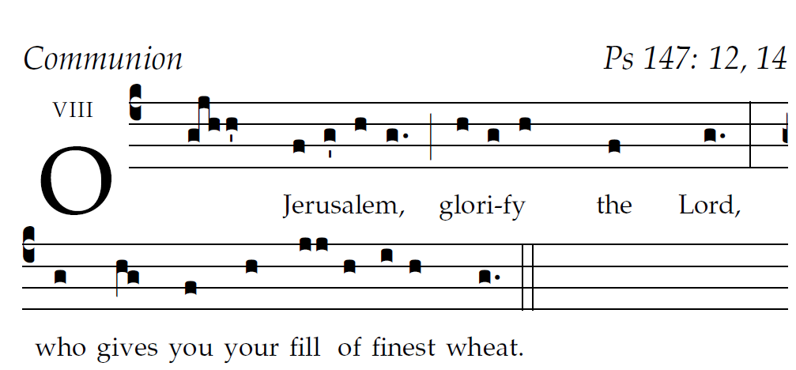

RB 2013, 2014, 2015
¹²O Jerusalem, glorify the LORD!
O Sion, praise your God!
¹³He has strengthened the bars of your gates;
he has blessed your children within you.

¹⁴He established peace on your borders;
he gives you your fill of finest wheat.
¹⁵He sends out his word to the earth,
and swiftly runs his command.

¹⁶He showers down snow like wool;
he scatters hoarfrost like ashes.
¹⁷He hurls down hailstones like crumbs;
before such cold, who can stand?

¹⁸He sends forth his word and it melts them;
at the blowing of his breath the waters flow.

RECESSIONAL HYMN

“ I Received the Living God”

