All propers are from illuminarepublication.com

20th Sunday Ordinary Time YEAR B

ENTRANCE ANTIPHON

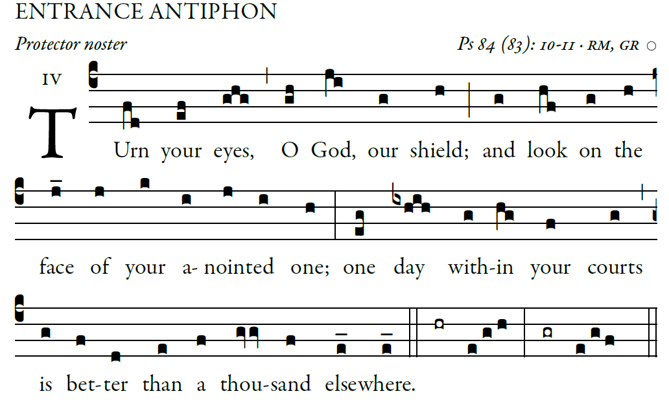

How lovely is your dwelling place, [6]
O Lord of hosts.
My soul is longing and yearning
for the courts of the Lord.
My heart and my flesh cry out
to the living God.

Blessed are they who dwell in your house,
forever singing your praise.
⁶Blessed the people whose strength is in you,
whose heart is set on pilgrim ways.

Ordinary of the Mass: Latin Chant Mass in The Music Issue

RESPONSORIAL PSALM and Alleluia from Today’s Missal

OFFERTORY HYMN
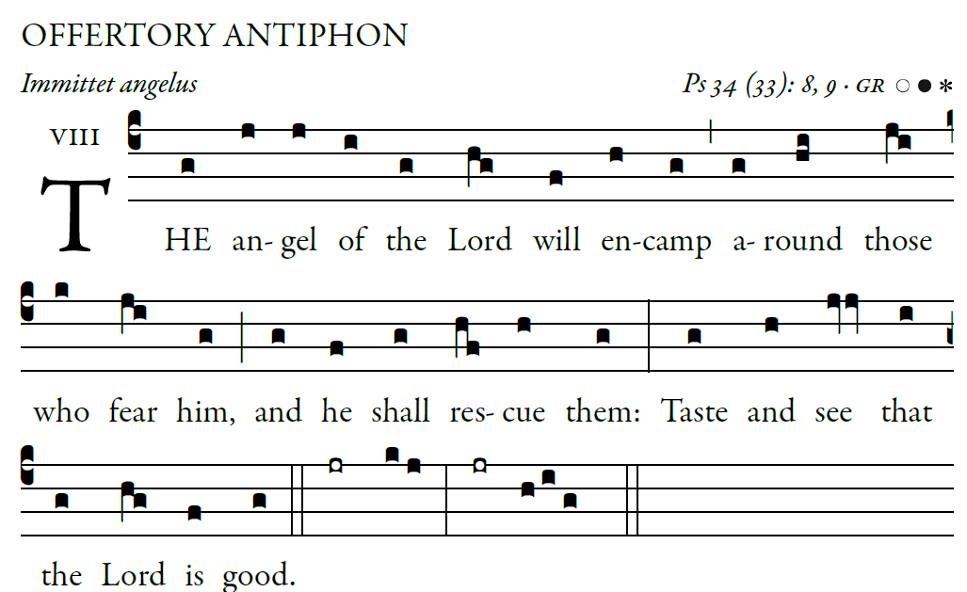

COMMUNION ANTIPHONS

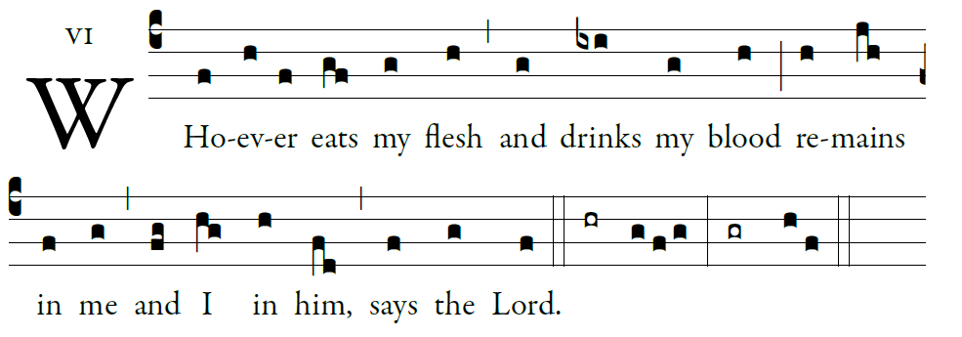

Blessed are those whose way is blameless,
who walk in the law of the LORD!
²Blessed are those who keep his decrees!
With all their hearts they seek him

They never do anything evil,
but walk in his ways.
You have laid down your precepts
to be carefully kept.

May my ways be firm
in keeping your statutes.
Then I shall not be put to shame
as I observe all your commands.

I will thank you with an upright heart,
as I learn your just judgments.
I will keep your statutes;
do not ever forsake me.

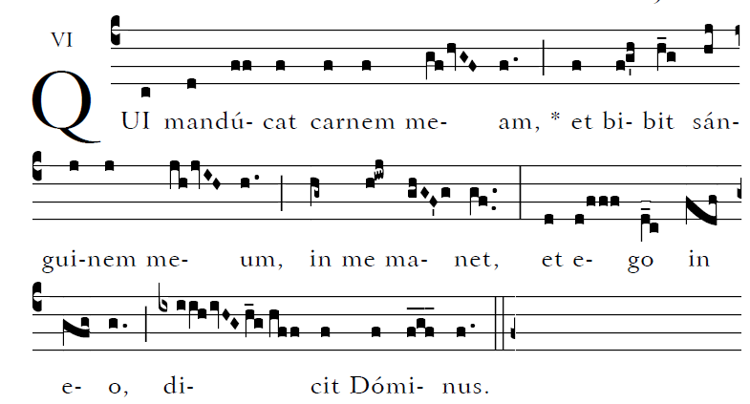

RECESSIONAL HYMN

“Hail Holy Queen”

