21 st Sunday Communion
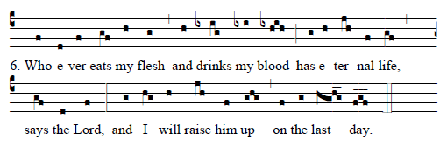
Music © 2012 Saint Meinrad Archabbey. All rights reserved.
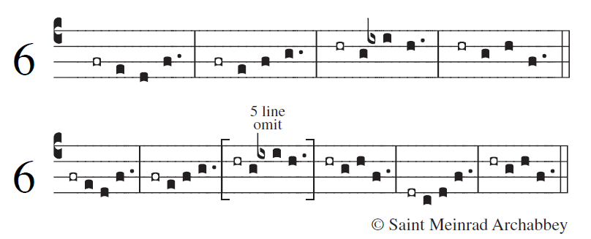

Psalm 119:1-8
¹Blessed are those whose way is blameless,
who walk in the law of the LORD!
²Blessed are those who keep his decrees!
With all their hearts they seek him

¹¹I treasure your word in my heart,
lest I sin against you.
¹²Blest are you, O LORD;
teach me your statutes

⁴⁹Remember your word to your servant,
by which you made me hope.
⁵⁰This is my comfort in sorrow:
that your promise gives me life.
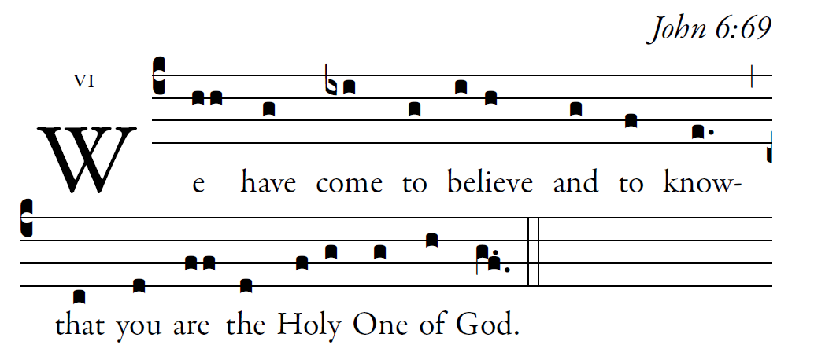
The law from your mouth means more to me
than large quantities of silver and gold.

¹⁰³How sweet is your promise to my tongue,
more than honey in the mouth.
¹⁰⁵Your word is a lamp for my feet,
and a light for my path.

The Revised Grail Psalms Co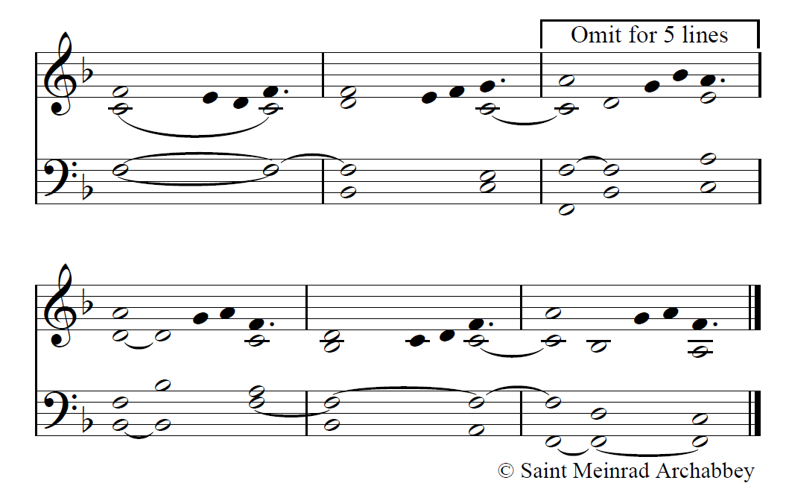pyright © 2010, Conception Abbey/The Grail, admin. by GIA Publications, Inc., www.giamusic.com All rights reserved.

(c4)We(hh) have(g) come(ixi) to(g) {be}lieve(i/ h) and(g) to(f) know(e.)(,) that(c) you(d) are(ff) the(d) {Hol}y(f/ g) One(g) of(h) God.(g.f.) (::)

(c4)Who-(f) ev- (d)er(f) eats(gf) my(h) flesh(g) (,) and(h) drinks(ixig) my(ixi) (ix)blood(hih) (;) has(g) e(h)ter-(jh)nal(f) life(gf__) says(gf) the(d) Lord,(f) (:) and(g) I(hg) will(h) raise(jh) him(f) up(ghg) (,) on(f) the(g) last(hghg__) day.(fgf___) (::)

