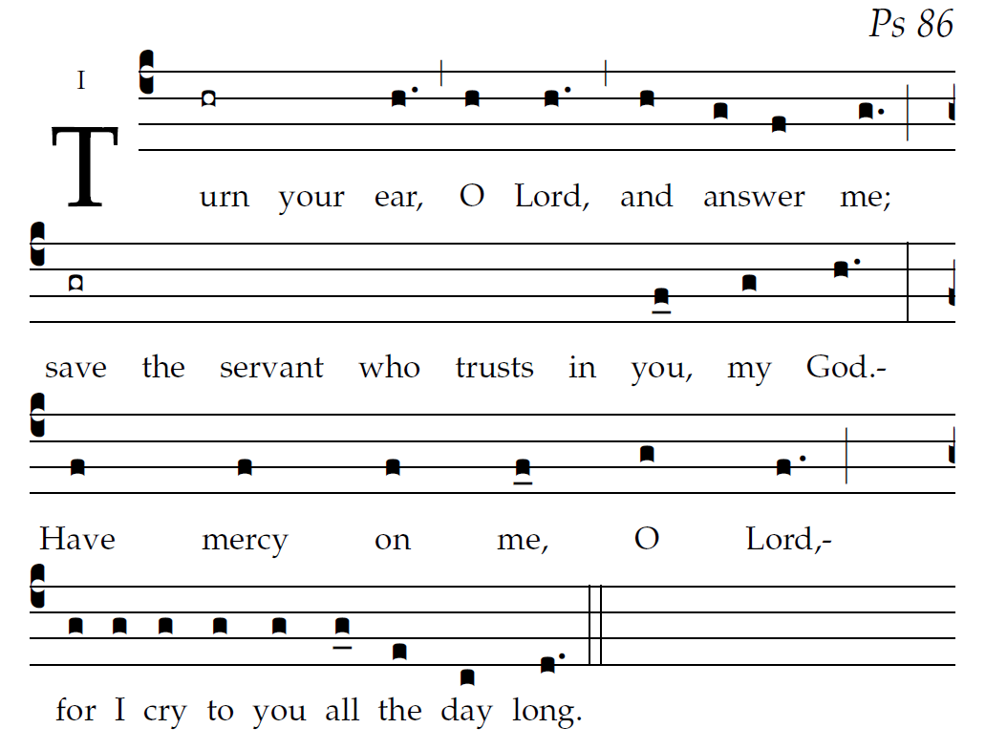

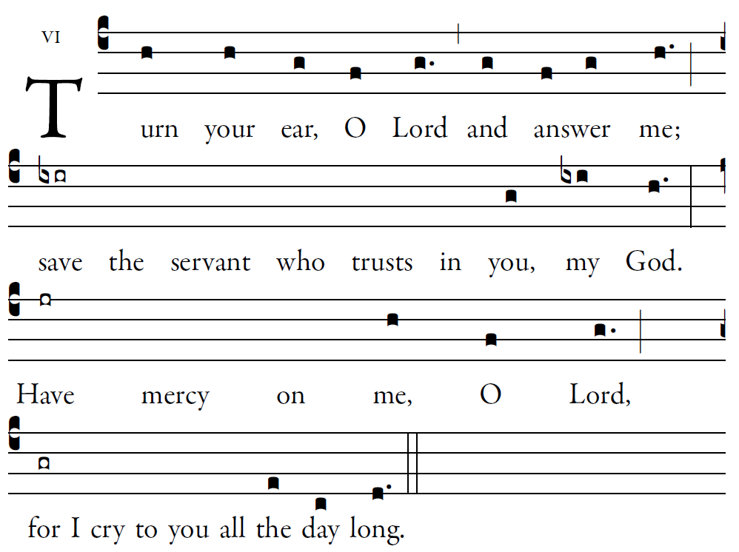

Psalm 86
⁴Gladden the soul of your servant,
for I lift up my soul to you, O LORD.
⁵O LORD, you are good and forgiving,
full of mercy to all who call to you.

⁶Give ear, O LORD, to my prayer,
and attend to my voice in supplication.
⁷In the day of distress, I will call to you,
and surely you will answer me.

³Your mercy to me has been great;
you have saved me from the depths of the grave.
¹⁴The proud have risen against me, O God;
a band of the ruthless seeks my life.
To you they pay no heed.

¹⁵But you, O God, are compassionate and gracious,
slow to anger, O LORD,
abundant in mercy and fidelity;
¹⁶turn and take pity on me.
O give your strength to your servant,
and save the son of your handmaid.
¹⁷Show me the sign of your favor,
that my foes may see to their shame
that you, O LORD, give me comfort and help.

ALT

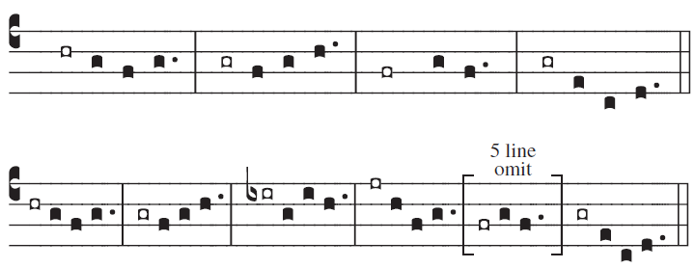
© St. Meinrad Archabbey

(c4)Turn(h) your(h) ear,(g) O(f) Lord(g.) (,) and(g) {an}swer(f/ g) me;(h.) (;)(z) save(ixir) the() servant() who() trusts() in() you,(g) my(ixi) God.(h.) (:)(z) Have(jr) mercy() on() me,(h) O(f) Lord,(g.) (;)(z) for(gr) I() cry() to() you() all() the(e) day(c) long.(d.) (::)

