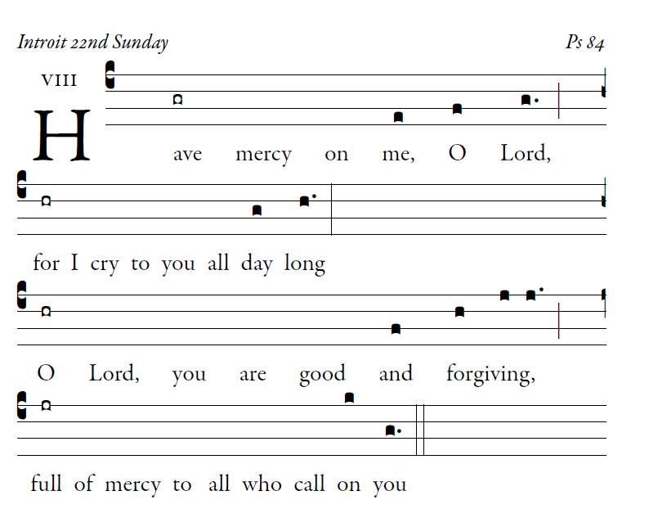

How lovely is your dwelling place,
O Lord of hosts.
my soul is longing and yearning
for the courts of the Lord.

My heart and my flesh cry out [6]
to the living God.
Even the sparrow finds a home,
and the swallow a nest for herself
in which she sets her young, at your altars,
O Lord of hosts, my king and my God.

Blessed are they who dwell in your house,
forever singing your praise.
Blessed the people whose strength is in you,
whose heart is set on pilgrim ways.

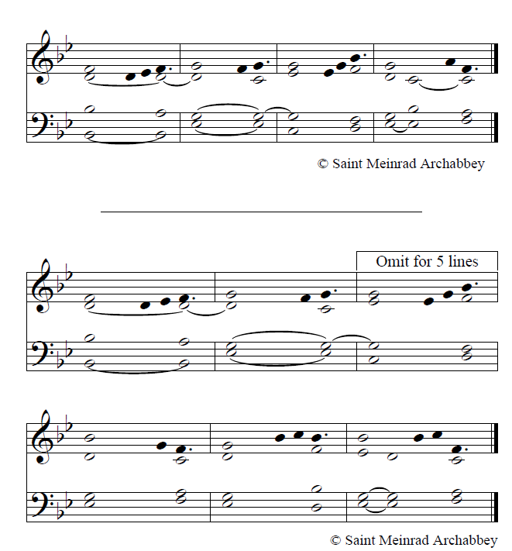

user-notes: Introit 22nd Sunday ;
commentary: Ps 84 ;
annotation: VIII ;
centering-scheme: english;
%spacing: vichi;
%font: GaramondPremierPro;
%width: 4;
%height: 11;
%%
(c4)Have(gr) mercy() on() me,(e) O(f) Lord,(g.) (;)(z) for(hr) I() cry() to() you() all() day(g) long(h.) (:)(Z) O(hr) Lord,() you() are() good() and(f) {for}giving,(h/ j j.) (;)(z) full(jr) of() mercy() to () all() who() call() on(k) you(g.) (::)

