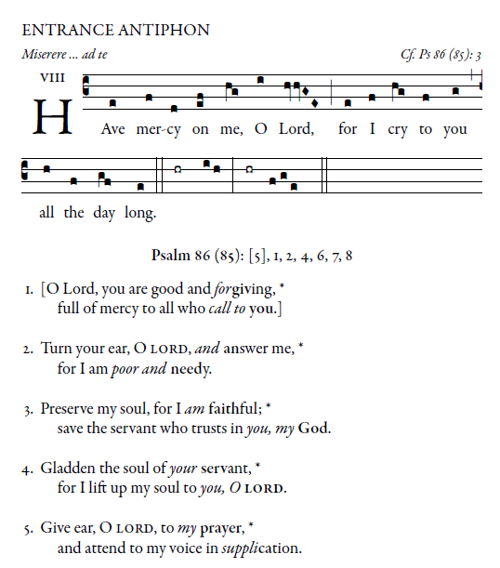

^{©Illuminarepublications.com}

The Ordinary of the Mass is found in the Today’s Missal within the order of the Mass

RESPONSORIAL PSALM
RB 2014,2017
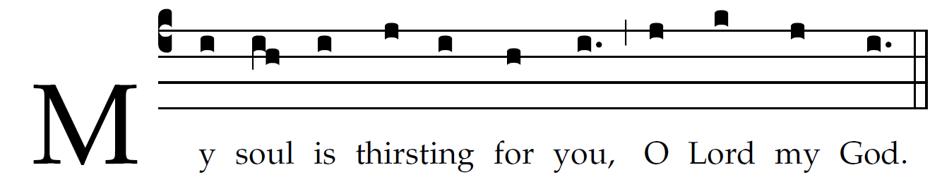

O God, you are my God whom I seek;
for you my flesh pines and my soul thirsts
like the earth,
parched, lifeless and without water.
Thus have I gazed toward you in the sanctuary
to see your power and your glory,
For your kindness is a greater good than life;
my lips shall glo- rify you.
Thus will I bless you while I live;
lifting up my hands, I will call up- on your name.
As with the riches of a banquet shall my soul be satisfied,
and with exultant lips my mouth shall praise you.

You are my help,
and in the shadow of your wings I shout for joy.
My soul clings fast to you;
your right hand upholds me.

OFFERTORY:
Abide With Me #641 MI
begisinging at verse 2

COMMUNION ANTIPHON:
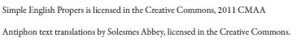
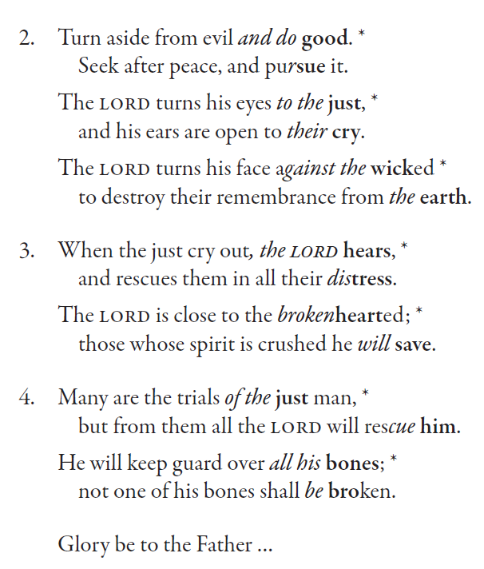

RECESSIONAL HYM “ Lift High the Cross “

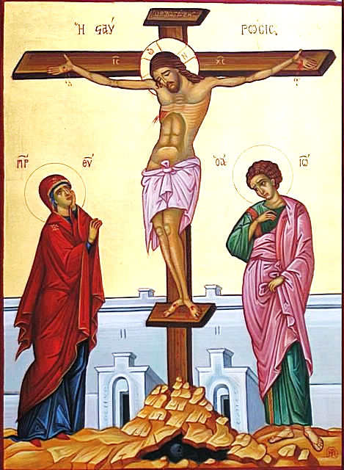
22nd Sunday
YEAR A

“Whoever wishes to come after me must deny himself,
Take up his cross, and follow me” Mathew 16:25

