RECESSIONAL HYMN

God of Mercy God of Grace
HEATHLANDS
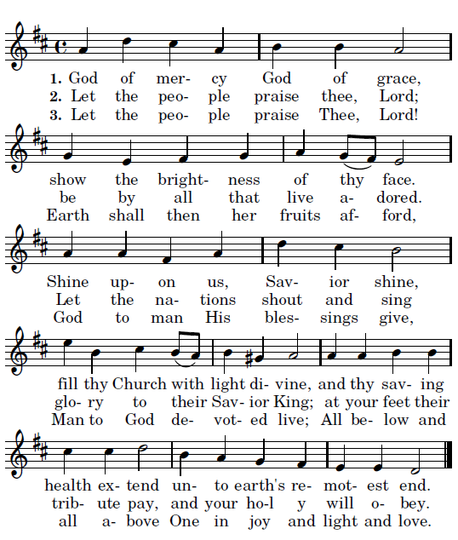
ly

24th Sunday of Ordinary Time YEAR A

ENTRANCE HYMN:
“ Where Charity and Love Prevail” MI #482

GLORY TO GOD
Music Issue #903
Mass of St. Frances Cabrini

RESPONSORIAL PSALM TM pages 52-53

ALLELLUIA: #904

OFFERTORY: God of Mercy and Compassion
Au Sang Qu’un Dieu
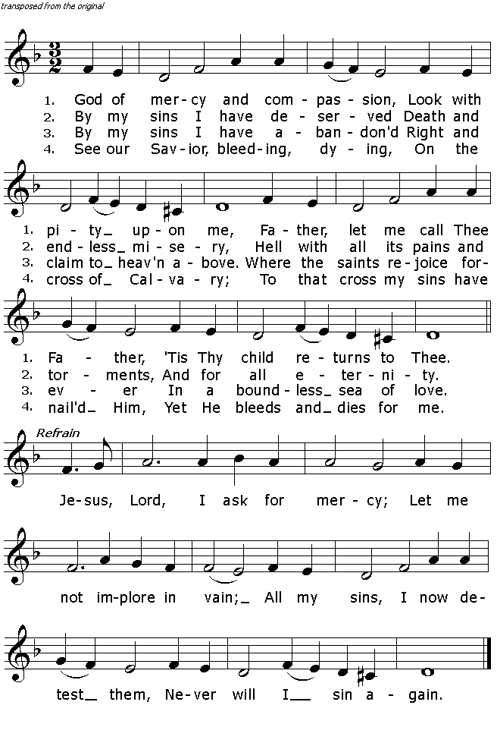 traditional French melody adaptation by G. B. Pergolesi 1736
Text: .E Vaughan C.SS.R.

HOLY, HOLY, HOLY LORD #906 TM

ACCLAMATION #907

AMEN #910

LAMB OF GOD #911 TM

COMMUNION HYMN
“ Humbly, Lord We Worship You” #33 TM

COMMUNION HYMN “Mary The Dawn”
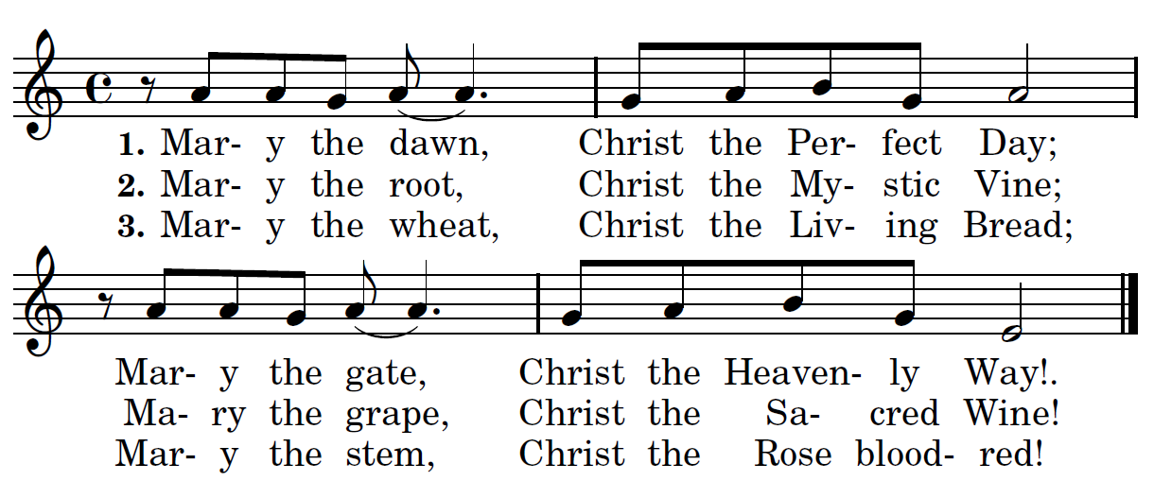

4. Mary the font, Christ the Cleansing Flood;
Mary the cup, Christ the Saving Blood!
5. Mary the temple, Christ the temple’s Lord;
Mary the shrine, Christ the God adored!
6. Mary the beacon, Christ the Haven’s Rest;
Mary the mirror, Christ the Vision Blest!
7. Mary the mother, Christ the mother’s Son
By all things blest while endless ages run. Amen.

