COMMUNION ANTIPHON

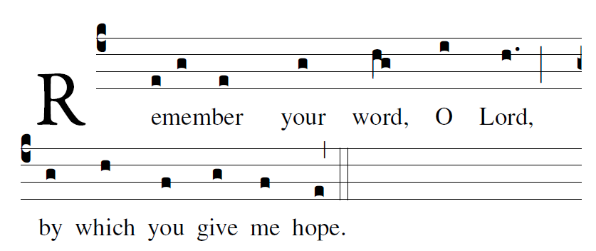
Blessed are those whose way is blameless,
who walk in the law of the LORD!
²Blessed are those who keep his decrees!
With all their hearts they seek him.

My soul holds fast to the dust;
revive me by your word.
²⁸My soul pines away with grief;
by your word raise me up.

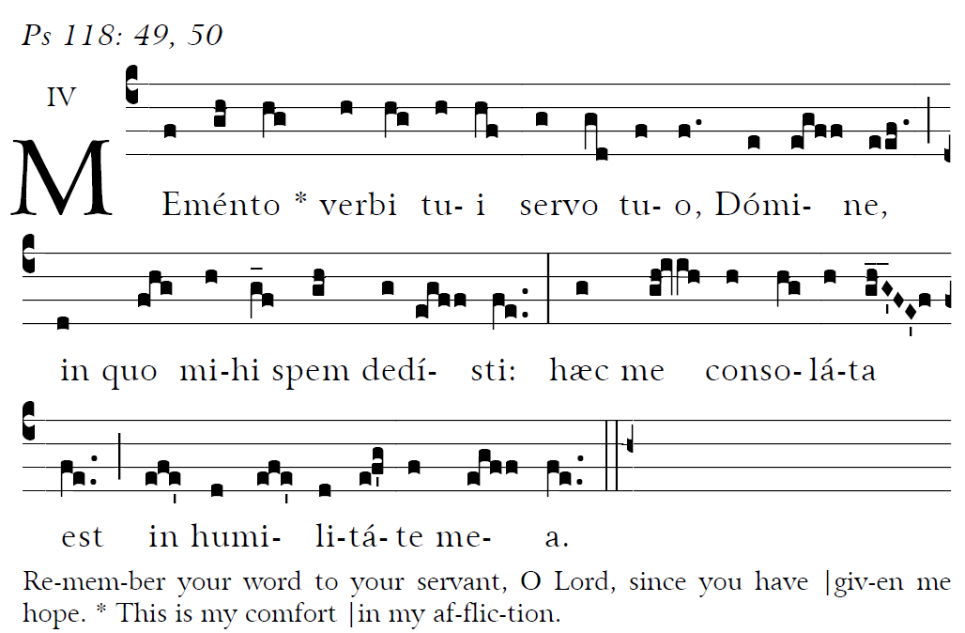

RECESSIONAL HYMN
“Christ Be Beside Me”

Offertory antiphon © 2012-2014 Adam Bartlett, licensed under a Creative Commons Licens www. Illuminarepublications.com Communion antiphon Fr. C Kelly St Meinrad Archabbey

26th Sunday in Ordinary Time

ENTRANCE HYMN
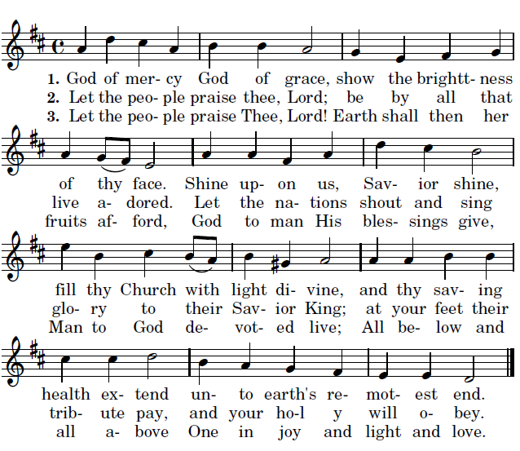

Mass XI “ ORBIS FACTOR”

Lord have mercy, Glory to God, Holy, Lamb of
God. are found in a separate program

LITURGY OF THE WORD
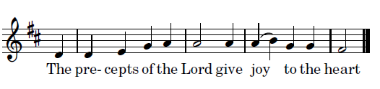

The law of the LORD is perfect,
refreshing the soul;
the decree of the LORD is trustworthy,
giving wisdom to the simple.

The fear of the LORD is pure,
enduring forever;
the ordinances of the LORD are true,
all of them just.

Though your servant is careful of them,
very diligent in keeping them,
Yet who can detect failings?
Cleanse me from my unknown faults!

From wanton sin especially, restrain your servant;
let it not rule over me.
Then shall I be blameless and innocent
of serious sin.

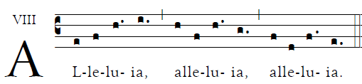

                                      Your word, O Lord Is truth;
Consecrate us in the truth. 

OFFERTORY ANTIPHON

On the poplars that grew there
we hung up our harps.
³For it was there that they asked us,
our captors, for songs,
our oppressors, for joy.
“Sing to us,” they said,
“one of Sion’s songs.”

⁴O how could we sing
the song of the LORD
on foreign soil?
⁵If I forget you, Jerusalem,
let my right hand wither!

⁶O let my tongue
cleave to my palate
if I remember you not,
if I prize not Jerusalem
as the first of my joys!

