⁶The LORD does just deeds,
gives full justice to all who are oppressed.
⁷He made known his ways to Moses,
and his deeds to the children of Israel.
⁸The LORD is compassionate and gracious,
slow to anger and rich in mercy.

RECESSIONAL HYMN “Daily, Daily Sing to Mary”

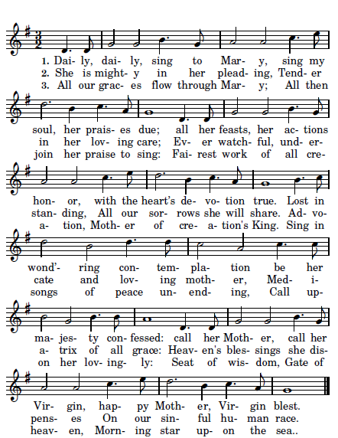

27th SUNDAY IN ORDINARY TIME YEAR A

ENTRANCE HYMN
“ Come , Ye Thankful People Come” Today’s Missal

GLORY TO GOD R.Bednarz

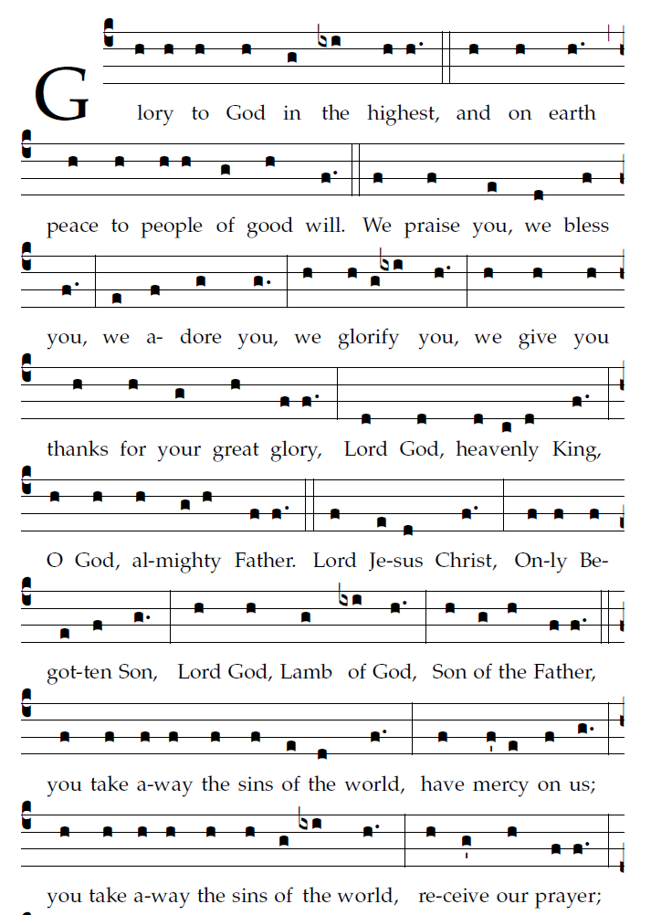

RESPONSORIAL PSALM

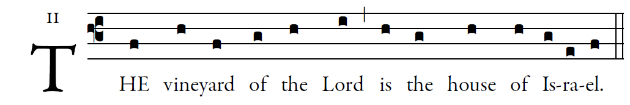

A vine from Egypt you transplanted;
you drove away the nations and planted it.
It put forth its foliage to the Sea,
its shoots as far as the River. 
Why have you broken down its walls,
so that every passer-by plucks its fruit,
The boar from the forest lays it waste,
and the beasts of the field feed upon it?       

Once again, O LORD of hosts,
look down from heaven, and see;
take care of this vine,
and protect what your right hand has planted
the son of man whom you yourself made strong. 
Then we will no more withdraw from you;
give us new life, and we will call upon your name.
O LORD, God of hosts, restore us;
if your face shine upon us, then we shall be saved.        

OFFERTORY HYMN “Ubi Caritas” Music Issue

COMMUNION ANTIPHON
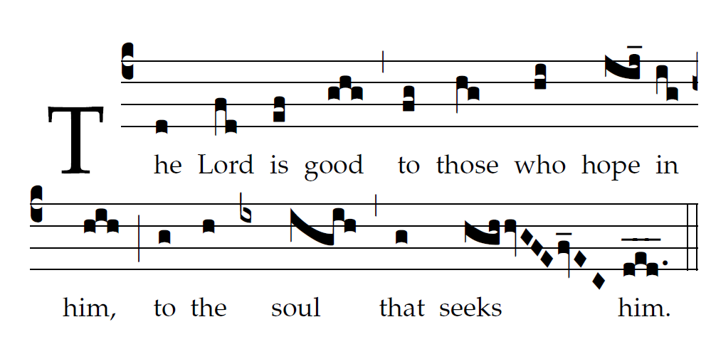
Fr. C Kelly @St. Meinrad Archabbey
Psalm 103

Bless the LORD, O my soul,
and all within me, his holy name.
²Bless the LORD, O my soul,
and never forget all his benefits.

³It is the LORD who forgives all your sins,
who heals every one of your ills,
⁴who redeems your life from the grave,
who crowns you with mercy and compassion,
⁵who fills your life with good things,
renewing our youth like an eagle’s.

continued

