COMMUNION ANTIPHON

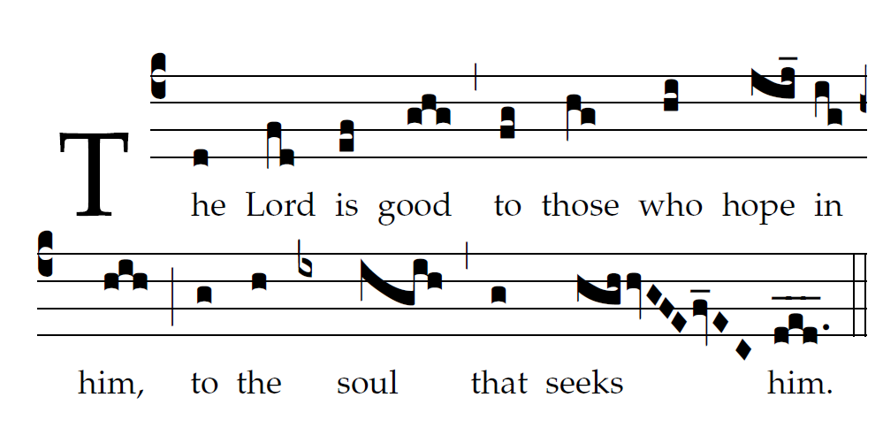
Fr. C Kelly @ St. Meinrad Archabbey
Psalm 103

Bless the LORD, O my soul,
and all within me, his holy name.
²Bless the LORD, O my soul,
and never forget all his benefits.

³It is the LORD who forgives all your sins,
who heals every one of your ills,
⁴who redeems your life from the grave,
who crowns you with mercy and compassion,
⁵who fills your life with good things,
renewing your youth like an eagle’s.

⁶The LORD does just deeds,
gives full justice to all who are oppressed.
⁷He made known his ways to Moses,
and his deeds to the children of Israel.
⁸The LORD is compassionate and gracious,
slow to anger and rich in mercy.

RECESSIONAL HYMN “Salve Regina”

27th SUNDAY IN ORDINARY TIME YEAR B

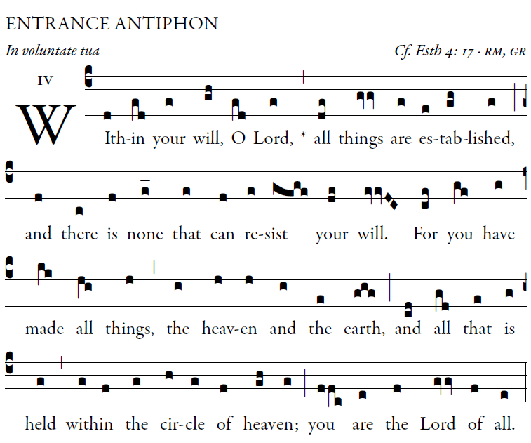
©illluminare publications, Adam Brtlett

Blessed are those whose way is blameless,
who walk in the law of the LORD!
Blessed are those who keep his decrees!
With all their hearts they seek him.

They never do anything evil,
but walk in his ways.
You have laid down your precepts
to be care-fully kept.

May my ways be firm
in keeping your statutes.
Then I shall not be put to shame
as I observe all your commands.

R.Bednarz
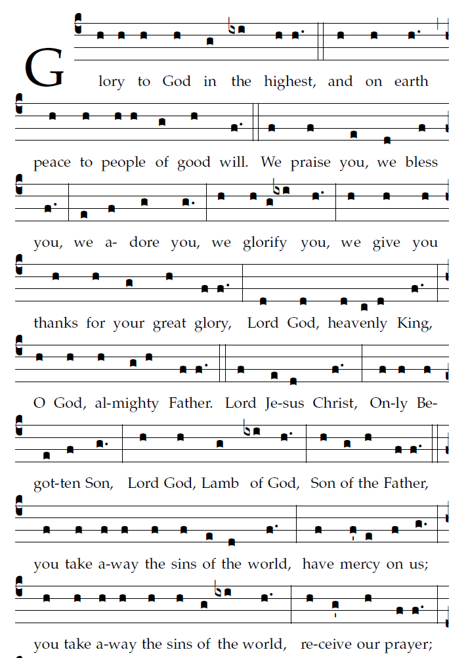

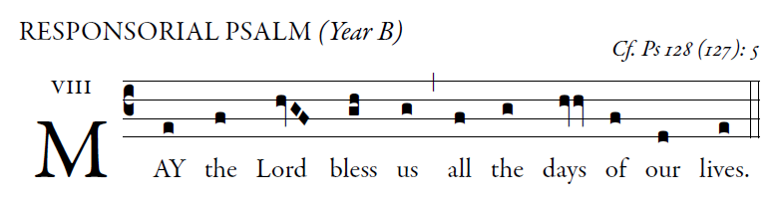
©illluminare publications, Adam Brtlett

Blessed are you who fear the LORD,
who walk in his ways!
For you shall eat the fruit of your handiwork;
blessed shall you be, and favored.
Your wife shall be like a fruitful vine
in the recesses of your home;
your children like olive plants
around your table.

Behold, thus is the man blessed
who fears the LORD.
The LORD bless you from Zion:
may you see the prosperity of Jerusalem
all the days of your life.
May you see your children's children.
Peace be upon Israel!

OFFERTORY HYMN “Lord, Who at Thy First Eucharist”

