COMMUNION ANTIPHON
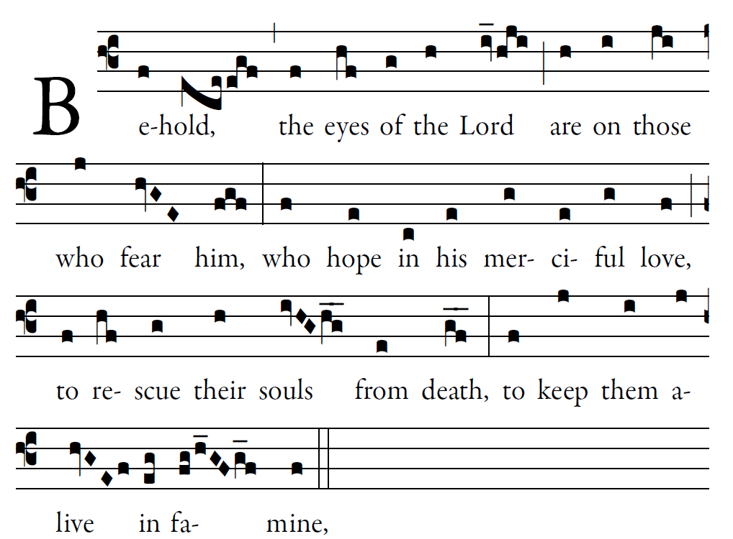
Fr. Columba Kelly ©St. Mainrad Archabbey

Blessed is he whose transgression is forgiven,
whose sin is remitted.
Blessed the man to whom the LORD imputes no guilt,
in whose spirit is no guile.

So let each faithful one pray to you
in the time of need.
The floods of water may reach high,
but such a one they shall not reach.

You are a hiding place for me;
you keep me safe from distress;
you surround me with cries of deliverance.
I will instruct you and teach you the way you should go; I will fix my eyes up-on you.

RECESSIONAL HYMN Salve Regina

29th SUNDAY IN ORDINARY TIME
YEAR C

ENTRANCE ANTIPHON

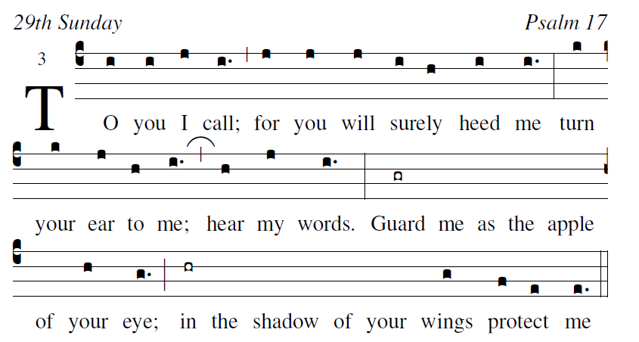

Psalm 17
O LORD, hear a cause that is just;
pay heed to my cry
Turn your ear to my prayer
no deceit is on my lips.

From you may my justice come forth.
Your eyes discern what is upright.
Search my heart and visit me by night.
Test me by fire,
and you will find no wrong in me.

Glory be to the Father…

RESPONSORIAL PSALM

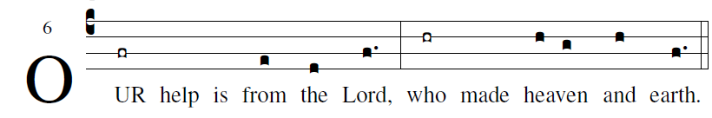

I lift up my eyes toward the mountains;
whence shall help come to me?
My help is from the LORD,
who made heaven and earth.
May he not suffer your foot to slip;
may he slumber not who guards you:
indeed he neither slumbers nor sleeps,
the guardian of Israel.
The LORD is your guardian; the LORD is your shade;
he is beside you at your right hand.
The sun shall not harm you by day,
nor the moon by night.
The LORD will guard you from all evil;
he will guard your life.
The LORD will guard your coming and your going,
both now and forever.
ALLELUIA
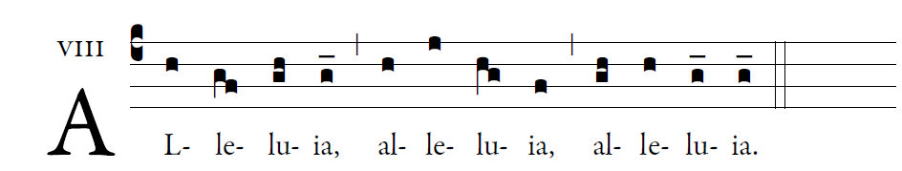
The Word of God is living and effective,
discerning reflections and thoughts of the heart

OFFERTORY

͡©illminarepublications.com

Blessed are those whose way is blameless,
who walk in the law of the LORD!
Blessed are those who keep his decrees!
With all their hearts they seek him.

They never do anything evil,
but walk in his ways.
You have laid down your precepts
to be carefully kept.

