COMMUNION ANTIPHON:
© ILLUMINAREPUBLICATION.COM
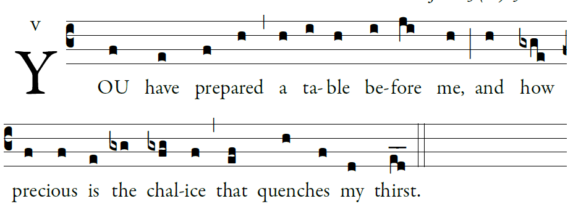

The LORD is my shepherd;
there is nothing I shall want.
²Fresh and green are the pastures
where he gives me repose.
Near restful waters he leads me;
³he revives my soul.
He guides me along the right path,
for the sake of his name.
Though I should walk in the valley of the shadow of death,
no evil would I fear, for you are with me.
Your crook and your staff will give me comfort.

You have prepared a table before me
in the sight of my foes.
My head you have anointed with oil
my cup is overflowing.

RECESSIONAL HYMN:
“Joyful, Joyful We Adore You”

2nd Sunday in ordinary Time
YEAR A

ENTRANCE ANTIPHON:
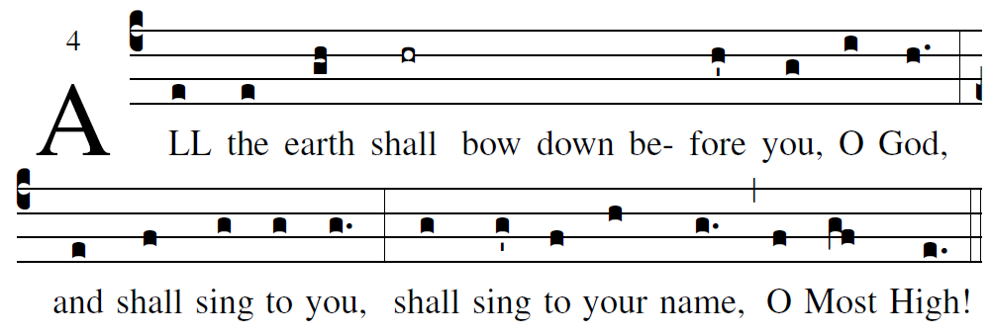
based on the Simple English propers adapted to the Missal 3rd ed.

Cry out with joy to God, all the earth;
O sing to the glory of his name.
O render him glorious praise.
Say to God, “How awesome your deeds!
Because of the greatness of your strength,
your enemies fawn upon you.
Before you all the earth shall bow down,
shall sing to you, sing to your name!”

Come and see the works of God:
awesome his deeds among the children of men.
He turned the sea into dry land;
they passed through the river on foot.

Music for The Liturgy of the Word is found in
Today’s Missal

GLORY TO GOD
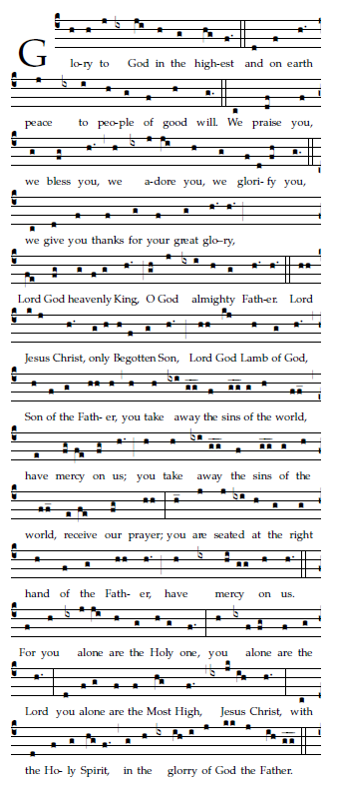

OFFERTORY HYMN “At the Name of Jesus”

HOLY
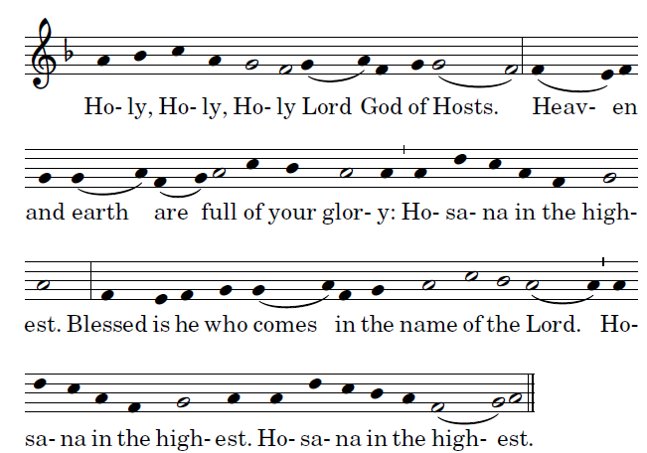
ACCLAMATION
