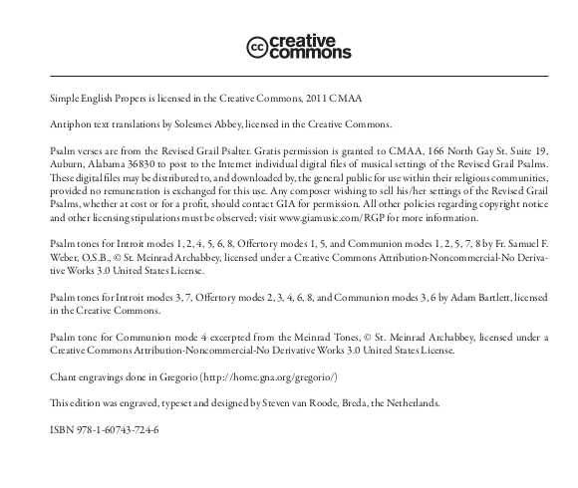

SECOND SUNDAY
in ORDINARY TIME c

ENTRANCE ANTIPHON:

Cry out with joy to God, all the earth;
O sing to the glory of his name.
O render him glor- ious praise.
Say to God, “How awe- some your deeds!
Because of the greatness of your strength,
your enemies fawn upon you.
Before you all the earth shall bow down,
shall sing to you, sing to your name!”

Come and see the works of God:
awesome his deeds among the children of men.
He turned the sea into dry land;
they passed through the river on foot.

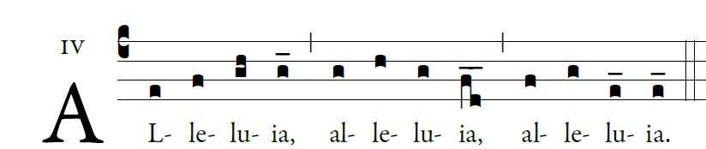

  God has called us through the Gospel to
possess the glory of our Lord Jesus Christ

OFFERTORY HYMN
“ All the Earth” #429 MI

COMMUNION ANTIPHON: Jn 2 :8,9 and 10-11
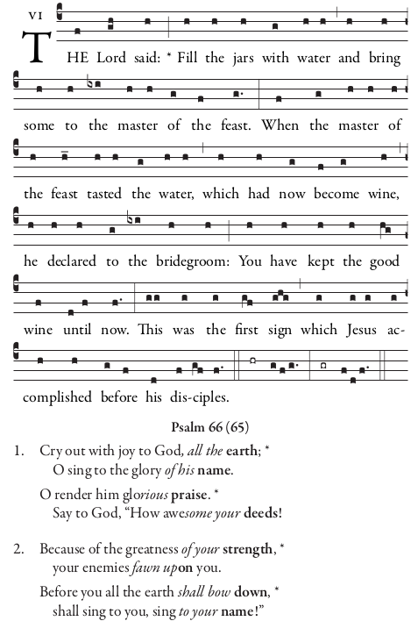

RECESSIONAL HYMN
“All Creatures of Our God and King” #543 MI

