COMMUNION ANTIPHON
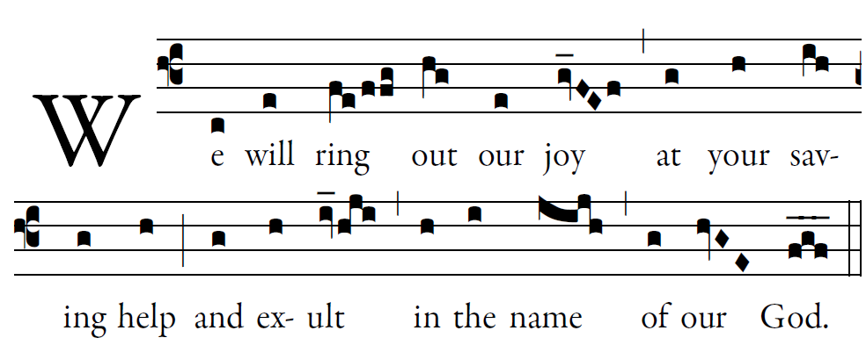
Fr .Columba Kelly © Saint Meinrad Archabbey

May the LORD answer you in time of trial;
may the name of Jacob’s God protect you.
May he send you help from the holy place,
and give you support from Sion.

May he remember all your offerings,
and receive your sacrifice with favor.
May he give you your heart’s desire,
and fulfill every one of your plans

Now I know the LORD saves his anointed,
and answers from his holy heaven
with the mighty victory of his hand.

Some put their trust in chariots or horses,
but we in the name of the LORD, our God

RECESSIONAL HYMN:
“Praise My Soul, The King of Heaven”

30th SUNDAY IN ORDINARY TIME YEAR B

ENTRANCE ANTIPHON
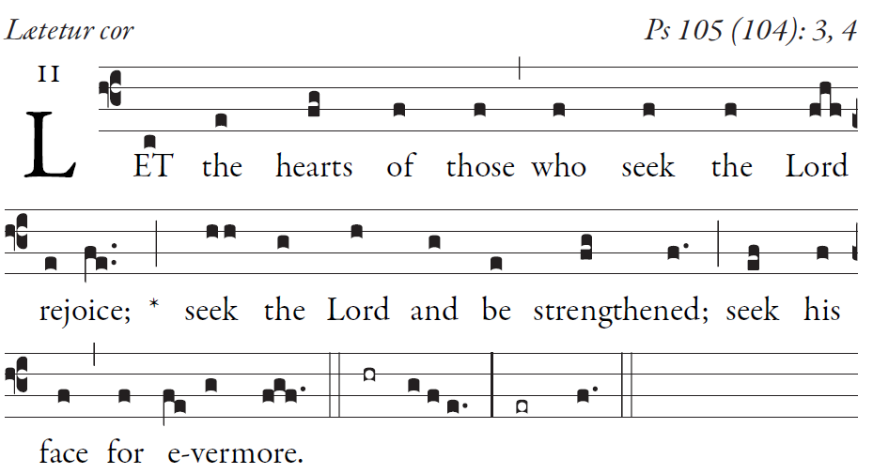
SIMPLE ENGLISH PROPER, ANDAM BARTLET ©CMAA

Give thanks to the LORD; proclaim his name.
Make known his deeds among the peoples.

O sing to him, sing his praise;
tell all his wonderful works!
Glory in his holy name;
let the hearts that seek the LORD rejoice.

Turn to the LORD and his strength;
constantly seek his face.
Remember the wonders he has done,
his marvels and his words of judgment

_______________________________________________________

The musical setting for the ordinary of the Mass is found withing the text of Mass in Today’s Misal (I.C.E.L. music)

RESPONSORIAL PSALM

©ILLUMINARE PUBLICATIONS.COM

When the LORD brought back the captives of Zion,
we were like men dreaming.
Then our mouth was filled with laughter,
and our tongue with rejoicing.

Then they said among the nations,
"The LORD has done great things for them."
The LORD has done great things for us;
we are glad indeed.

Restore our fortunes, O LORD,
like the torrents in the southern desert.
Those that sow in tears
shall reap rejoicing.

Although they go forth weeping,
carrying the seed to be sown,
They shall come back rejoicing,
carrying their sheaves.

OFFERTORY: AVE MARIS STELLA
All
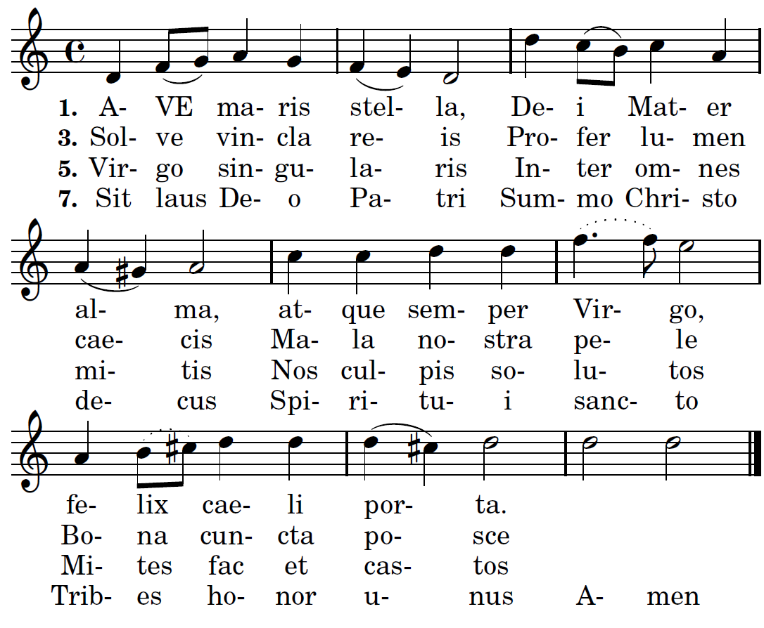
CHOIR
2. Sumens illud Ave, Gabrielis ore, funda nos in pace,
mutans Evæ nomen.
4. Monstra te esse matrem,sumat per te precem [9]
qui pro nobis natus tulit esse tuus.
6. Vitam præsta puram, iter para tutum,
ut videntes Jesum semper collætemur.

Hail, bright star of ocean God's own Mother blest, Ever sinless Virgin, Gate of heavenly rest.
2. Taking that sweet Ave, Which from Gabriel came, Peace confirm within us, Changing Eve's name.
3. Break the captives' fetters, Light on blindness pour, All our ills expelling, Every bliss implore.
4. Show thyself a Mother; May the Word Divine, Born for us thy Infant, Hear our prayers through thine.
5. Virgin all excelling, Mildest of the mild, Freed from guilt, preserve us, Pure and undefiled. 6. Keep our life all spotless, Make our way secure, Till we find in Jesus, J oy forevermore.7. Through the highest heaven To the Almighty Three, Father, Son and Spirit, One same glory be. Amen.

