COMMUNION ANTIPHON
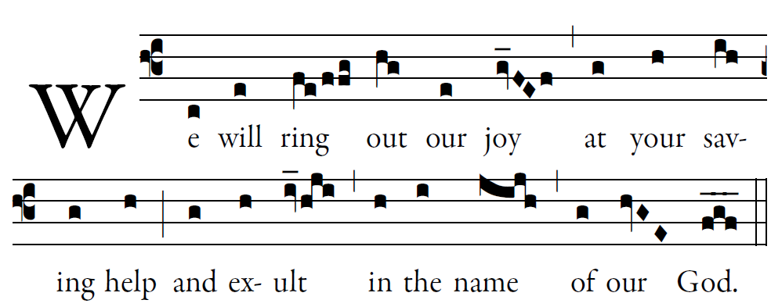
Fr .Columba Kelly © Saint Meinrad Archabbey

May the LORD answer you in time of trial;
may the name of Jacob’s God protect you.
May he send you help from the holy place,
and give you support from Sion.

May he remember all your offerings,
and receive your sacrifice with favor.
May he give you your heart’s desire,
and fulfill every one of your plans

Now I know the LORD saves his anointed,
and answers from his holy heaven
with the mighty victory of his hand.

Some put their trust in chariots or horses,
but we in the name of the LORD, our God

RECESSIONAL HYMN:
“Hail Holy Queen”

30th SUNDAY IN ORDINARY TIME

ENTRANCE ANTIPHON
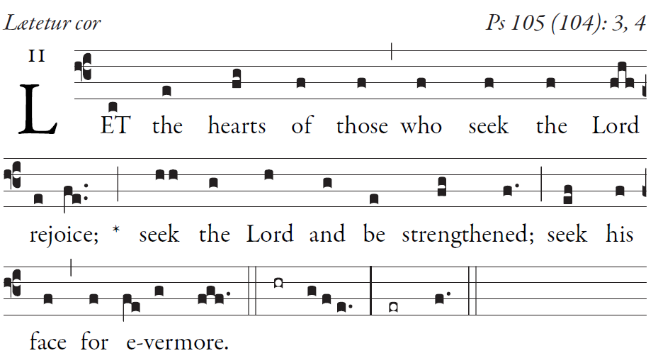
SIMPLE ENGLISH PROPER, ANDAM BARTLET ©CMAA
Give thanks to the LORD; proclaim his name.
Make known his deeds among the peoples.

O sing to him, sing his praise;
tell all his wonderful works!
Glory in his holy name;
let the hearts that seek the LORD rejoice.

Turn to the LORD and his strength;
constantly seek his face.
Remember the wonders he has done,
his marvels and his words of judgment

LORD HAVE MERCY
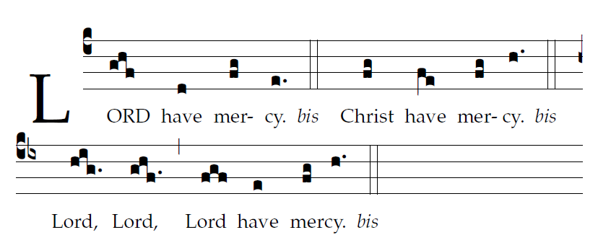
GLORY TO GOD

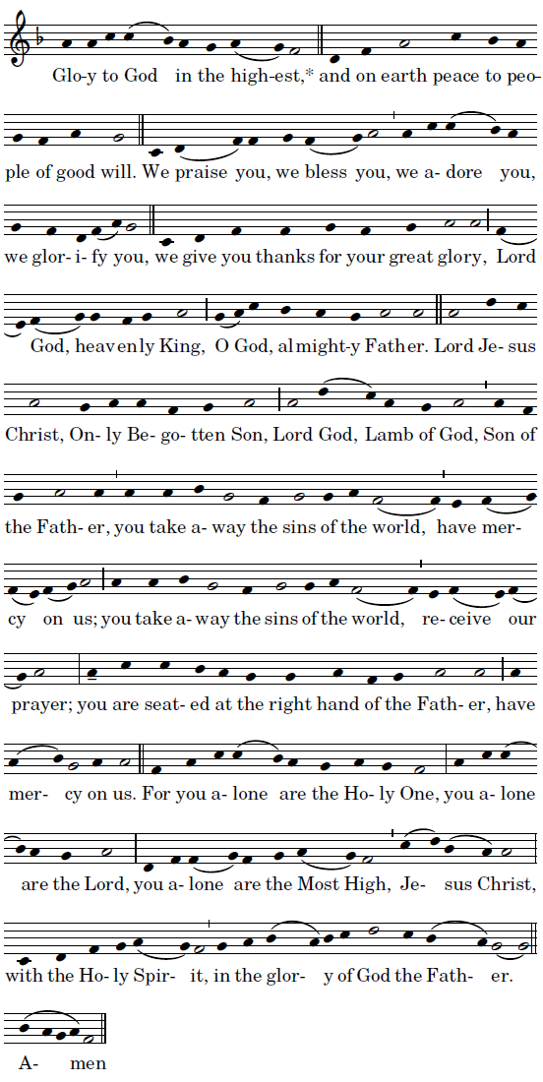

OFFERTORY: “All Is Well with My Soul”

HOLY
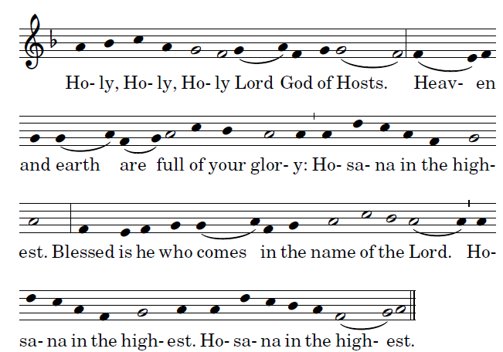
LAMB OF GOD
