(But) you, O LORD, are eternally on high.
See, your enemies, O LORD,
see, your enemies will perish;
all who do evil will be scattered.

(quinque)Five wise virgins brought oil with their lamps. In the middle of the night there was a noise. Behold, Christ, the bridegroom comes.

You have poured out on me purest oil.[5]
My eyes looked in triumph on my foes;
my ears heard gladly of their fall.
The just will flourish like the palm tree,
and grow like a Lebanon cedar.

(quinque)Five wise virgins brought oil with their lamps. In the middle of the night there was a noise. Behold, Christ the bridegroom comes.

Planted in the house of the LORD,
they will flourish in the courts of our God,
still bearing fruit when they are old,
still full of sap, still green,
to proclaim that the LORD is upright.
In him, my rock, there is no wrong.

COMMUNION ANTIPHON 2
May light eternal shine upon them, O Lord, with your saints forever, for you are gracious

RECESSIONAL HYMN
“Abide with Me”

32nd SUNDAY ORDINARY TIME YEAR A
Commemoration of the Faithful Departed

ENTRANCE ANTIPHON ©St. Mainrad Archabbey

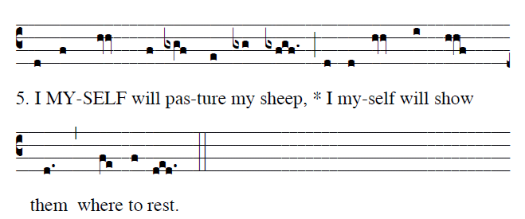

Frésh and gréen are the pástures
where he gíves me repóse.
Near réstful wáters he léads me;
he revíves my sóul.

He guídes me alóng the right páth,
for the sáke of his náme.
Though I should wálk in the válley of the shádow of déath,
no évil would I féar, for you are wíth me.

You have prepáred a táble befóre me
in the síght of my fóes.
My héad you have anóinted with óil;
my cúp is overflówing.

Eternal rest grant unto them, O Lord,
And let perpetual light shine upon them. 

Kyrie page 9 and GLory to God Page 10 in Todays Missal

RESPONSORIAL PSALM
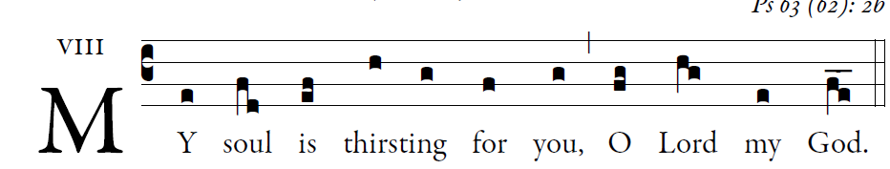
©Illuminarepublications.co

O God, you are my God whom I seek;
for you my flesh pines and my soul thirsts
like the earth, parched, lifeless and without water.   
Thus have I gazed toward you in the sanctuary
to see your power and your glory,
For your kindness is a greater good than life;
my lips shall glo- rify you.                                                                                                                    

Thus will I bless you while I live;
lifting up my hands, I will call upon your name.
As with the riches of a banquet shall my soul be satisfied,
and with exultant lips my mouth shall praise you. 

You are my help,
and in the shadow of your wings I shout for joy.
My soul clings fast to you;
your right hand up- holds me.                                                                                             

ALLELUIA

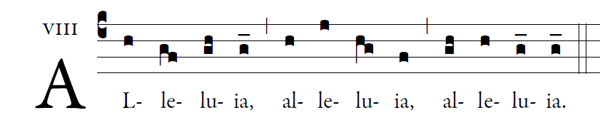

 Stay awake and be ready: For you do not know
on what day the Lord will come. 

OFFERTORY HYMN

“O Saving Victim” O Salutaris

COMMUNION ANTIPHON 1

Five wise virgins brought oil with their lamps. In the midle of the night there was a noise. Behold the bridegroom comes. Chirst the Lord.

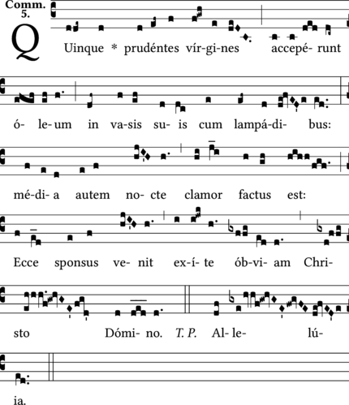

       It is good to give thanks to the LORD,
to make music to your name, O Most High,
to proclaim your loving mercy in the morning,
and your truth in the watches of the night,

