COMMUNION ANTIPHON

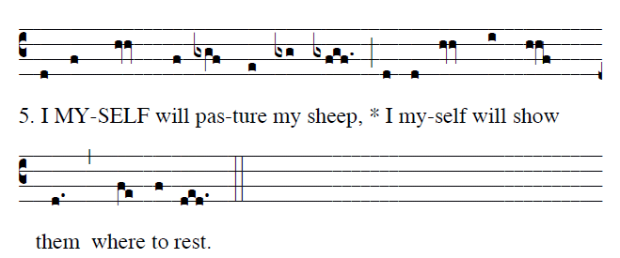
©St. Mainrad Archabbey

You have prepáred a táble befóre me
in the síght of my fóes.
My héad you have anóinted with óil;
my cúp is overflówing.

COMMEMERATION OF ALL SOULS

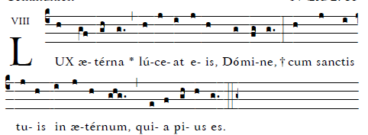
May eternal light shine on them, Lord, with your saints forever.

RECESSIONAL HYMN

“ Jesus Remember Me””

32nd SUNDAY in ORDINARY TIME
YEAR C

www.illuminarepublication.com

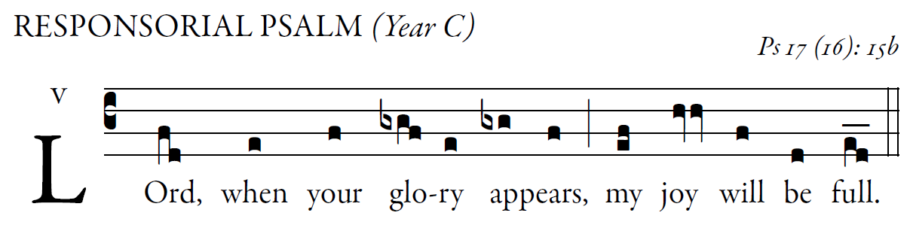
www.illuminarepublications.com

Hear, O LORD, a just suit;
attend to my outcry;
hearken to my prayer from lips without deceit. 
My steps have been steadfast in your paths,
my feet have not faltered.
I call upon you, for you will answer me, O God;
incline your ear to me; hear my word. 
Keep me as the apple of your eye,
hide me in the shadow of your wings.
But I in justice shall behold your face;
on waking I shall be content in your presence. 

ALLELUIA

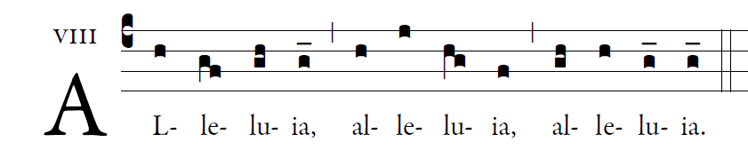

Jesus Christ is the first born of the Dead
To him be power and Glory forever. 

OFFERTORY HYMN
We Prasie Thee King of Kings

