RECESSIONAL HYMN

We Praise Thee King of Kings.
(Dich König loben wir)
Text Angleus Silesius 1657
Music Georg Josef 1657

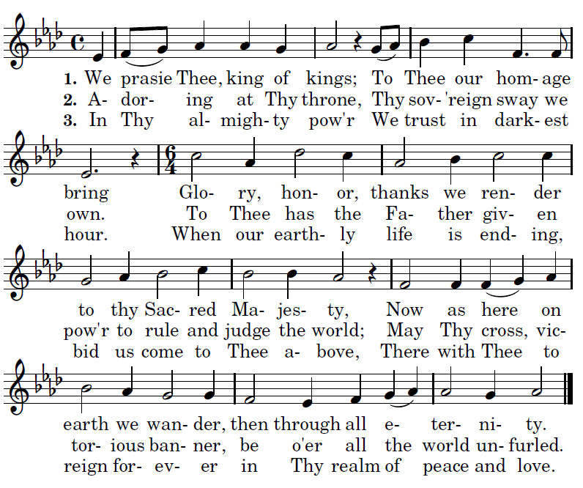

32nd SUNDAY ORDINARY TIME
YEAR B

ENTRANCE ANTIPHON

©Illuminare Publication.com

O LORD and God of my salvation,
I cry before you day and night.
Incline your ear to my cry.
For my soul is filled with evils;
my life is on the brink of the grave.

I am reckoned as one in the tomb;
I am like a warrior without strength,
like one roaming among the dead,
like the slain lying in their graves,
like those you remember no more,
cut off, as they are, from your hand.

RESPONSORIAL PSALM

©Illuminare Publication.com
The Lord keeps faith forever,
secures justice for the oppressed,
gives food to the hungry.
The LORD sets captives free.
The LORD gives sight to the blind;
the LORD raises up those who were bowed down.
The LORD loves the just;
the LORD protects strangers.
The fatherless and the widow the LORD sustains,
but the way of the wicked he thwarts.
The LORD shall reign forever;
your God, O Zion, through all generations. Alleluia

ALLELUIA

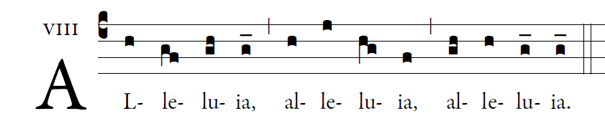
Blessed are the poor in spirit,
For theirs is the kingdom o heaven. 

OFFERTORY HYMN “Blest are They”

COMMUNION ANTIPHON

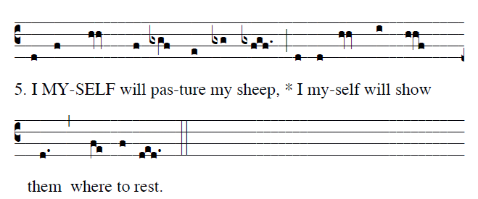
©Saint Meinrad Archabbey Used with permission

The LORD is my shepherd;
there is nothing I shall want.
Fresh and green are the pastures
where he gives me repose.
Near restful waters he leads me;
he revives my soul.
He guides me along the right path, [5]
for the sake of his name.
Though I should walk in the valley of the shadow of death,
no evil would I fear, for you are with me.
Your crook and your staff will give me comfort.

You have prepared a table before me [6]
in the sight of my foes.
My head you have anointed with oil;
my cup is overflowing.
In the LORD’s own house shall I dwell
for length of days unending.

Surely goodness and mercy shall follow me
all the days of my life.

