Anima Christe

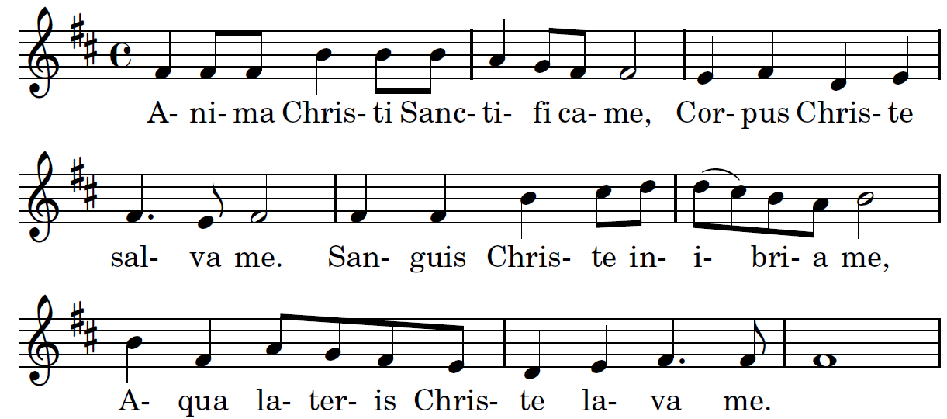

Soul of Christ, sanctify me
Body of Christ, save me
Blood of Christ, inebriate me
Water from Christ's side, wash me
Passion of Christ, strengthen me
O good Jesus, hear me
Within Thy wounds hide me
Suffer me not to be separated from Thee
From the malicious enemy defend me
In the hour of my death call me
And bid me come unto Thee
That I may praise Thee with Thy saints
and with Thy angels
Forever and ever
Amen

RECESSIONAL HYMN
“For the Beauty of the Earth”

33rd SUNDAY IN ORDINARY TIME
YEAR A

ENTRANCE ANTIPHON
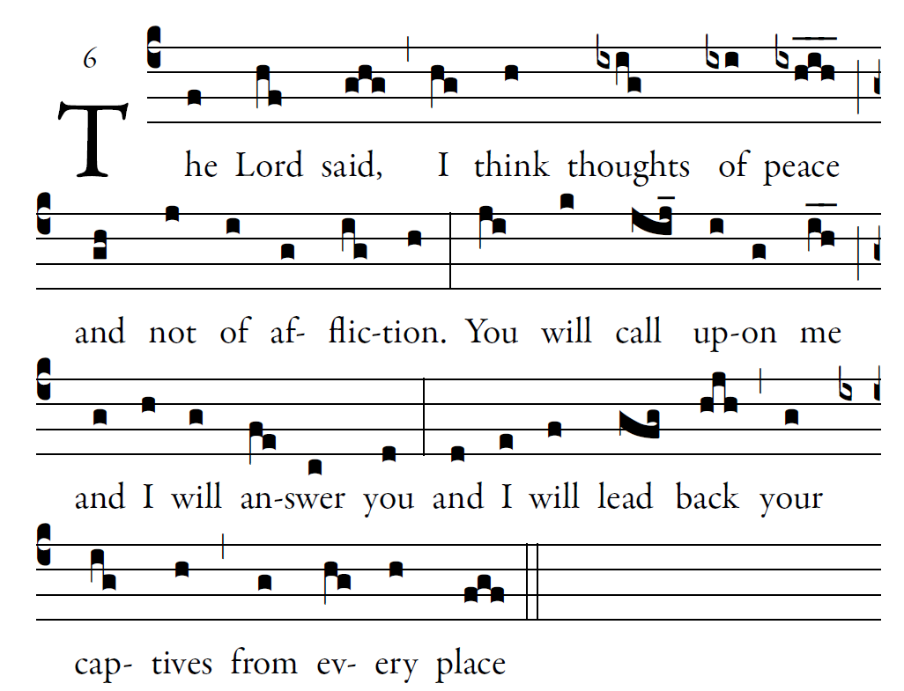
Fr. Columba Kelly © Saint Meinrad Archabbey

O Lord, you have favored your land,
and brought back the captives of Jacob.
You forgave the guilt of your people,
and covered all their sins.

You averted all your rage;
you turned back the heat of your anger.
Bring us back, O God, our savior!
Put an end to your grievance against us.
Let us see, O Lord, your mercy, *
and grant us your salvatio

RESPONSORIAL PSALM in Today’s Missal

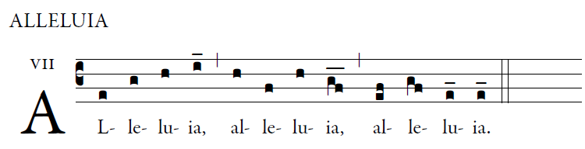

  Remain in me as I remain in you, says the Lord
Whoever remains in me bears much fruit. 

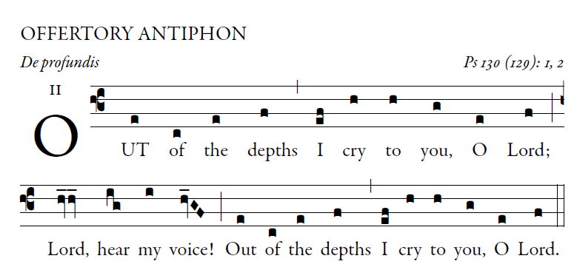
Illulminarepublication.com

O let your ears be attentive
to the sound of my pleadings.
If you, O LORD, should mark iniquities,
LORD, who could stand?

But with you is found forgiveness,
that you may be revered.
I long for you, O LORD,
my soul longs for his word.

My soul hopes in the LORD
more than watchmen for daybreak.
More than watchmen for daybreak,
let Israel hope for the LORD.
COMMUNION ANTIPHON

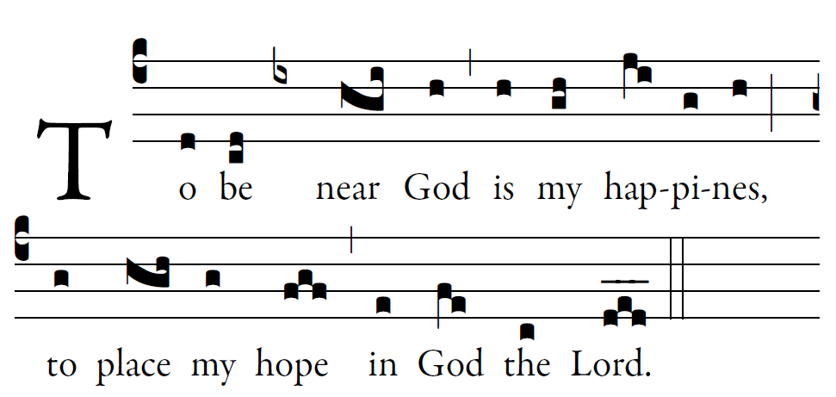

Fr. Columba Kelly © Saint Meinrad Archabbey

Psalm73 (72)
How good is God to Israel,
to those who are pure of heart!
As for me, I came close to stumbling;
my feet had almost slipped,

And so when my heart grew embittered,
and I was pierced to the depths of my being,
I was stupid and did not understand;
I was like a beast in your sight.

As for me, I was always in your presence;
you were holding me by my right hand.
By your counsel you will guide me,
and then you will lead me to glory.

What else have I in heaven but you?
Apart from you, I want nothing on earth.
My body and my heart waste away;
God is the strength of my heart;
God is my portion forever.

