Lamb of God
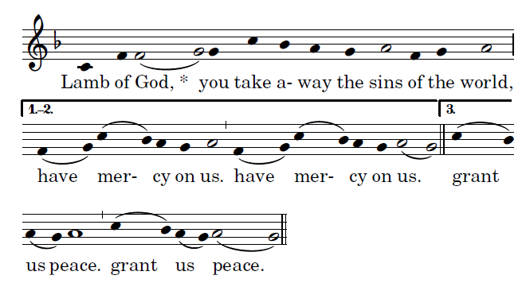
Music copyright © 2014 Richard J. Clark | rjcceciliamusic.com

COMMUNION ANTIPHON ©SAINT MEINRAD ARCHABBEY used with perimission

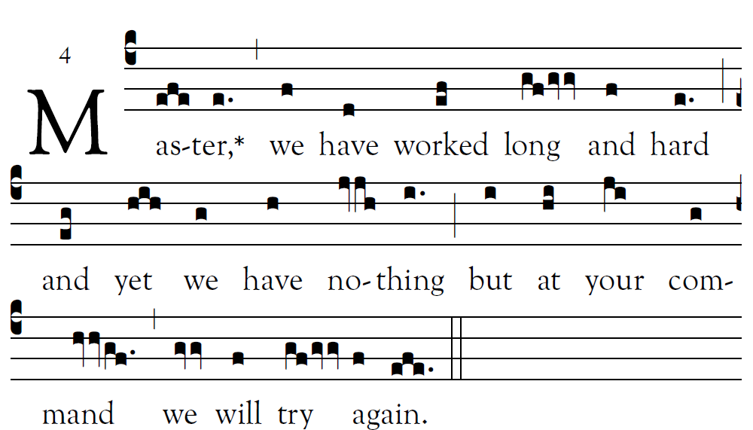

Let your deed be seen by your servants,
and your glorious power by their children.
Let the favor of the LORD our God be upon us;
give success to the work of our hands.
O give success to the work of our hands.

COMMUNION HYMN “Gift of Finest Wheat”

RECESSIONAL HYMN: “Be Not Afraid”

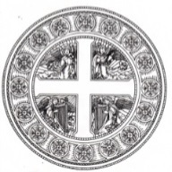
Fifth Sunday
in Ordinary Time (year c)

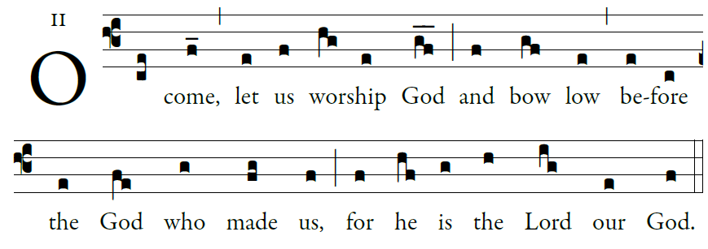

Come, let us ring out our joy to the LORD;
hail the rock who saves us.
Let us come into his presence, giving thanks;
let us hail him with a song of praise.

A mighty God is the LORD,
a great king above all gods.
In his hands are the depths of the earth;
the heights of the mountains are his.

To him belongs the sea, for he made it,
and the dry land that he shaped by his hands.

©Illuminare publications Adam Bartlet

KYRIE AND GLORIA : TODAY’S MISSAL

RESPONSORIAL PSALM ©illuminarepublications.com
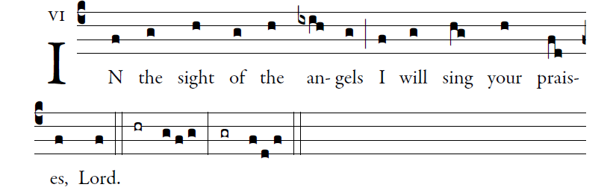

I will give thanks to you, O LORD, with all my heart,
for you have heard the words of my mouth;
in the presence of the angels I will sing your praise;
I will worship at your holy temple
and give thanks to your name.

Because of your kindness and your truth;
for you have made great above all things
your name and your promise.
When I called, you answered me;
you built up strength within me.

All the kings of the earth shall give thanks to you, O LORD,
when they hear the words of your mouth;
and they shall sing of the ways of the LORD:
“Great is the glory of the LORD.”

Your right hand saves me.
The LORD will complete what he has done for me;
your kindness, O LORD, endures for-ever;
forsake not the work of your hands.

ALLELUIA
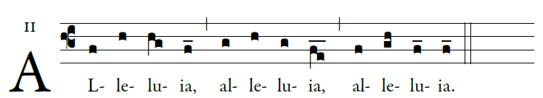
Come after Me and I will make you fishers of men.

OFFERORY
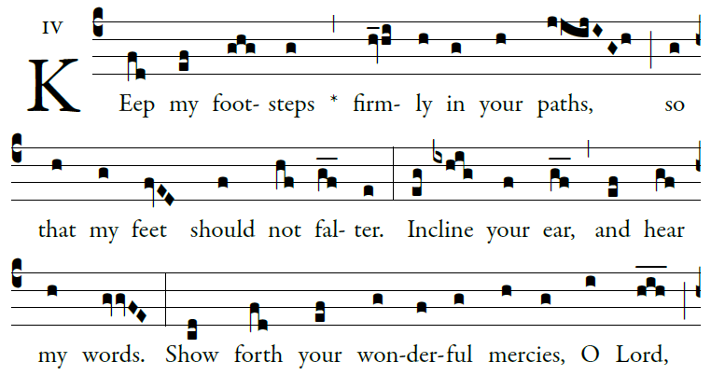
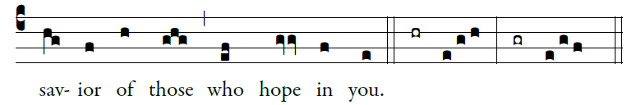
©illuminarepublications.com

SANCTUS
Music copyright © 2014 Richard J. Clark | rjcceciliamusic.com
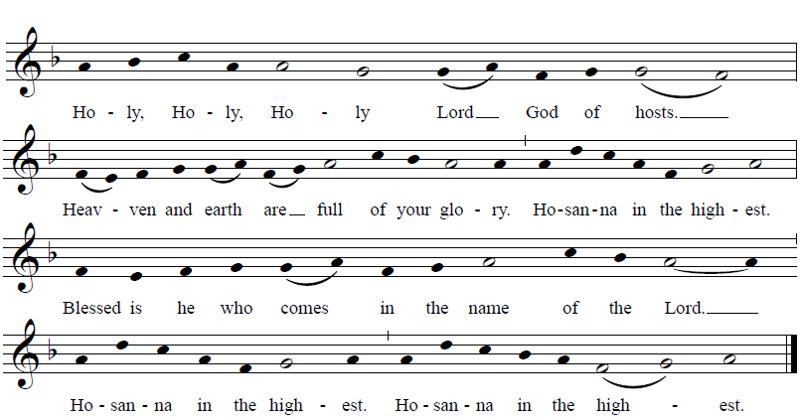
MEMORIAL ACCLAMATION
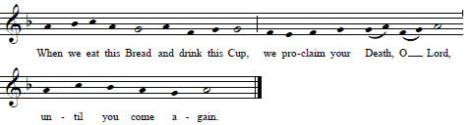
Music copyright © 2014 Richard J. Clark | rjcceciliamusic.com

