COMMUNION HYMN “Gift of Finest Wheat”

RECESSIONAL HYMN:
“What You Hear in the Dark”
Glory and Praise #685

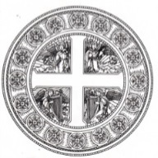
Fifth Sunday
in Ordinary Time (year A)

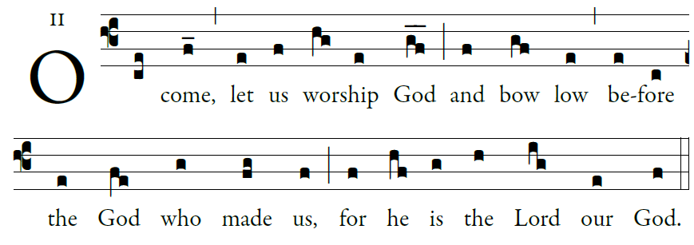

Come, let us ring out our joy to the LORD;
hail the rock who saves us.
Let us come into his presence, giving thanks;
let us hail him with a song of praise.

A mighty God is the LORD,
a great king above all gods.
In his hands are the depths of the earth;
the heights of the mountains are his.

To him belongs the sea, for he made it,
and the dry land that he shaped by his hands.

©Illuminare publications Adam Bartlett

RESPONSORIAL PSALM PS 112:4-5, 6-7, 8-9

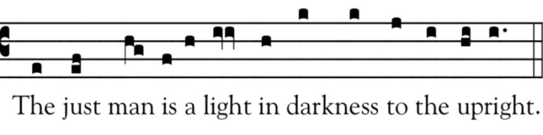
T
Light shines through the darkness for the upright;
he is gracious and merciful and just.
Well for the man who is gracious and lends,
who conducts his affairs with justice.               
He shall never be moved;
the just one shall be in everlasting remembrance.
An evil report he shall not fear;
his heart is firm, trusting in the LORD.   
His heart is steadfast; he shall not fear.
Lavishly he gives to the poor;
His justice shall endure forever;
his horn shall be exalted in glory.   

ALLELUIA
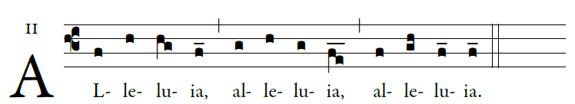

 I Am the light of the world says the Lord;
Whoever follows me will have the light of life.

OFFERTORY

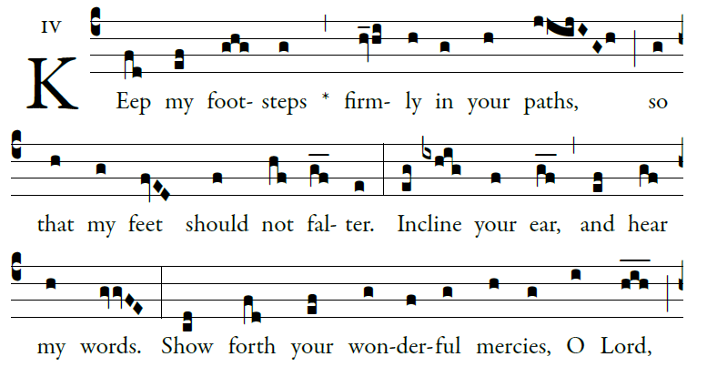
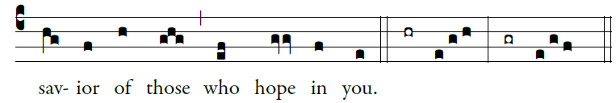
©illuminarepublications.com

O Lord, hear a cause that is just;
pay heed to my cry.
Turn your ear to my prayer:
no deceit is on my lips.

From you may my justice come forth.
Your eyes discern what is upright.
Search my heart and visit me by night.
Test me by firre, and you will find no wrong in me.

My mouth does not transgress as others do;
on account of the words of your lips,
I closely watched the paths of the violent.

