COMMUNION ANTIPHON
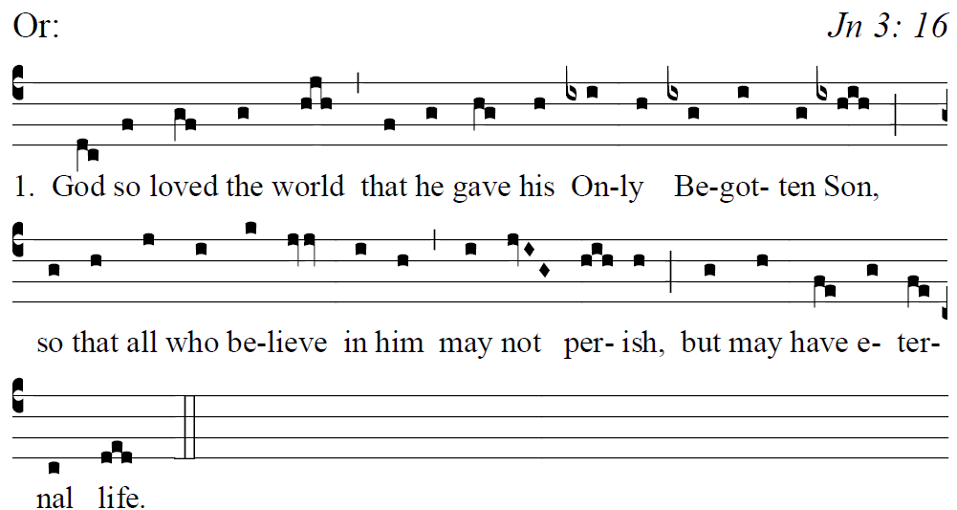
Fr. Columba Kelly ©St. Meinrad Archabbey
¹Bless the LORD, O my soul,
and all within me, his holy name.
²Bless the LORD, O my soul,
and never forget all his benefits. +

³It is the LORD who forgives all your sins,
who heals every one of your ills,
⁴who redeems your life from the grave,
who crowns you with mercy and compassion,
⁵who fills your life with good things,
renewing your youth like an eagle’s. +

⁸The LORD is compassionate and gracious,
slow to anger and rich in mercy.
⁹He will not always find fault;
nor persist in his anger forever. +

RECESSIONAL HYMN:
“ A Mighty Fortress is Our God”

Sixth Sunday
in Ordinary Time (year A)

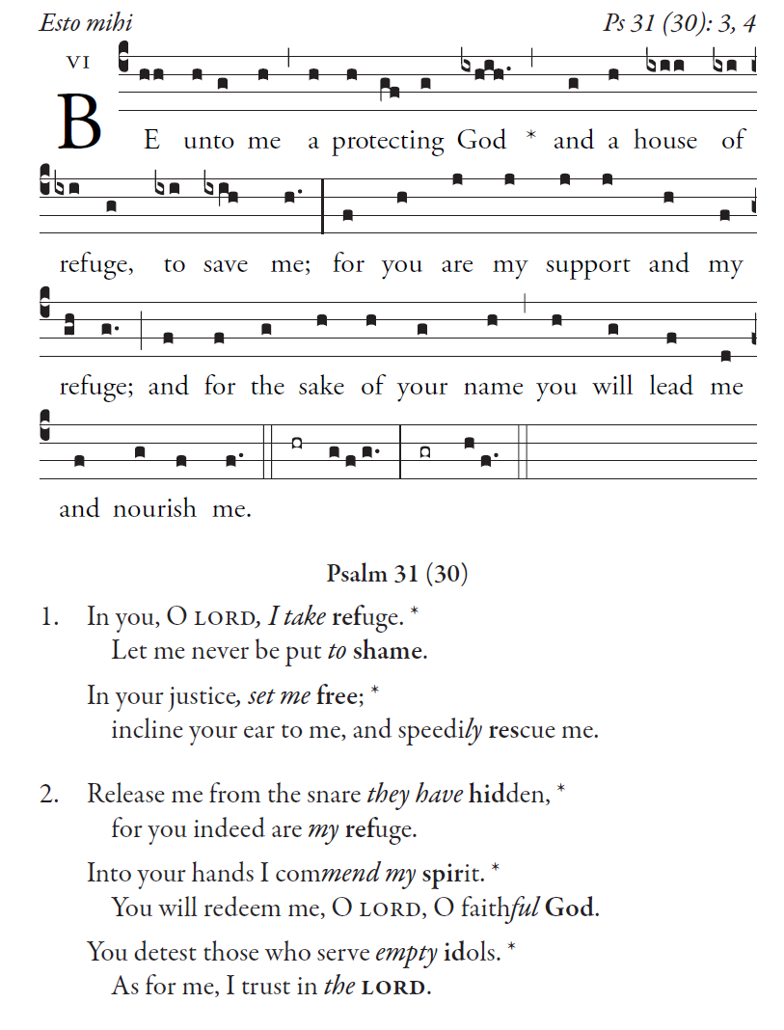

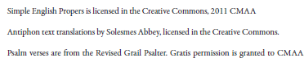

RESPONSORIAL PSALM \
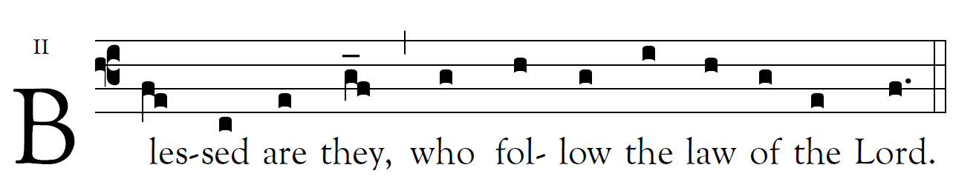
R. Bednarz 2014, 2017 2020
Blessed are they whose way is blameless,
who walk in the law of the LORD.
Blessed are they who observe his decrees,
who seek him with all their heart.  
You have commanded that your precepts
be diligently kept.
Oh, that I might be firm in the ways
of keeping your statutes!  

Be good to your servant, that I may live
and keep your words.
Open my eyes, that I may consider
the wonders of your law. 
Instruct me, O LORD, in the way of your statutes,
that I may exactly observe them.
Give me discernment, that I may observe your law
and keep it with all my heart. 

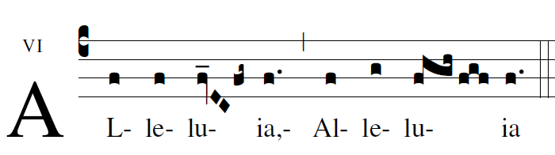

OFFERTORY HYMN

O
Jesus, joy of loving hearts,
the fount of life, the light of all,
from fullest bliss that earth imparts
we turn unfilled to hear your call.

2 Your truth unchanged has ever stood;
you save all those who on you call.
To those who seek you, you are good;
to those who find you, all in all.

3 We taste you, ever-living Bread,
and long to feast upon you still;
we drink of you, the fountain-head,
our thirst to quench, our souls to fill.

4 Our restless spirits yearn for you
where'er our changeful lot is cast;
glad when you smile on us anew,
blest that our faith can hold you fast.

5 O Jesus, ever with us stay;
make all our moments calm and bright!
Chase the dark night of sin away;
shed o'er the world your holy light!

