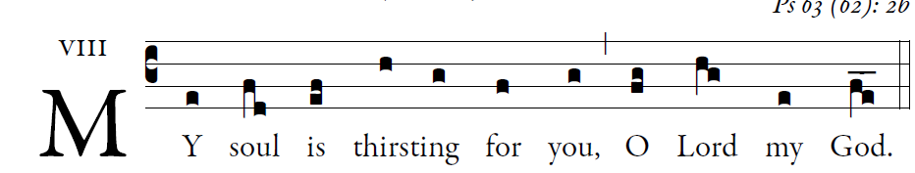
illuminarepublications.com

O God, you are my God whom I seek;
for you my flesh pines and my soul thirsts
like the earth, parched, lifeless and without water.
Thus have I gazed toward you in the sanctuary
to see your power and your glory,
For your kindness is a greater good than life;
my lips shall glo- rify you.

Thus will I bless you while I live;
lifting up my hands, I will call upon your name.
As with the riches of a banquet shall my soul be satisfied,
and with exultant lips my mouth shall praise you.
You are my help,
and in the shadow of your wings I shout for joy.
My soul clings fast to you;
your right hand up- holds me.

ALT.
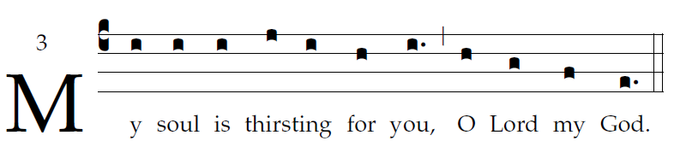

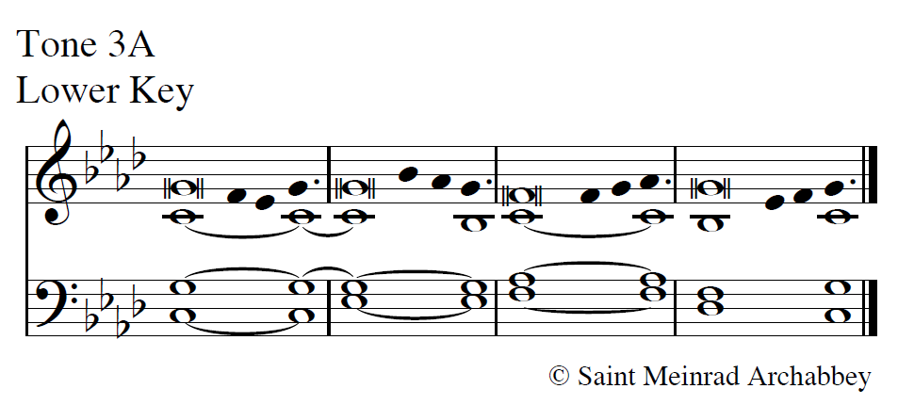
alt 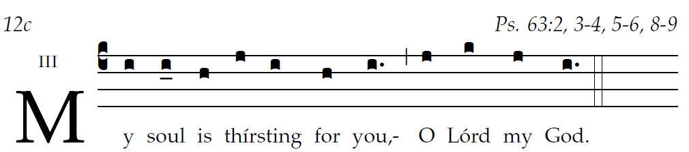
user-notes: ;
commentary: ;
annotation: 3 ;
centering-scheme: english;
%fontsize: 12;
%spacing: smith;
%font: palatino;
%width: 4;
%height: 11;
%%
(c4)My(i) soul(i) is(i) {thirst}ing(j/ i) for(h) you,(i.) (,) O(h) Lord(g) my(f) God.(e.) (::)

