COMMUNION ANTIPHON
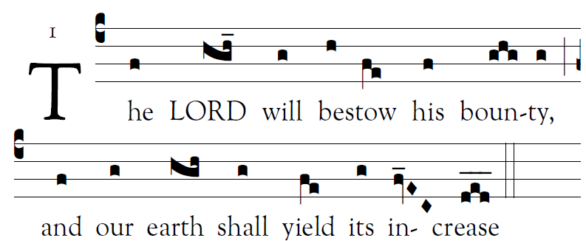
Fr. Columba Kelly© Saint Meinrad Archabbey
Psalm85 (84): 2-3, 4-5, 7-8, 10, 11-12

1. O Lord, you have favored your land,
and brought back the captives of Jacob.
You forgave the guilt of your people,
and covered all their sins.

2. You averted all your rage;
you turned back the heat of your anger.
Bring us back, O God, our savior!
Put an end to your grievance against us.

3. Will you not restore again our life,
that your people may rejoice in you?
Let us see, O lord, your mercy,
and grant us your salvation.

4. His salvation is near for those who fear him,
and his glory will dwell in our land.
5. Merciful love and faithfulness have met;
justice and peace have kissed.
Faithfulness shall spring from the earth,
and justice look down from heaven.

RECESSIONAL HYMN

“Comfort, Comfort, O my People”

FIRST SUNDAY OF ADVENT
YEAR A

Entrance and Responsorial psalm from illuminarepublications.com
© 2012, 2013 Adam Bartlett, licensed under a Creative Commons Attribution-NonCommercial-NoDerivs 3.0 Unported License.
Excerpts from the English translation of The Roman Missal © 2010, International Commission on English in the Liturgy Corporation. All rights reserved.
Excerpts from the Lectionary for Mass for Use in the Dioceses of the United States of America, second typical edition © 2001, 1998, 1997, 1986, 1970 Confraternity of Christian Doctrine, Inc., Washington, DC.. Communion antiphon by Fr. Columba Kelly , Saint Meinrad Archabbey

ENTRANCE ANTIPHON
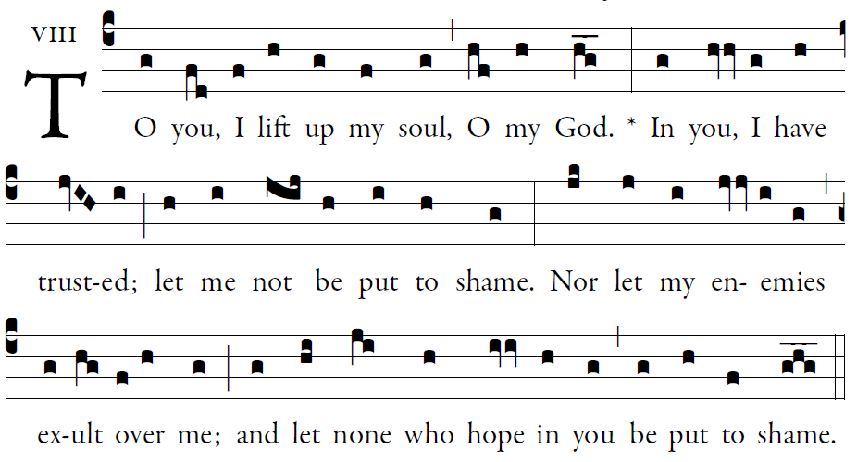

O LORD, make me know your ways. [5]
Teach me your paths.
Guide me in your truth, and teach me;
for you are the God of my salvation.
I have hoped in you all day long.

Remember your compassion, O LORD, [5]
and your merciful love,
for they are from of old.
In your merciful love remember me,
because of your goodness, O lord.

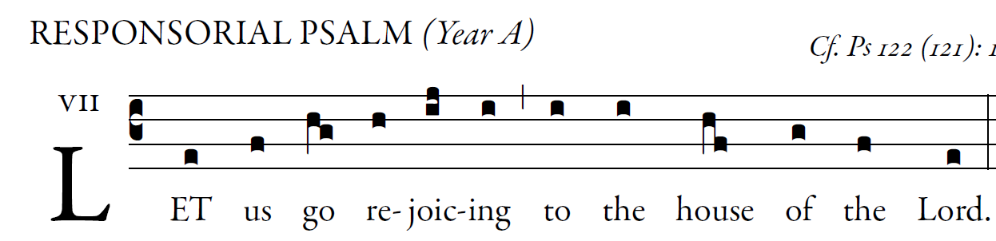

I rejoiced because they said to me,
“We will go up to the house of the LORD.”
And now we have set foot
within your gates, O Jerusalem.

Jerusalem, built as a city
with compact unity.
To it the tribes go up,
the tribes of the LORD.

According to the decree for Israel,
to give thanks to the name of the LORD.
In it are set up judgment seats,
seats for the house of David.
Pray for the peace of Jerusalem!
May those who love you prosper!
May peace be within your walls,
prosperity in your buildings.
Because of my brothers and friends
I will say, “Peace be within you!”
Because of the house of the LORD, our God,
I will pray for your good.

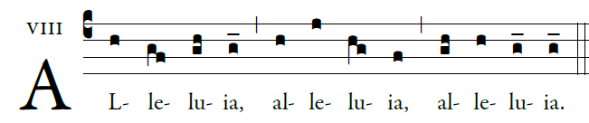
Show us, Lord, your love;
and grant us your salvation.

OFFERTORY HYMN:

“O Come, O Come Emanuel”

