COMMUNION HYMN: AVE MARIS STELLA
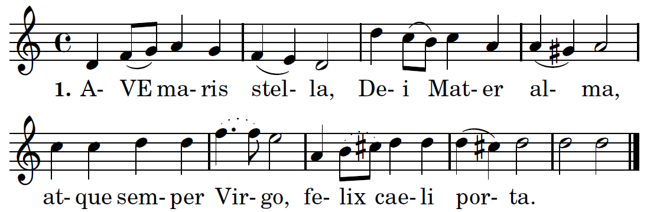

Translation 1. Hail, bright star of ocean,
God's own Mother blest,
Ever sinless Virgin,
Gate of heavenly rest.

2. Taking that sweet Ave
Which from Gabriel came,
Peace confirm within us,
Changing Eve's name.

3. Break the captives' fetters,
Light on blindness pour,
All our ills expelling,
Every bliss implore.

4. Show thyself a Mother;
May the Word Divine,
Born for us thy Infant,
Hear our prayers through thine.
.
5. Virgin all excelling,
Mildest of the mild,
Freed from guilt, preserve us,
Pure and undefiled.

6. Keep our life all spotless,
Make our way secure,
Till we find in Jesus,
Joy forevermore.

7. Through the highest heaven
To the Almighty Three,
Father, Son and Spirit,
One same glory be. Amen.

RECESSIONAL HYMN
“Comfort, Comfort, O My People” TM

1st SUNDAY OF ADVENT
YEAR B

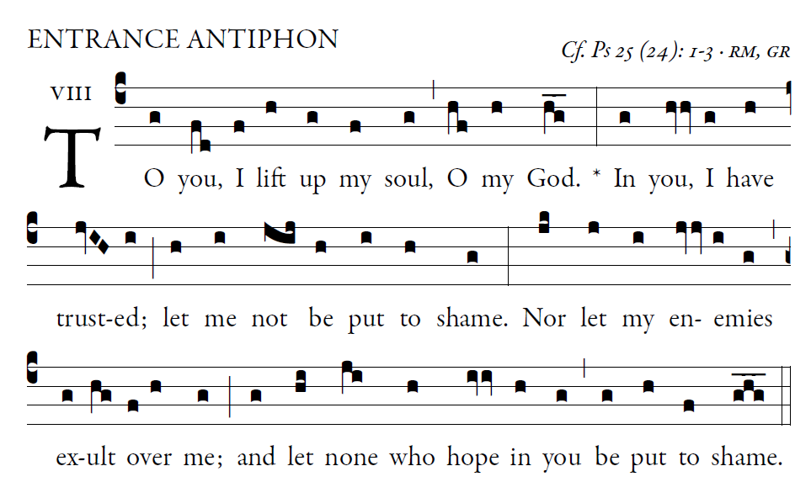

O Lord, make me know your ways.
Teach me your paths.
Guide me in your truth, and teach me;
for you are the God of my salvation.
I have hoped in you all day long.

Remember your compassion, O lord,
and your merciful love,
for they are from of old.
In your merciful love remember me,
because of your goodness, O Lord.

Glory be to the Father.

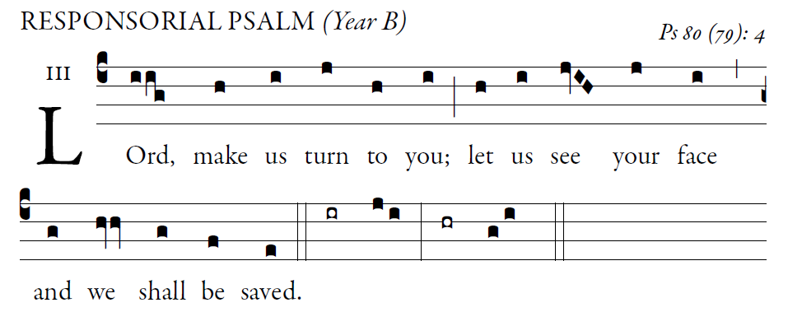

O shepherd of Israel, hear us,
enthroned on the cherubim, shine forth
Rouse up your might and come to save us.

2. God of hosts, turn again, we implore;
look down from heaven and see.
Visit this vine and protect it,
the vine your right hand has planted,
the son of man you have claimed for yourself.

3. May your hand be on the man at your right
hand,
the son of man you have con_rmed as your own.
And we shall never forsake you again; *give us life
that we may call upon your name.

ALLELUIA
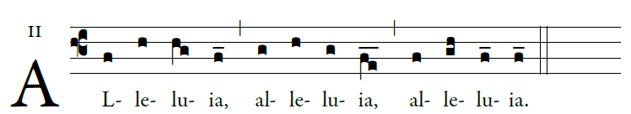

Show us Lord, your love;
and grant us your salvation.

OFFERTORY HYMN:
“O Come, O Come Emanuel” TM

COMMUNION ANTIPHON

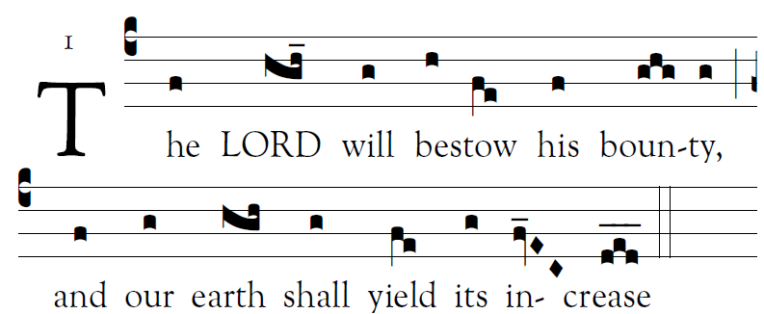

Fr. Columba Kelly© Saint Meinrad Archabbey

Psalm85 (84):
O Lord, you have favored your land,
and brought back the captives of Jacob.
You forgave the guilt of your people,
and covered all their sins.

Will you not restore again our life,
that your people may rejoice in you?
Let us see, O lord, your mercy,
and grant us your salvation.

His salvation is near for those who fear him,
and his glory will dwell in our land.
Merciful love and faithfulness have met;
justice and peace have kissed.
Faithfulness shall spring from the earth,
and justice look down _om heaven.

© 2012, 2013 Adam Bartlett, licensed under a Creative Commons Attribution-NonCommercial-NoDerivs 3.0 Unported License.
Excerpts from the English translation of The Roman Missal © 2010, International Commission on English in the Liturgy Corporation. All rights reserved.
Excerpts from the Lectionary for Mass for Use in the Dioceses of the United States of America, second typical edition © 2001, 1998, 1997, 1986, 1970 Confraternity of Christian Doctrine, Inc., Washington, DC.

