COMMUNION ANTIPHON
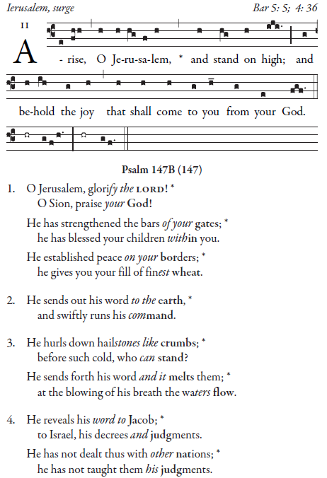
Simple English Propers by Adam Bartlett is licensed under a Creative Commons
Attribution 4.0 International License.Based on a work at http://musicasacra.com/sep.

RECESSIONAL HYMN

“Comfort, Comfort, O my People”
SECOND SUNDAY OF ADVENT
.

ENTRANCE ANTIPHON

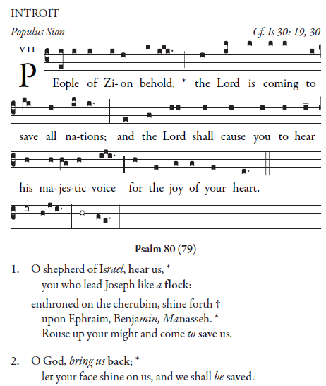

Simple English Propers by Adam Bartlett is licensed under a Creative Commons Attribution 4.0 International License.Based on a work at http://musicasacra.com/sep.

Ordinary of the Mass : Orbis Factor Mass XI Yellow program

RESPONSORIAL PSALM ( YEAR C)

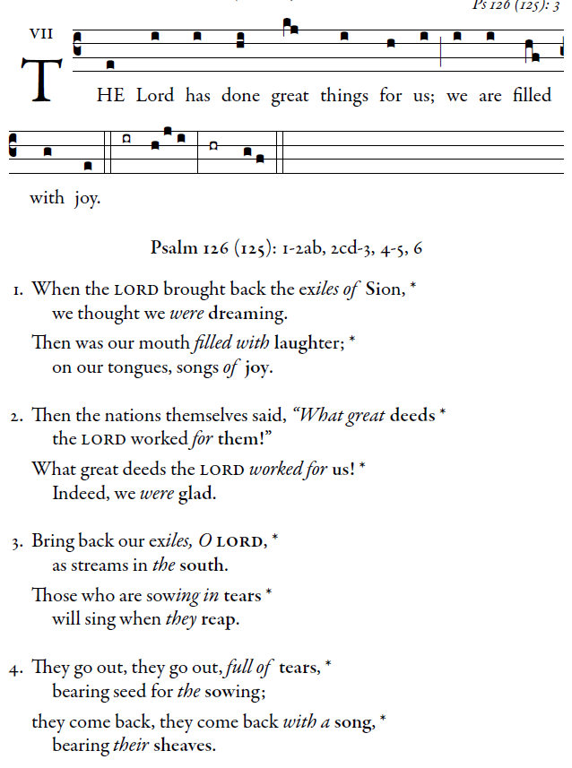
illuminarepublications.com

ALLELUIA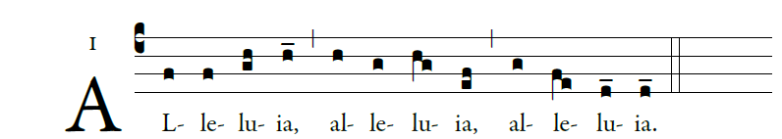

illuminarepublications.com

OFFERTORY
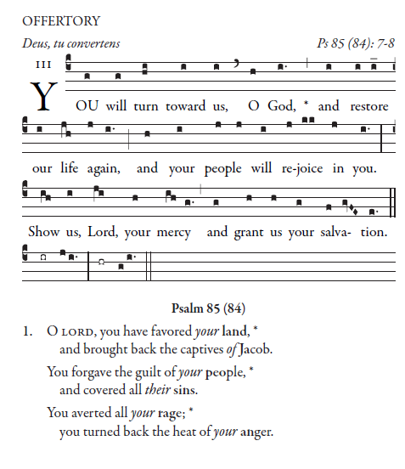
Simple English Propers by Adam Bartlett is licensed under a Creative Commons Attribution 4.0 International License.Based on a work at http://musicasacra.com/sep.

