COMMUNION HYMN AVE VERUM CORPUS
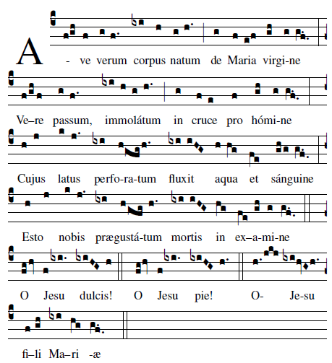

Hail, true body born of theVirgin Mary, Who truly suffered, sacrificed on the Cross for man,
Whose pierced side overflowedwith water and blood, Be forus a foretaste in the test of death
O sweet Jesus! O Loving Jesus! O Jesus Son of Mary.

RECESSIONAL HYMN

“Creator of the Stars of Night”

SECOND SUNDAY OF ADVENT
YEAR AB

ENTRANCE ANTIPHON

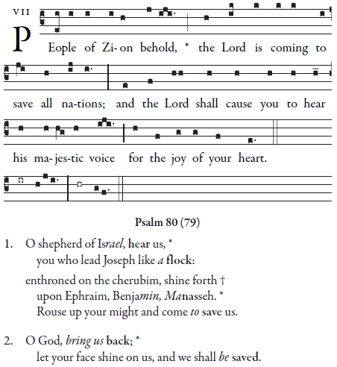

Simple English Propers by Adam Bartlett is licensed under a Creative Commons Attribution 4.0 International License.Based on a work at http://musicasacra.com/sep.

RESPONSORIAL PSALM
From Today’s Missal

ALLELUIA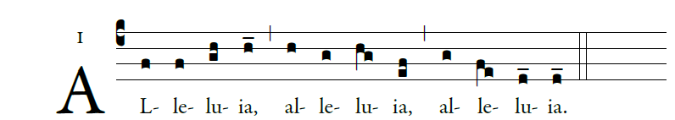

illuminarepublications.com
OFFERTORY 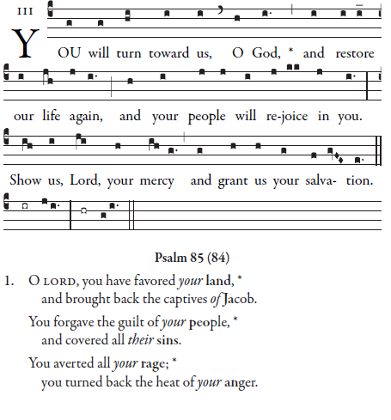
Simple English Propers by Adam Bartlett is licensed under a Creative Commons Attribution 4.0 International License.Based on a work at http://musicasacra.com/sep.

COMMUNION ANTIPHON

Simple English Propers by Adam Bartlett is licensed under a Creative CommonsAttribution 4.0 International License.Based on a work at http://musicasacra.com/sep.

COMMUNION HYMN next page

