REJOICE

THIRD SUNDAY of ADVENT
.

ENTRANCE ANTIPHON ©CMMA Adam Bartlett

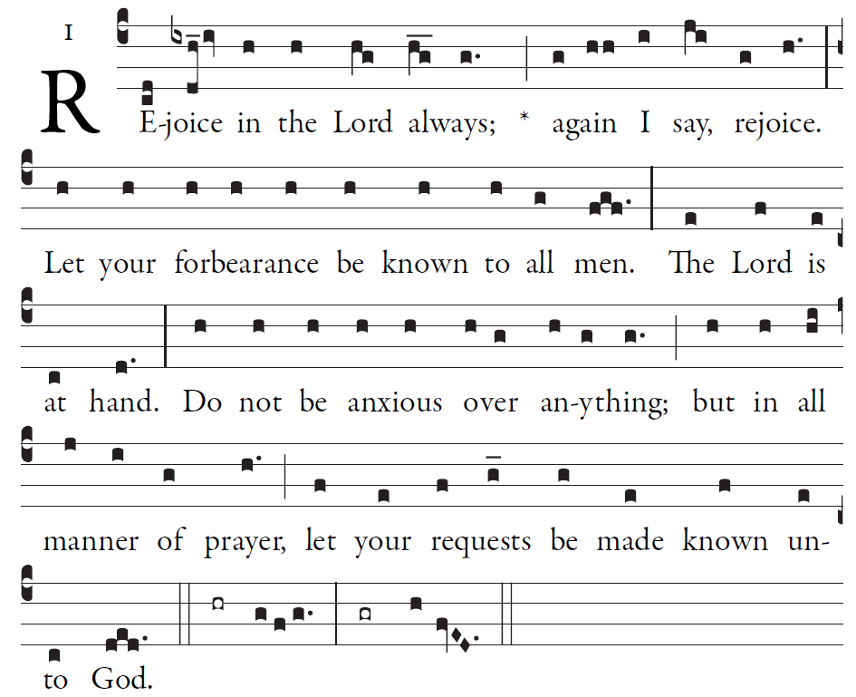

O LORD, you have favored your land,
and brought back the captives of Jacob.
Will you not restore again our life,
that your people may rejoice in you?

Bring us back, O God, our savior!
Put an end to your grievance against us.
Will you be angry with us forever?
Will your anger last from age to age?

OFFERTORY ANTIPHON

©CMMA Adam Bartlett

You forgave the guilt of your people,
and covered all their sins.
You averted all your rage;
you turned back the heat of your anger.

Bring us back, O God, our savior!
Put an end to your grievance against us.
Will you be angry with us forever?
Will your anger last from age to age?

REJOICE

COMMUNION ANTIPHON

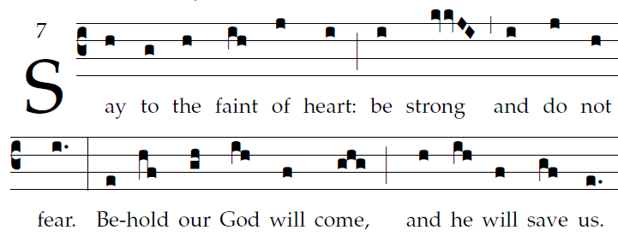
Fr. Coluba Kelly © Saint Meinrad Archabbey
ISAIAH 35
The wilderness and the parched land will exult;
the Arabah will rejoice and bloom;
Like the crocus it shall bloom abundantly,
and rejoice with joyful song.

The glory of Lebanon will be given to it,
the splendor of Carmel and Sharon;
They will see the glory of the LORD,
the splendor of our God.

COMMUNION HYMN:

“I Received the Living God”

RECESSIONAL HYMN

“Comfort, Comfort, O my People.”

