OFFERTORY ANTIPHON

“Ave Maria”: chant in the Music Issue

COMMUNION HYMN “ O Holy Mary” Music Issue

COMMUNION CHANT

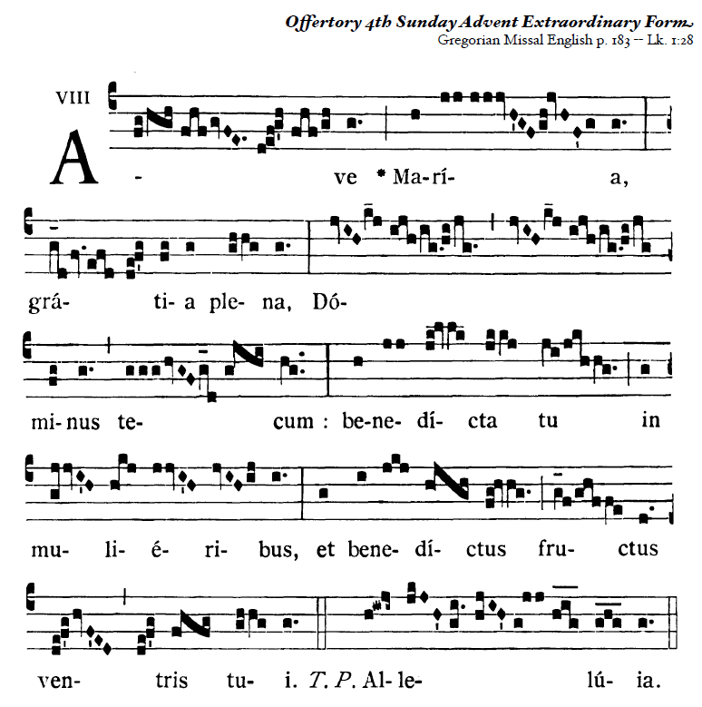

RECESSIONAL HYMN

English antiphons from ©Illuminare Publications Adam Bartlett

F O U R T H S U N D A Y of A D V E N T

year A

PRELUDE

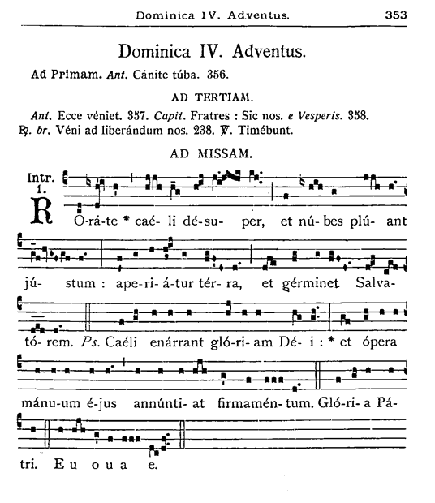

Drop down dew from heaven above, and let the clouds rain down the Just One; let the earth be openedand bring forth a Savior.

ENTRANCE ANTIPHON

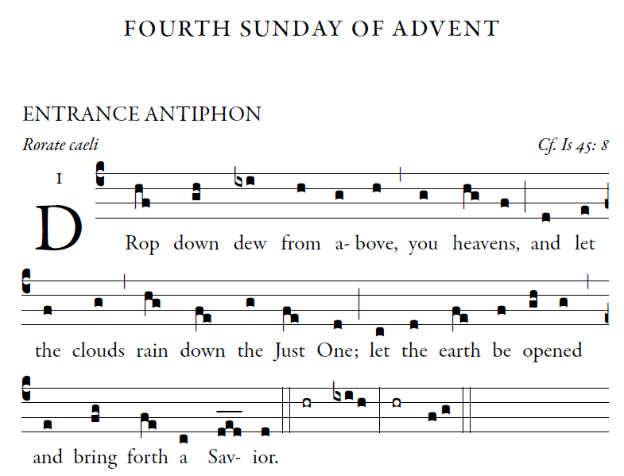

English antiphons from ©Illuminare Publications Adam Bartlett

The heavens declare the glory of God,

and the firmament proclaims the work of his hands.

Day unto day conveys the message,

and night unto night imparts the knowledge.

No speech, no word, whose voice goes unheeded;

their sound goes forth through all the earth,

their message to the utmost bounds of the world.

There he has placed a tent for the sun;

it comes forth like a bridegroom coming from his tent,

rejoices like a champion to run his course.

***Ordinary of the Mass : Orbis Factor Mass XI***

*Yellow program*



Illuminarepublications.com

The LORD's are the earth and its fullness;  
the world and those who dwell in it.  
For he founded it upon the seas  
and established it upon the rivers.

+ **Let the Lord enter; he is king of glory.**  
Who can ascend the mountain of the LORD?  
or who may stand in his holy place?  
One whose hands are sinless, whose heart is clean,  
who desires not what is vain.

 + **Let the Lord enter; he is king of glory.**  
He shall receive a blessing from the LORD,  
a reward from God his savior.  
Such is the race that seeks for him,  
that seeks the face of the God of Jacob.

+ **Let the Lord enter; he is king of glory.**