All Saints: Responsorial Psalm 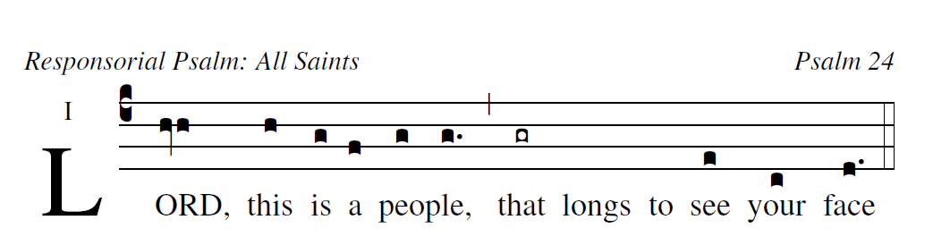

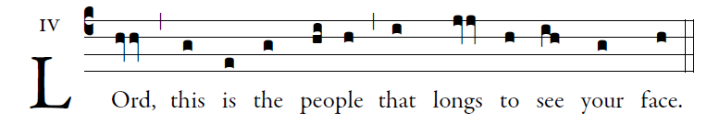
illuminarepublications.com

The LORD's are the earth and its fullness;
the world and those who dwell in it.
For he founded it upon the seas
and established it upon the rivers.
Psalm Tone ©St. Meinrad Archabbey
Who can ascend the mountain of the LORD?
or who may stand in his holy place?
One whose hands are sinless, whose heart is clean,
who desires not what is vain.
He shall receive a blessing from the LORD,
a reward from God his savior.
Such is the race that seeks him,
that seeks the face of the God of Jacob.
user-notes: Responsorial Psalm: All Saints ;
commentary: Psalm 24 ;
annotation: i ;
centering-scheme: english;
%spacing: vichi;
%font: times;
%width: 4.5;
%height: 11;
%%
(c4)LORD,(hvh) this(h) is(g) a(f) {peo}ple,(g/ g.) (,) that(gr) longs() to() see(e) your(c) face(d.) (::)

