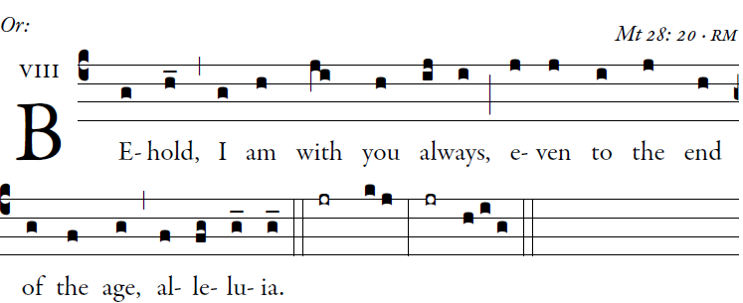
Illulmunarepublications.com

(Psalm 67[68]: 2, 5-6, 19-21, 25, 29-36: GR 238; or Psalm 33[34]: GR, Praenotanda, p. 12)

Psalm 68

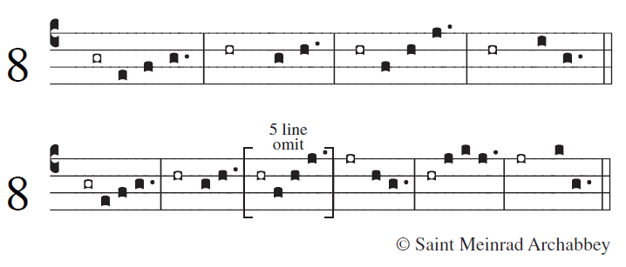
²Let God arise; let his |foes be scattered.
Let those who hate him flee |from his presence.

⁵O sing to God; make music| to his name. [5]
Extol the One who rides |on the clouds.
The LORD is his name; exult at | his presence.
⁶Father of orphans, defend- |er of widows:
such is God in his |holy place.

¹⁹You have ascended on high; leading captive- |ity captive [5]
as tribute receiving prison- |ers, O God,
so that even rebels may dwell near | the LORD God.
²⁰Day after day, may the | LORD be blest.
He bears our burdens; God |is our savior.

²¹This God of ours is a | God who saves.
The LORD our LORD provides an es- |cape from death.
²⁹Summon forth your might, | O God;
your might, O God, which you have |shown for us.

³⁰From your temple high | in Jerusalem,
kings will come to you bring- | ing their tribute.
³¹Rebuke the wild beast that dwells in | the reeds,
the bands of the mighty and rulers | of the peoples.

Scatter the peoples who de-|light in war. [3]
³²Rich merchants will make their | way from Egypt;
Ethiopia will stretch out her | hands to God.

³³You kingdoms of the earth, sing to God, | praise the LORD [6]
³⁴who rides on the heavens, the | ancient heavens.
Behold, he thunders his voice, his | mighty voice.
³⁵Come, acknowledge the pow- |er of God.
His glory is on Israel; his might is | in the skies.

³⁶Awesome is God in his |holy place.
He is God, the God |of Israel.
He himself gives strength and power |to his people.
| Blest be God!

