ENTRANCE HYMN
Hymn: “ O Most Holy One” Music Issue

Lord have Mercy, Glory to God , from the Missa Simplex

RESPONSORIAL PSALM R.Bednarz ,2014

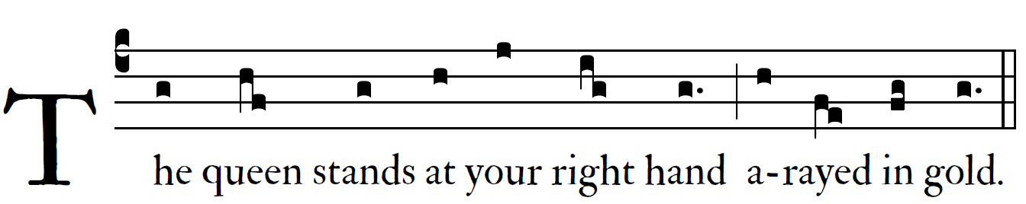

The queen takes her place at your right hand in gold of Ophir.
Hear, O daughter, and see; turn your ear,
forget your people and your father’s house. 
So shall the king desire your beauty;
for he is your Lord.
They are borne in with gladness and joy;
they enter the palace of the king. 

OFFERTORY: “ O Holy Mary”

HOLY, ACCLAMATION, Amen and Lamb of God from the
MISSA SIMPLEX booklet.

COMMUNION ANTIPHON

R.Bednarz 2013, 2014,201
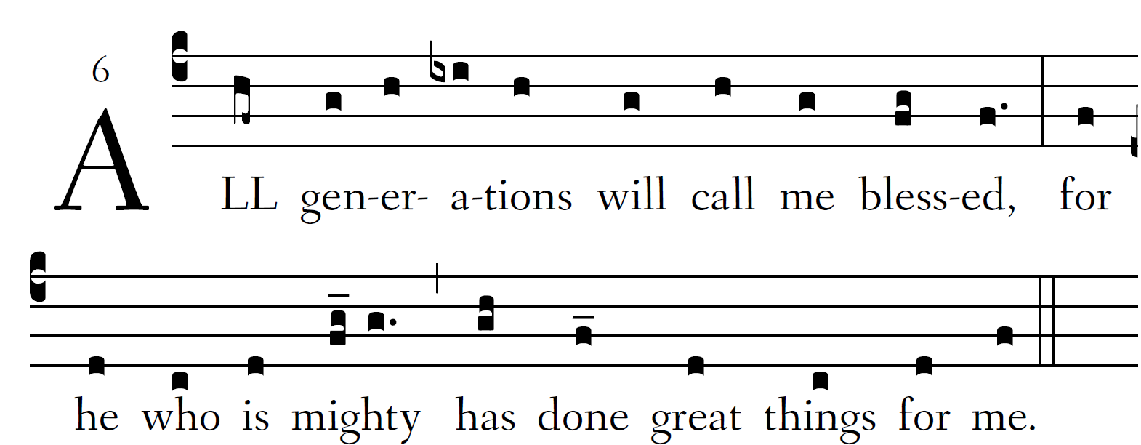

My soul proclaims the greatness of the Lord,
my spirit rejoices in God my Saviour;
he has looked with favour on his lowly servant.
From this day all generations will call me blessed;

the Almighty has done great things for me
and holy is his name.
He has mercy on those who fear him,
from generation to generation.

He has shown strength with his arm
and has scattered the proud in their con-ceit,
Casting down the mighty from their thrones
and lifting up the lowly.

He has filled the hungry with good things
and sent the rich away empty.
He has come to the aid of his servant Israel,
to remember his promise of mercy,
The promise made to our ancestors,
to Abraham and his children for ever.

RECESSIONAL HYMN

“ Hail Holy Queen”

Hail, Holy Queen enthroned above, O Maria!
Hail, Mother of mercy and of love, O Maria!
Triumph all ye cherubim!
Sing with us ye seraphim!
Heaven and earth resound the hymn!
Salve, salve, salve, Regina!

Our life, our sweetness, here below, O Maria!
Our hope in sorrow and in woe, O Maria!
Triumph, all ye cherubim,
Sing with us, ye seraphim,
Heaven and earth resound the hymn:
Salve, salve, salve Regina!

ASSUMPTION
of the
 Blessed Virgin Mary 

