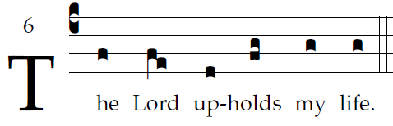

O God, by your name save me,
and by your might defend my cause.
O God, hear my prayer;
hearken to the words of my mouth.

For the haughty men have risen up against me,
the ruthless seek my life;
they set not God before their eyes.

Behold, God is my helper;
the Lord sustains my life.
Freely will I offer you sacrifice;
I will praise your name, O LORD, for its goodness.

