Ps 34:2-3, 4-5, 6-7, 8-9

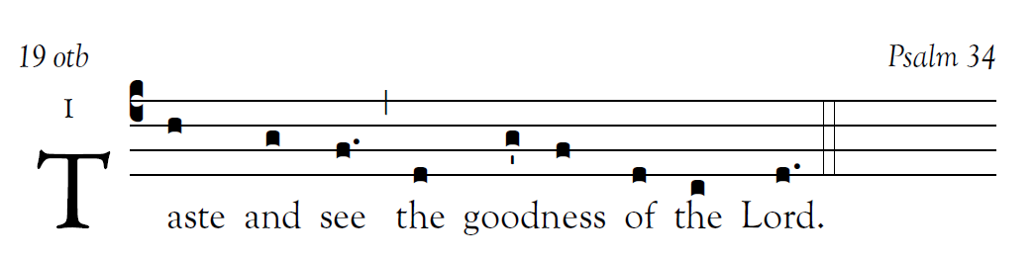
I will bless the LORD at all times;
his praise shall be ever in my mouth.
Let my soul glory in the LORD;
the lowly will hear me and be glad.
Glorify the LORD with me,
Let us together ex-tol his name.
I sought the LORD, and he answered me
And delivered me from all my fears.

2012 2015

Look to him that you may be radi-ant with joy.
And your faces may not blush with shame.
When the afflicted man called out, the LORD heard,
And from all his distress he saved him.
The angel of the LORD encamps
around those who fear him and delivers them.
Taste and see how good the LORD is;
blessed the man who takes refuge in him.

user-notes: 19 otb ;
commentary: Psalm 34 ;
annotation: I ;
centering-scheme: english;
%spacing: vichi;
%font: OFLSortsMillGoudy;
%width: 4.5;
%height: 11;
%%
(c4)Taste(h) and(g) see(f.) (,) the(d) {goodn}ess(g'/ f) of(d) the(c) Lord.(d.)(::)

