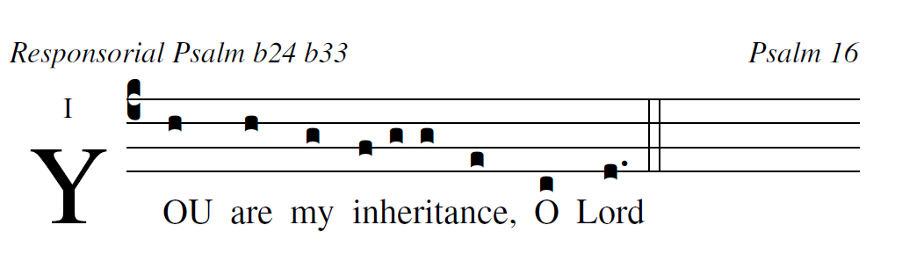
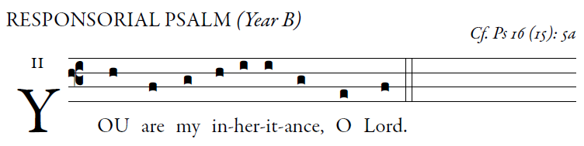
illuminarepubllications.com

Responsorial Psalm Ps 16:5, 8, 9-10, 11
O LORD, my allotted portion and my cup,
you it is who hold fast my lot.
I set the LORD ever be-fore me;
with him at my right hand I shall not be disturbed.
Therefore my heart is glad and my soul rejoices,
my body, too, a-bides in confidence;
because you will not abandon my soul to the neth-erworld,
nor will you suffer your faithful one to under-go corruption.
You will show me the path to life,
fullness of joys in your presence,
the delights at your right hand forever.
user-notes: Responsorial Psalm b24 b33 ;
commentary: Psalm 16 ;
annotation: i;
centering-scheme: english;
%spacing: vichi;
%font: times;
%width: 4;
%height: 11;
%%
(c4)YOU(h) are(h) my(g) {in}heritance,(f/ g g e) O(c) Lord(d.) (::)

