Communion Antiphon:
Fr. Columba Kelly © Saint Meinrad Archabbey
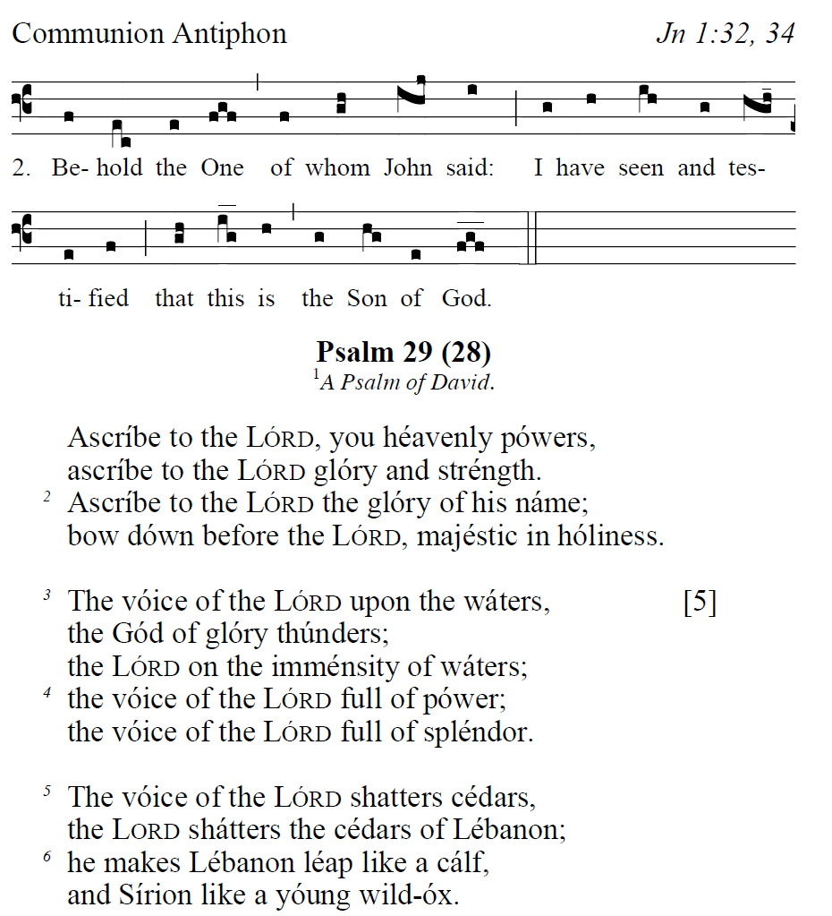

Recessional Hymn:
“ Holy God, We Praise Thy Name”

Baptism of the Lord

ENTRANCE HYMN “ Joy to the World”

SPRINKLING RITE ANTIPHON
Ralph Bednarz
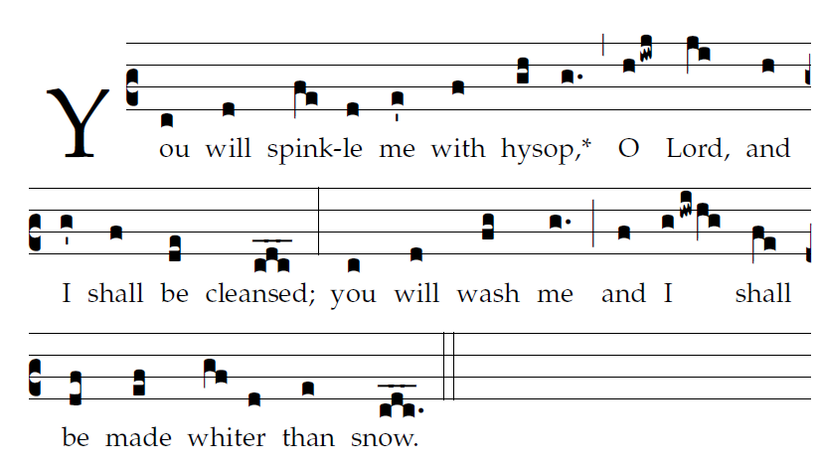
Psalm 51

 Have mercy on m, O God
according to your great mercy.

Glory be to the Father , and to the Son,
and to the Holy Spirit.

As it was in the beginning,
is now and evershal be Amen

RESPONSORIAL PSALM

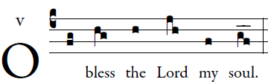

O LORD, my God, you are great indeed!
you are clothed with majesty and glory,
robed in light as with a cloak.
You have spread out the heavens like a tent-cloth;


You have constructed your palace upon the waters.
You make the clouds your chariot;
you travel on the wings of the wind.
You make the winds your messengers,
and flaming fire your ministers.


How manifold are your works, O LORD!
In wisdom you have wrought them all—
the earth is full of your creatures;
the sea also, great and wide,
in which are schools without number
of living things both small and great.


They look to you to give them food in due time.
When you give it to them, they gather it;
when you open your hand, they are filled with good things.


If you take away their breath, they perish and return to the dust.
When you send forth your spirit, they are created,
and you renew the face of the earth.


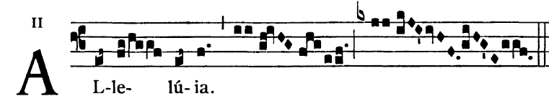

John said: One mightier than I is coming:
He will baptize you with the Holy Spirit and with fire.

OFFERTORY HYMN

“At the Name of Jesus”

