Communion Antiphon:
Fr. Columba Kelly © Saint Meinrad Archabbey
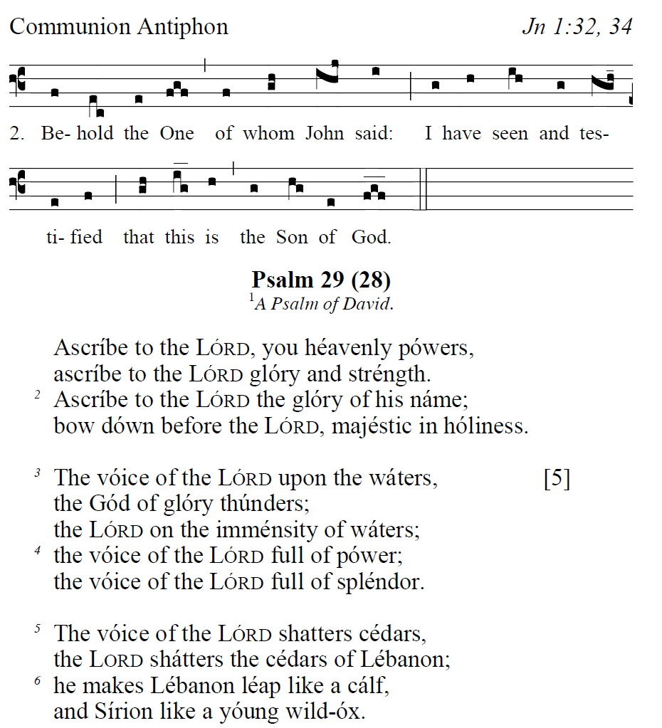

Communion Hymn:
“At the Name of Jesus” #739 MIkk

Recessional Hymn:
“The Church’s One Foundation” #420 MI

Baptism of the Lord

ENTRANCE HYMN “ O God Almighty Father “ #719 MI

SPRINKLING RITE ANTIPHON
Ralph Bednarz
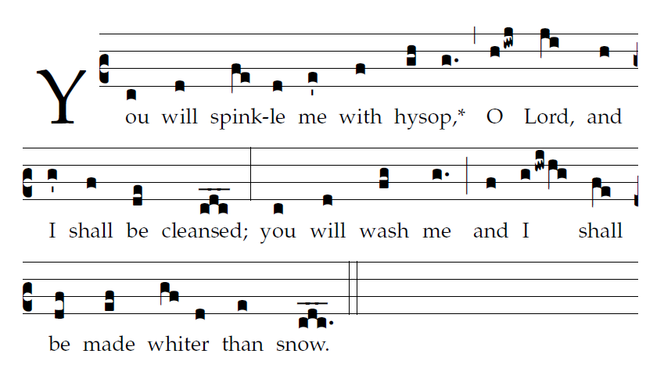
Psalm 51

 Have mercy on m, O God
according to your great mercy.

Glory be to the Father , and to the Son,
and to the Holy Spirit.

As it was in the beginning,
is now and evershal be Amen

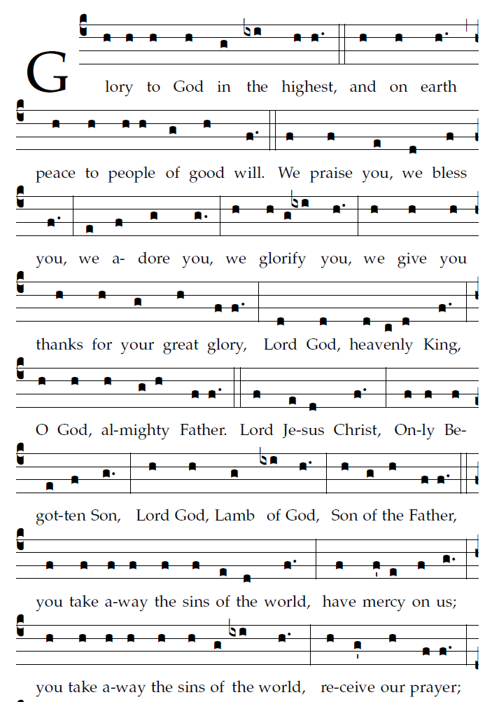

Psalm tone© St.. Meinrad Archabbey Ralph Bednarz 2014

Liturgy of the Word page 47 TM
Aristotle Esguerra
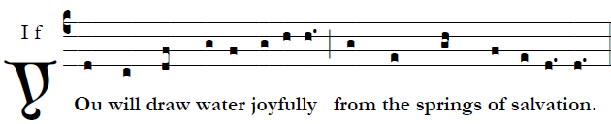


God indeed is my savior; [6]
I am confident and unafraid.
My strength and my courage is the LORD,
and he has been my savior.
With joy you will draw water
at the fountain of salvation.         
Give thanks to the LORD, acclaim his name; [3]
among the nations make known his deeds,
proclaim how exalted is his name. 
Sing praise to the LORD for his glorious achievement;
let this be known throughout all the earth.
Shout with exultation, O city of Zion,
for great in your midst is the Holy One of Israel 
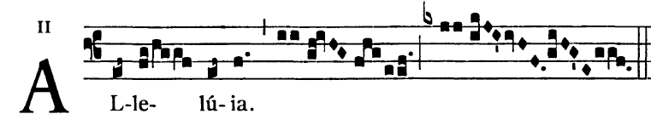

Offertory Hymn:
“Immortal, Invisible, God Only Wise” #570 MI

Holy & Lamb of God (Mass of Christian Unity)
