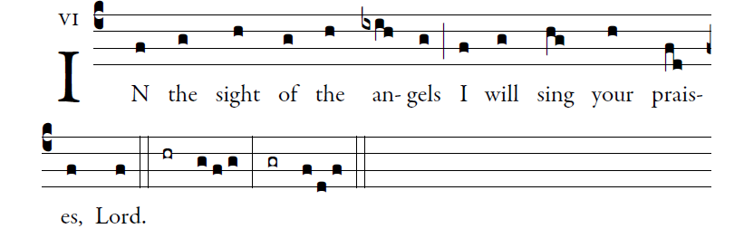
ILLUMINAREPUBLICATIONS.COM
I will give thanks to you, O LORD, with all my heart,
for you have heard the words of my mouth;
in the presence of the angels I will sing your praise;
I will worship at your holy temple
and give thanks to your name.

Because of your kindness and your truth;
for you have made great above all things
your name and your promise.
When I called, you answered me;
you built up strength within me.

All the kings of the earth shall give thanks to you, O LORD,
when they hear the words of your mouth;
and they shall sing of the ways of the LORD:
“Great is the glory of the LORD.”

Your right hand saves me.
The LORD will complete what he has done for me;
your kindness, O LORD, endures for-ever;
forsake not the work of your hands.
